

NOTICE FOR SALE OF VEHICLE

Caterpillar Forklift

- Offers are invited for the purchase of the above vehicle belonging to the Government of Saint Lucia. The vehicle will be sold under an open tender process and sealed offers are invited accordingly.

- Appendix (1) one of this notice contains photographs of the vehicle, and the vehicle can be viewed and inspected at the grounds of the Dennery Infrastructure Workshop, from Monday to Friday during the hours of 9:00 AM to 12:00 PM and 2:00 PM to 3:30 PM.

- The vehicle will be sold “as is, where is” with the purchaser being responsible for all transfer fees and related costs.

- Bid forms can be obtained during normal working hours at the Department of Finance, 2nd Floor, Finance Administrative Centre, Pointe Seraphine, Castries. Bidders can also write to dof.fso@govt.lc to request a copy of the Bid Form.

- Bid forms must be submitted in a sealed envelope entitled:

“Tender for Caterpillar Forklift
Director of Finance
Department of Finance, Constituency Development & People Empowerment

2nd Floor, Finance Administrative Centre, Pointe Seraphine”

- Envelopes, containing completed tender documents must be submitted to the Department of Finance, 2nd Floor, Finance Administrative Centre, Pointe Seraphine no later than 4:00 pm on Tuesday August 11, 2026.
Late offers will NOT be considered.

- The tender process shall become null and void if the successful bidder fails to make payment for the vehicle within five (5) business days of being informed of his or her success in the tender process. This provision will not apply if the successful bidder has provided an explanation on their inability to pay within the stipulated period, which has been accepted by the Department of Finance.

- Please note the Department of Finance reserves the right to cancel the present notice. The Department of Finance does not bind itself to accept the highest or any offer. The Department of Finance reserves the right to reject or accept any offer without giving and reason(s) thereof.

END

APPENDIX ONE
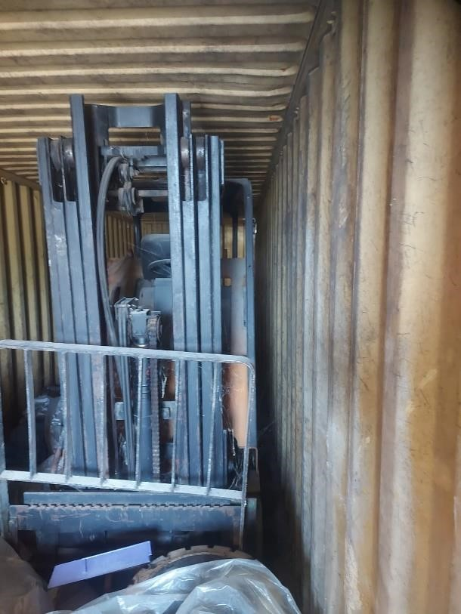

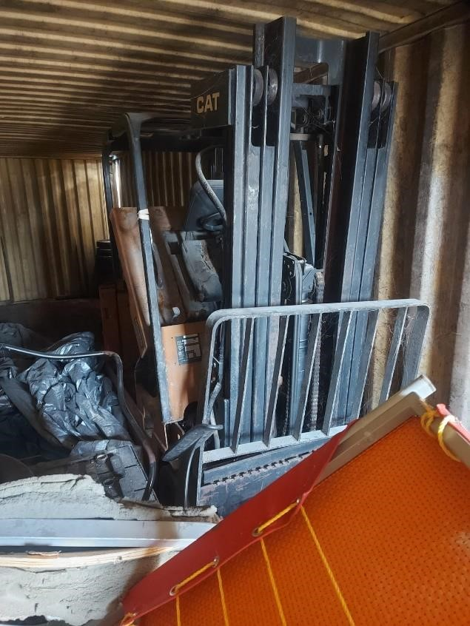
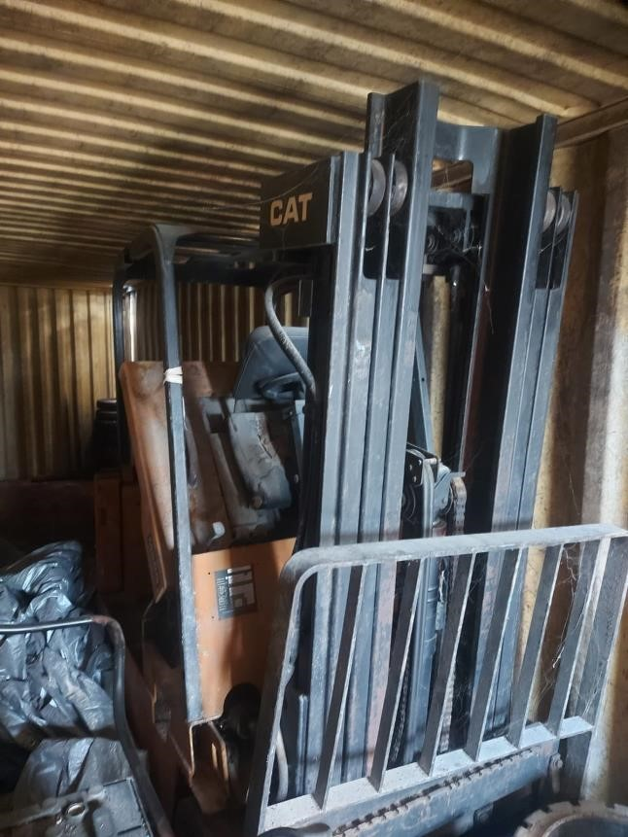

NOTICE FOR SALE OF VEHICLE

2011 Nissan Navara - Registration Number SLG 049

- Offers are invited for the purchase of the above vehicle belonging to the Government of Saint Lucia. The vehicle will be sold under an open tender process and sealed offers are invited accordingly.

- Appendix (1) one of this notice contains photographs of the vehicle, and the vehicle can be viewed and inspected at the grounds of the Vieux Fort Fire Station, from Monday to Friday during the hours of 9:00 AM to 12:00 PM and 2:00 PM to 3:30 PM.

- The vehicle will be sold “as is, where is” with the purchaser being responsible for all transfer fees.

- Bid forms can be obtained during normal working hours at the Department of Finance, 2nd Floor, Finance Administrative Centre, Pointe Seraphine, Castries. Bidders can also write to dof.fso@govt.lc to request a copy of the Bid Form.

- Bid forms must be submitted in a sealed envelope entitled:
“Tender for SLG 049
Director of Finance
Department of Finance, Constituency Development & People
Empowerment

2nd Floor, Finance Administrative Centre, Pointe Seraphine”

- Envelopes, containing completed tender documents must be submitted to the Department of Finance, 2nd Floor, Finance Administrative Centre, Pointe Seraphine no later than 4:00 pm on Tuesday August 11, 2026. Late offers will NOT be considered.

- The tender process shall become null and void if the successful bidder fails to make payment for the vehicle within five (5) business days of being informed of his or her success in the tender process. This provision will not apply if the successful bidder has provided an explanation on their inability to pay within the stipulated period, which has been accepted by the Department of Finance.

- Please note the Department of Finance reserves the right to cancel the present notice. The Department of Finance does not bind itself to accept the highest or any offer. The Department of Finance reserves the right to reject or accept any offer without giving and reason(s) thereof.

END

APPENDIX ONE
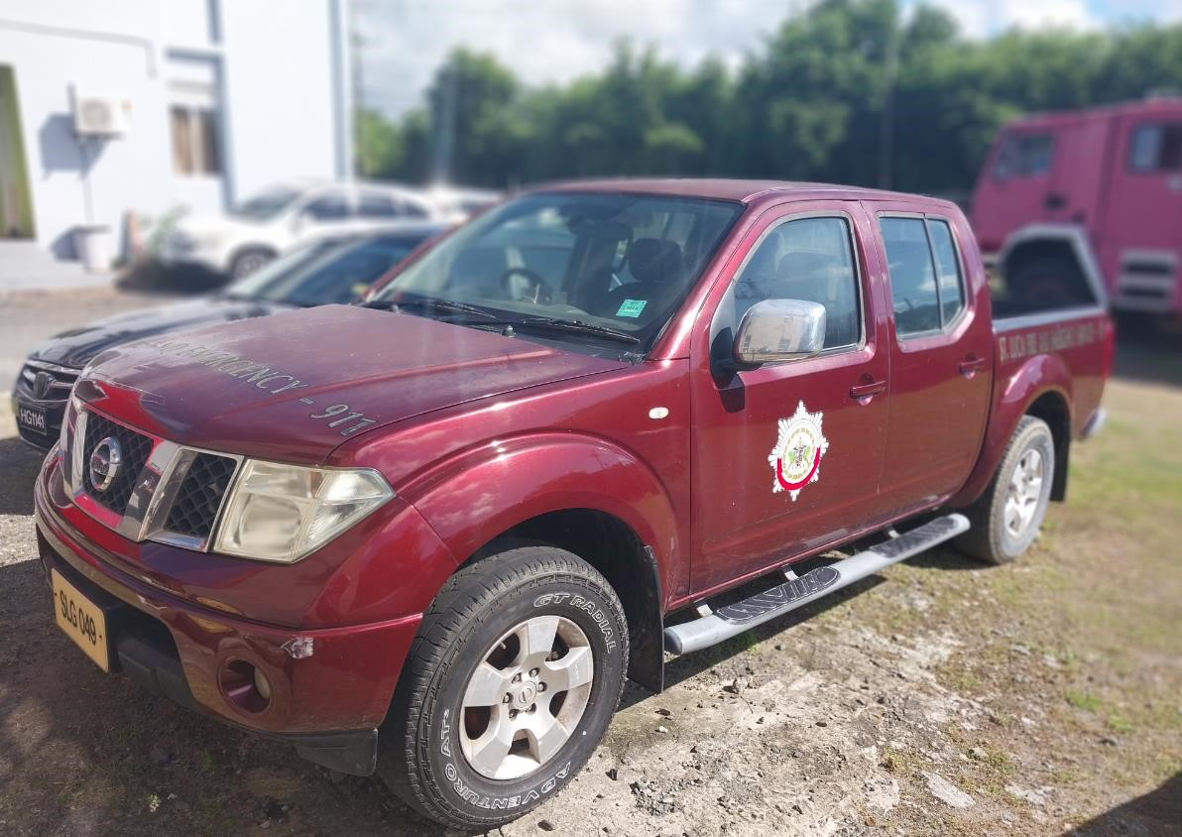
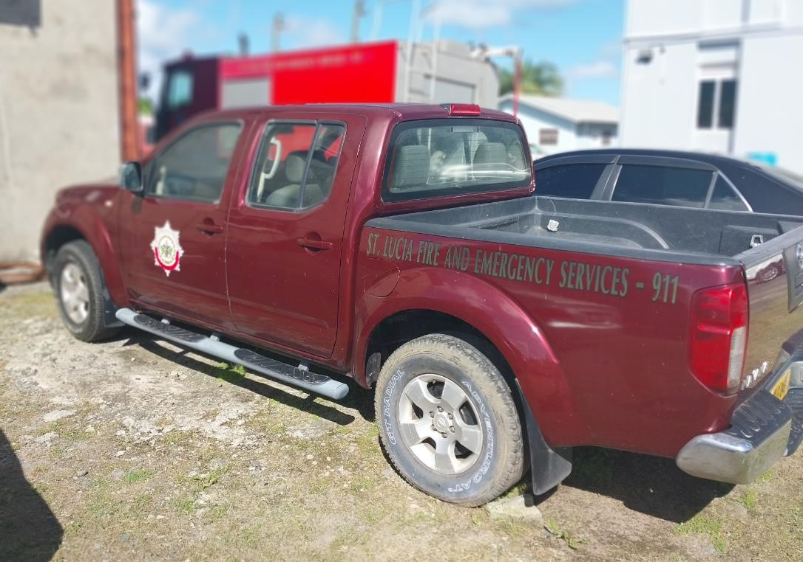

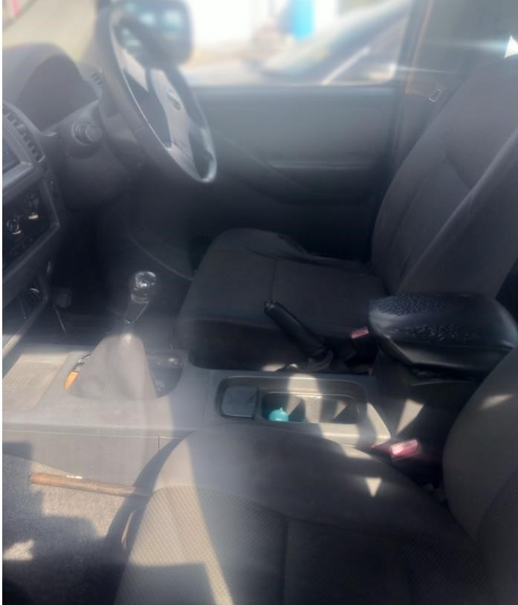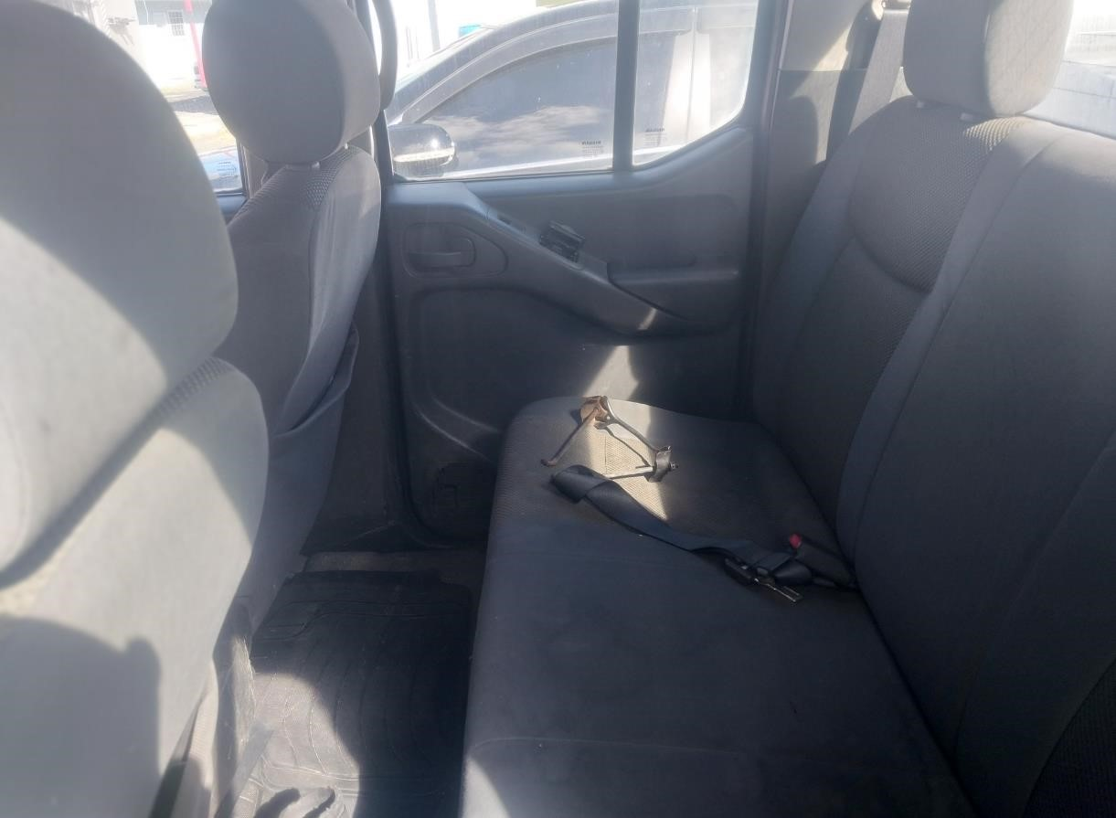

NOTICE FOR SALE OF VEHICLE

20011 Nissan Urvan - Registration Number SLG 183

- Offers are invited for the purchase of the above vehicle belonging to the Government of Saint Lucia. The vehicle will be sold under an open tender process and sealed offers are invited accordingly.

- Appendix (1) one of this notice contains photographs of the vehicle, and the vehicle can be viewed and inspected at the grounds of the Hasache Grounds (Ministry of Education Office, Good lands, Castries), from Monday to Friday during the hours of 9:00 AM to 12:00 PM and 2:00 PM to 3:30 PM.

- The vehicle will be sold “as is, where is” with the purchaser being responsible for all transfer fees and other costs.

- Bid forms can be obtained during normal working hours at the Department of Finance, 2nd Floor, Finance Administrative Centre, Pointe Seraphine, Castries. Bidders can also write to dof.fso@govt.lc to request a copy of the Bid Form.

- Bid forms must be submitted in a sealed envelope entitled:
“Tender for SLG 183
Director of Finance
Department of Finance, Constituency Development & People
Empowerment

2nd Floor, Finance Administrative Centre, Pointe Seraphine”

- Envelopes, containing completed tender documents must be submitted to the Department of Finance, 2nd Floor, Finance Administrative Centre, Pointe Seraphine no later than 4:00 pm on Tuesday July 7, 2026. Late offers will NOT be considered.

- The tender process shall become null and void if the successful bidder fails to make payment for the vehicle within five (5) business days of being informed of his or her success in the tender process. This provision will not apply if the successful bidder has provided an explanation on their inability to pay within the stipulated period, which has been accepted by the Department of Finance.

- Please note the Department of Finance reserves the right to cancel the present notice. The Department of Finance does not bind itself to accept the highest or any offer. The Department of Finance reserves the right to reject or accept any offer without giving and reason(s) thereof.

END

APPENDIX ONE
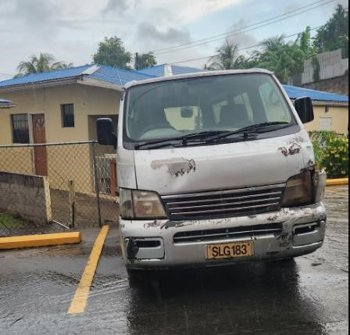

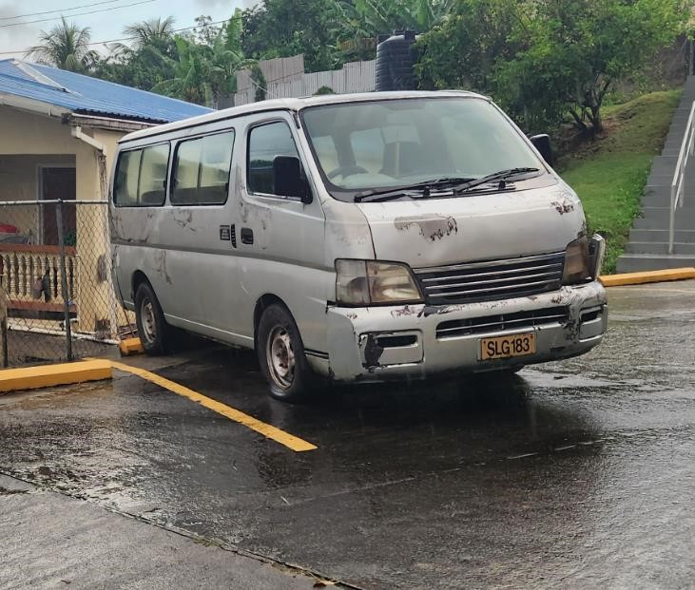

NOTICE FOR SALE OF VEHICLE

1991 Leyland Angloco Fire Truck - Registration Number SLG 475

- Offers are invited for the purchase of the above vehicle belonging to the Government of Saint Lucia. The vehicle will be sold under an open tender process and sealed offers are invited accordingly.

- Appendix (1) one of this notice contains photographs of the vehicle, and the vehicle can be viewed and inspected at the grounds of the Vieux Fort Fire Station, from Monday to Friday during the hours of 9:00 AM to 12:00 PM and 2:00 PM to 3:30 PM.

- The vehicle will be sold “as is, where is” with the purchaser being responsible for all transfer fees.

- Bid forms can be obtained during normal working hours at the Department of Finance, 2nd Floor, Finance Administrative Centre, Pointe Seraphine, Castries. Bidders can also write to dof.fso@govt.lc to request a copy of the Bid Form.

- Bid forms must be submitted in a sealed envelope entitled:
“Tender for SLG 475
Director of Finance
Department of Finance, Constituency Development & People
Empowerment

2nd Floor, Finance Administrative Centre, Pointe Seraphine”

- Envelopes, containing completed tender documents must be submitted to the Department of Finance, 2nd Floor, Finance Administrative Centre, Pointe Seraphine no later than 4:00 pm on Tuesday August 11, 2026. Late offers will NOT be considered.

- The tender process shall become null and void if the successful bidder fails to make payment for the vehicle within five (5) business days of being informed of his or her success in the tender process. This provision will not apply if the successful bidder has provided an explanation on their inability to pay within the stipulated period, which has been accepted by the Department of Finance.

- Please note the Department of Finance reserves the right to cancel the present notice. The Department of Finance does not bind itself to accept the highest or any offer. The Department of Finance reserves the right to reject or accept any offer without giving and reason(s) thereof.

END

APPENDIX ONE

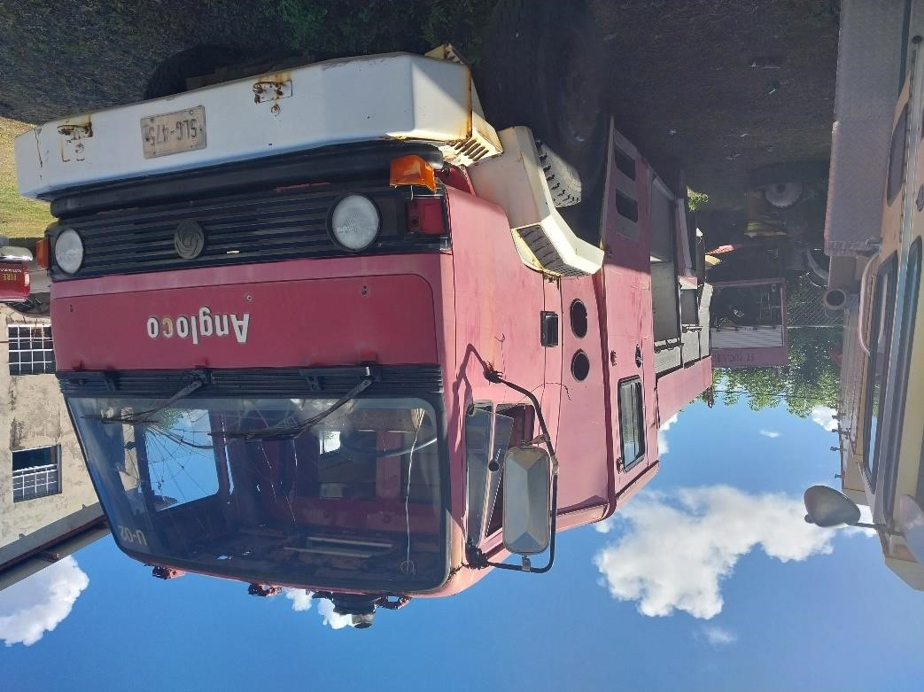

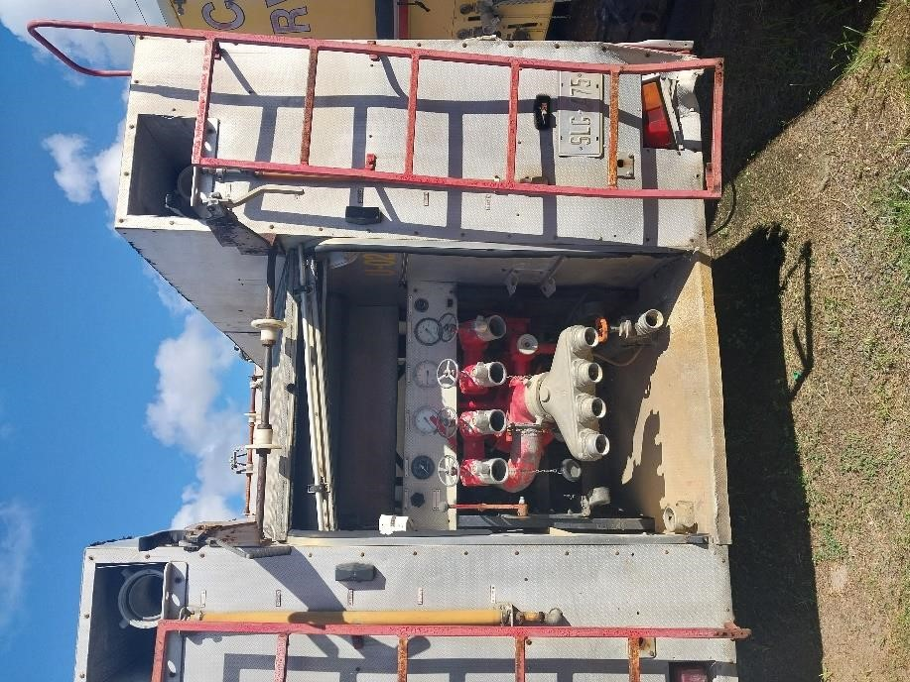
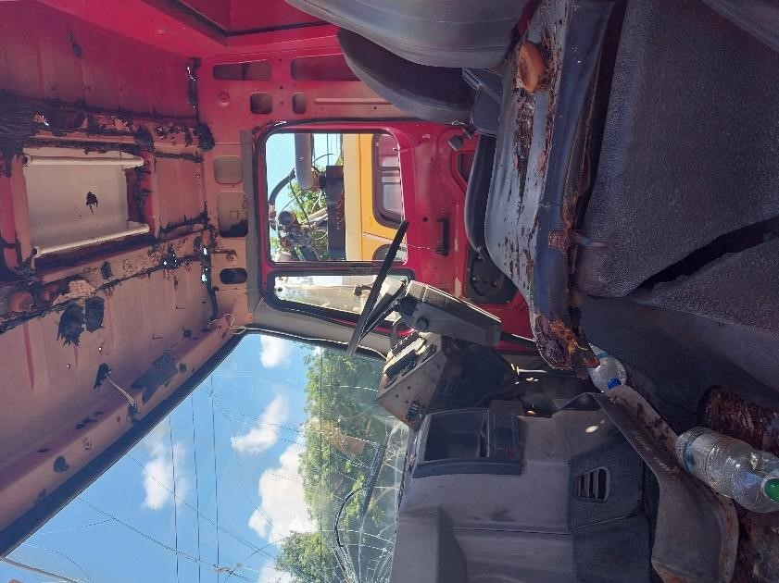

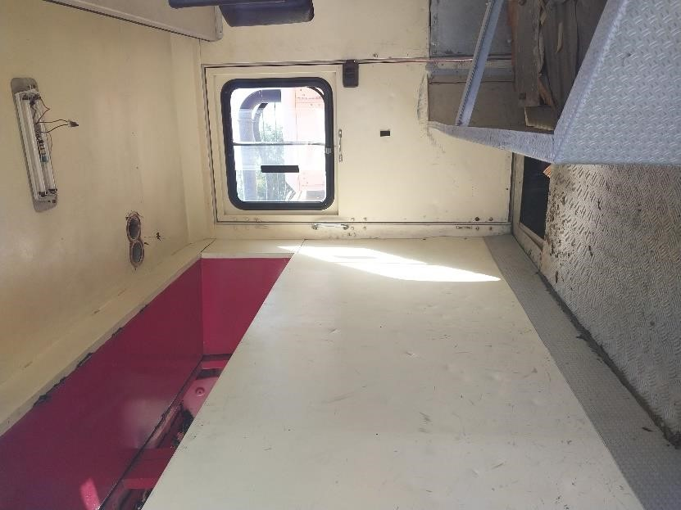

NOTICE FOR SALE OF VEHICLE

1991 Leyland Comet Fire Truck - Registration Number SLG 478

- Offers are invited for the purchase of the above vehicle belonging to the Government of Saint Lucia. The vehicle will be sold under an open tender process and sealed offers are invited accordingly.

- Appendix (1) one of this notice contains photographs of the vehicle, and the vehicle can be viewed and inspected at the grounds of the Vieux Fort Fire Station, from Monday to Friday during the hours of 9:00 AM to 12:00 PM and 2:00 PM to 3:30 PM.

- The vehicle will be sold “as is, where is” with the purchaser being responsible for all transfer fees.

- Bid forms can be obtained during normal working hours at the Department of Finance, 2nd Floor, Finance Administrative Centre, Pointe Seraphine, Castries. Bidders can also write to dof.fso@govt.lc to request a copy of the Bid Form.

- Bid forms must be submitted in a sealed envelope entitled:
“Tender for SLG 478
Director of Finance
Department of Finance, Constituency Development & People
Empowerment

2nd Floor, Finance Administrative Centre, Pointe Seraphine”

- Envelopes, containing completed tender documents must be submitted to the Department of Finance, 2nd Floor, Finance Administrative Centre, Pointe Seraphine no later than 4:00 pm on Tuesday August 11, 2026. Late offers will NOT be considered.

- The tender process shall become null and void if the successful bidder fails to make payment for the vehicle within five (5) business days of being informed of his or her success in the tender process. This provision will not apply if the successful bidder has provided an explanation on their inability to pay within the stipulated period, which has been accepted by the Department of Finance.

- Please note the Department of Finance reserves the right to cancel the present notice. The Department of Finance does not bind itself to accept the highest or any offer. The Department of Finance reserves the right to reject or accept any offer without giving and reason(s) thereof.

END

APPENDIX ONE

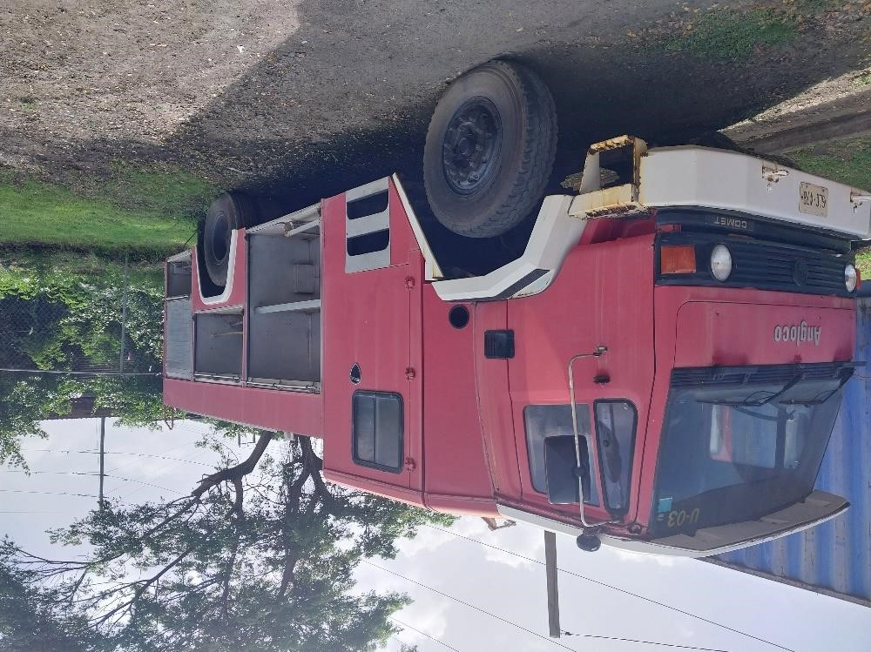

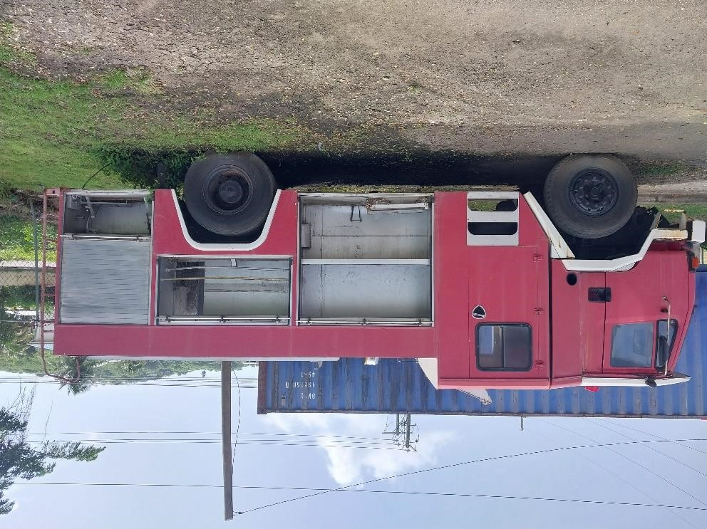

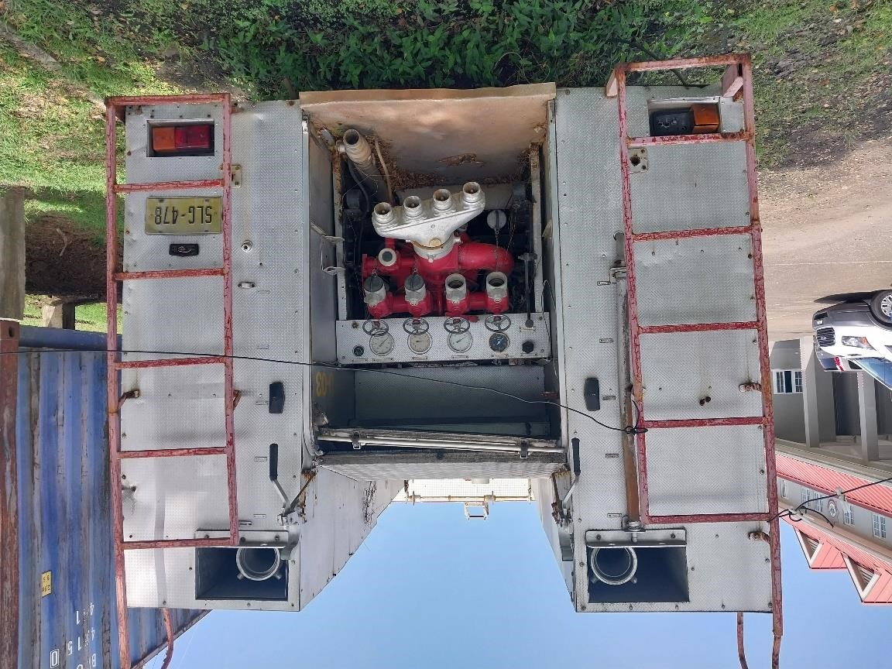

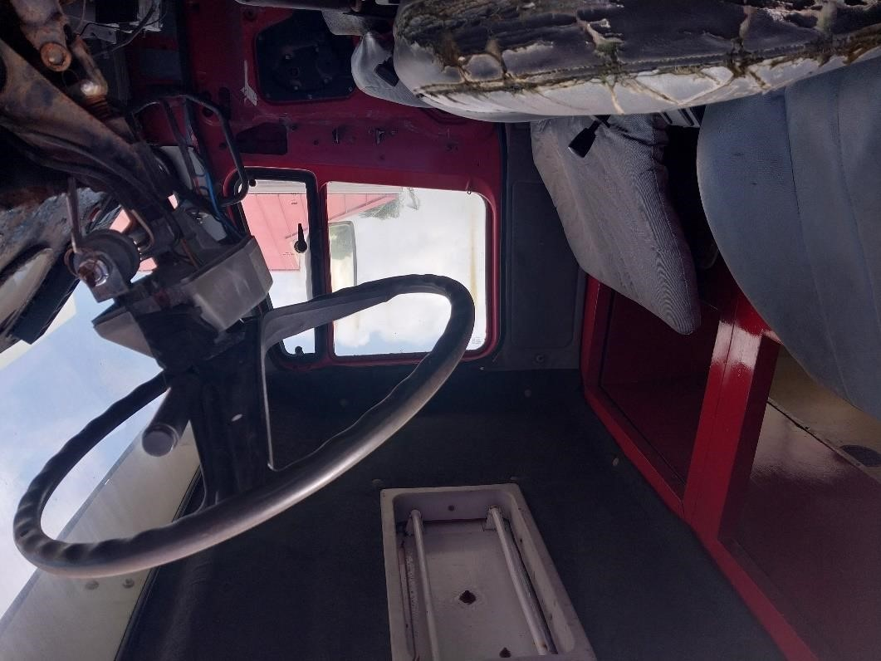

NOTICE FOR SALE OF VEHICLE

2011 Nissan Frontier - Registration Number SLG 515

- Offers are invited for the purchase of the above vehicle belonging to the Government of Saint Lucia. The vehicle will be sold under an open tender process and sealed offers are invited accordingly.

- Appendix (1) one of this notice contains photographs of the vehicle, and the vehicle can be viewed and inspected at the grounds of the Vieux Fort Fire Station, from Monday to Friday during the hours of 9:00 AM to 12:00 PM and 2:00 PM to 3:30 PM.

- The vehicle will be sold “as is, where is” with the purchaser being responsible for all transfer fees and costs.

- Bid forms can be obtained during normal working hours at the Department of Finance, 2nd Floor, Finance Administrative Centre, Pointe Seraphine, Castries. Bidders can also write to dof.fso@govt.lc to request a copy of the Bid Form.

- Bid forms must be submitted in a sealed envelope entitled:
“Tender for SLG 515
Director of Finance
Department of Finance, Constituency Development & People
Empowerment

2nd Floor, Finance Administrative Centre, Pointe Seraphine”

- Envelopes, containing completed tender documents must be submitted to the Department of Finance, 2nd Floor, Finance Administrative Centre, Pointe Seraphine no later than 4:00 pm on Tuesday August 11, 2026. Late offers will NOT be considered.

- The tender process shall become null and void if the successful bidder fails to make payment for the vehicle within five (5) business days of being informed of his or her success in the tender process. This provision will not apply if the successful bidder has provided an explanation on their inability to pay within the stipulated period, which has been accepted by the Department of Finance.

- Please note the Department of Finance reserves the right to cancel the present notice. The Department of Finance does not bind itself to accept the highest or any offer. The Department of Finance reserves the right to reject or accept any offer without giving and reason(s) thereof.

END

APPENDIX ONE
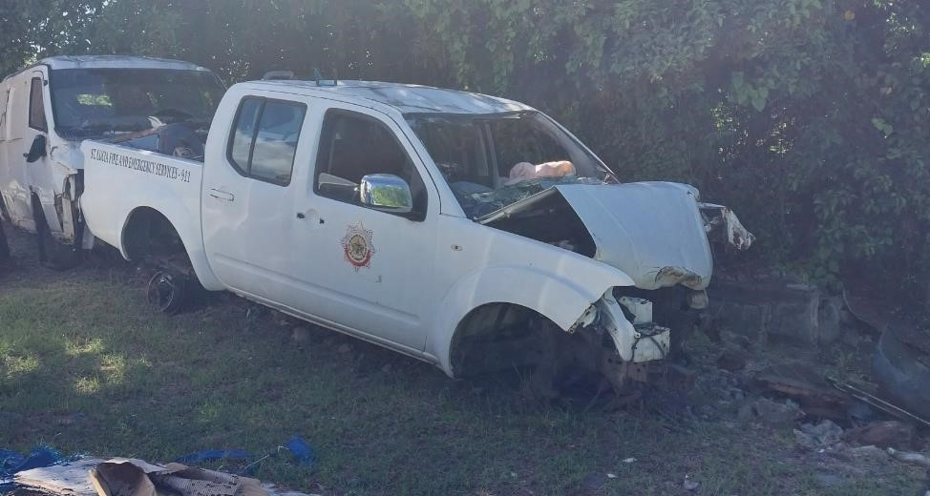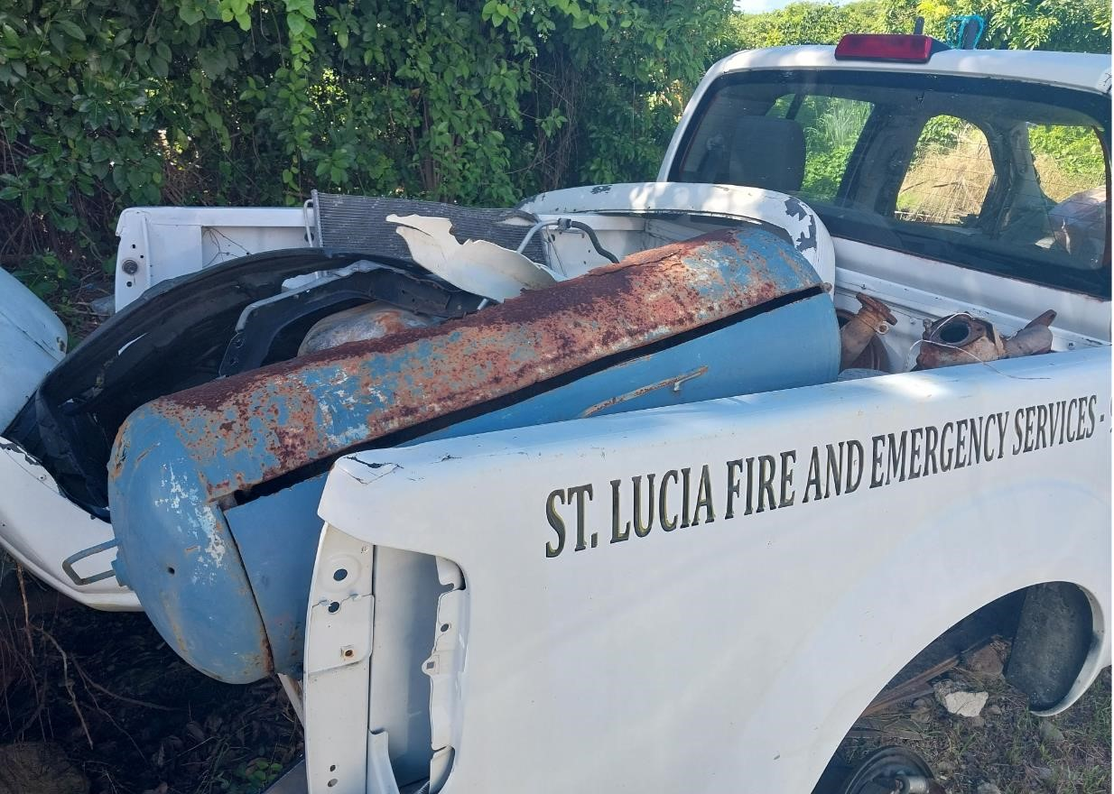

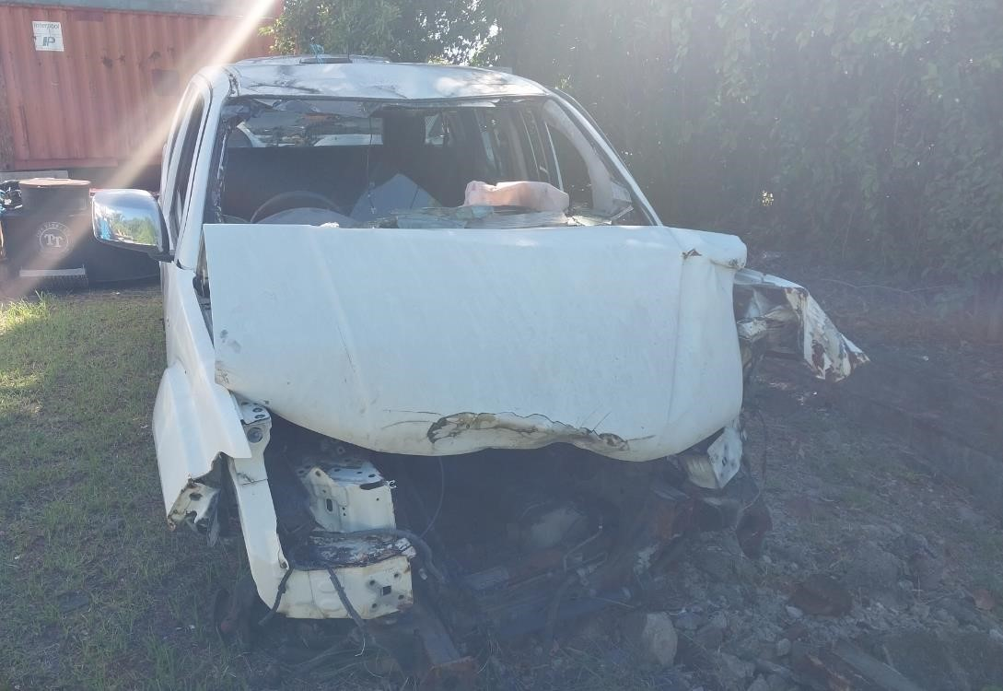

NOTICE FOR SALE OF VEHICLE

1995 Oshkosh Fire Truck - Registration Number SLG 626

- Offers are invited for the purchase of the above vehicle belonging to the Government of Saint Lucia. The vehicle will be sold under an open tender process and sealed offers are invited accordingly.

- Appendix (1) one of this notice contains photographs of the vehicle, and the vehicle can be viewed and inspected at the grounds of the Vieux Fort Fire Station, from Monday to Friday during the hours of 9:00 AM to 12:00 PM and 2:00 PM to 3:30 PM.

- The vehicle will be sold “as is, where is” with the purchaser being responsible for all transfer fees.

- Bid forms can be obtained during normal working hours at the Department of Finance, 2nd Floor, Finance Administrative Centre, Pointe Seraphine, Castries. Bidders can also write to dof.fso@govt.lc to request a copy of the Bid Form.

- Bid forms must be submitted in a sealed envelope entitled:
“Tender for SLG 626
Director of Finance
Department of Finance, Constituency Development & People
Empowerment

2nd Floor, Finance Administrative Centre, Pointe Seraphine”

- Envelopes, containing completed tender documents must be submitted to the Department of Finance, 2nd Floor, Finance Administrative Centre, Pointe Seraphine no later than 4:00 pm on Tuesday August 11, 2026. Late offers will NOT be considered.

- The tender process shall become null and void if the successful bidder fails to make payment for the vehicle within five (5) business days of being informed of his or her success in the tender process. This provision will not apply if the successful bidder has provided an explanation on their inability to pay within the stipulated period, which has been accepted by the Department of Finance.

- Please note the Department of Finance reserves the right to cancel the present notice. The Department of Finance does not bind itself to accept the highest or any offer. The Department of Finance reserves the right to reject or accept any offer without giving and reason(s) thereof.

END

APPENDIX ONE

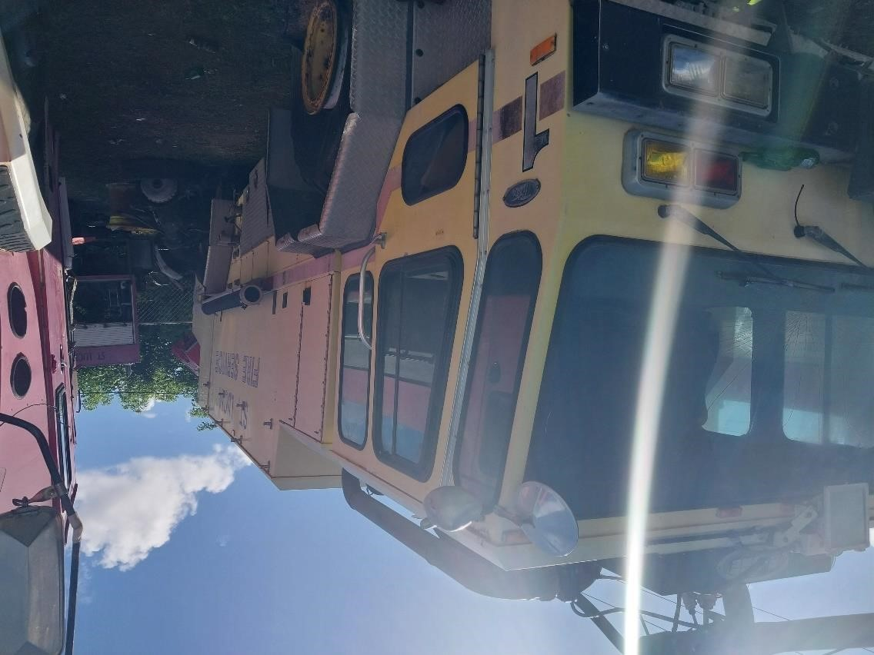

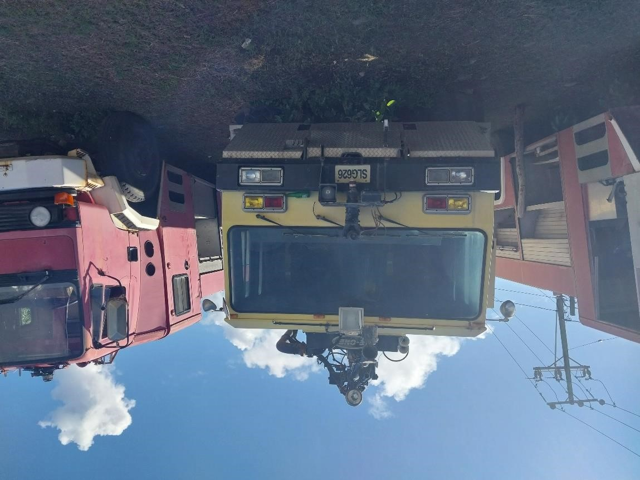
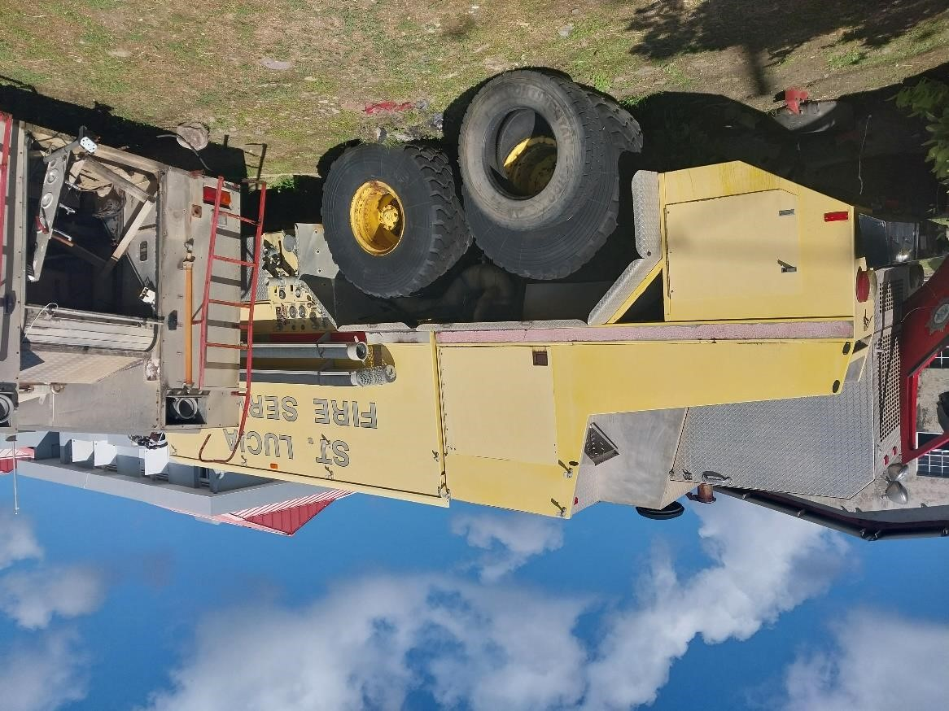

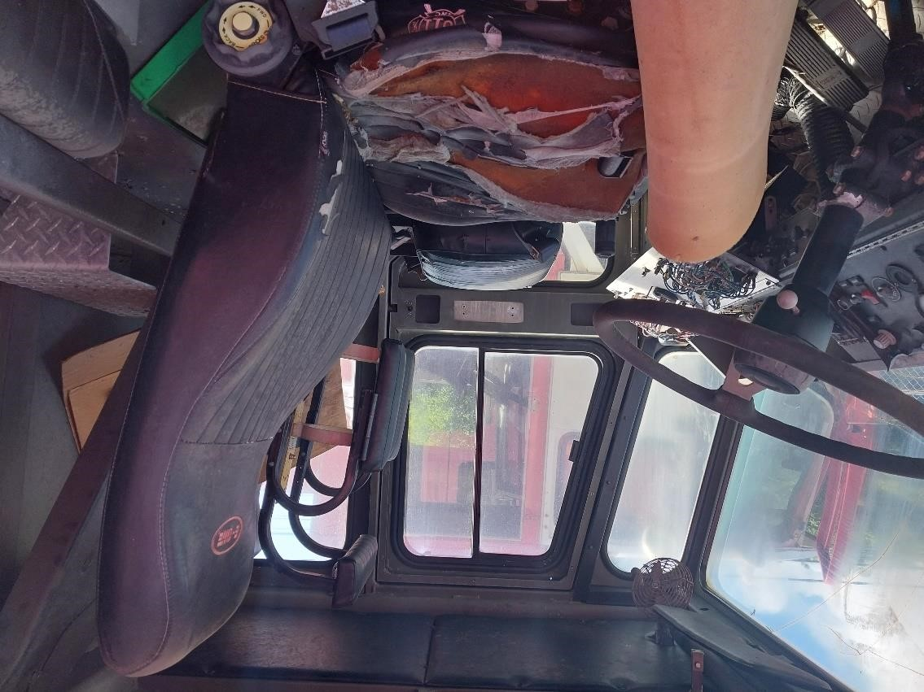

NOTICE FOR SALE OF VEHICLE

2000 Oshkosh Fire Truck - Registration Number SLG 813

- Offers are invited for the purchase of the above vehicle belonging to the Government of Saint Lucia. The vehicle will be sold under an open tender process and sealed offers are invited accordingly.

- Appendix (1) one of this notice contains photographs of the vehicle, and the vehicle can be viewed and inspected at the grounds of the Vieux Fort Fire Station, from Monday to Friday during the hours of 9:00 AM to 12:00 PM and 2:00 PM to 3:30 PM.

- The vehicle will be sold “as is, where is” with the purchaser being responsible for all transfer fees.

- Bid forms can be obtained during normal working hours at the Department of Finance, 2nd Floor, Finance Administrative Centre, Pointe Seraphine, Castries. Bidders can also write to dof.fso@govt.lc to request a copy of the Bid Form.

- Bid forms must be submitted in a sealed envelope entitled:

“Tender for SLG 813
Director of Finance
Department of Finance, Constituency Development & People
Empowerment
2nd Floor, Finance Administrative Centre, Pointe Seraphine”

- Envelopes, containing completed tender documents must be submitted to the Department of Finance, 2nd Floor, Finance Administrative Centre, Pointe Seraphine no later than 4:00 pm on Tuesday August 11, 2026. Late offers will NOT be considered.

- The tender process shall become null and void if the successful bidder fails to make payment for the vehicle within five (5) business days of being informed of his or her success in the tender process. This provision will not apply if the successful bidder has provided an explanation on their inability to pay within the stipulated period, which has been accepted by the Department of Finance.

- Please note the Department of Finance reserves the right to cancel the present notice. The Department of Finance does not bind itself to accept the highest or any offer. The Department of Finance reserves the right to reject or accept any offer without giving and reason(s) thereof.

END

APPENDIX ONE

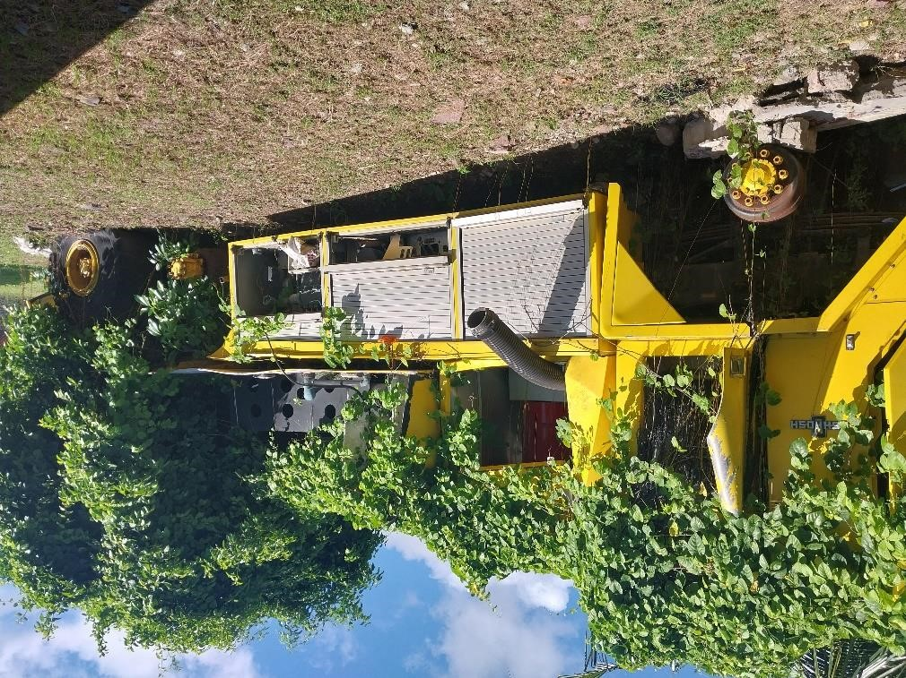

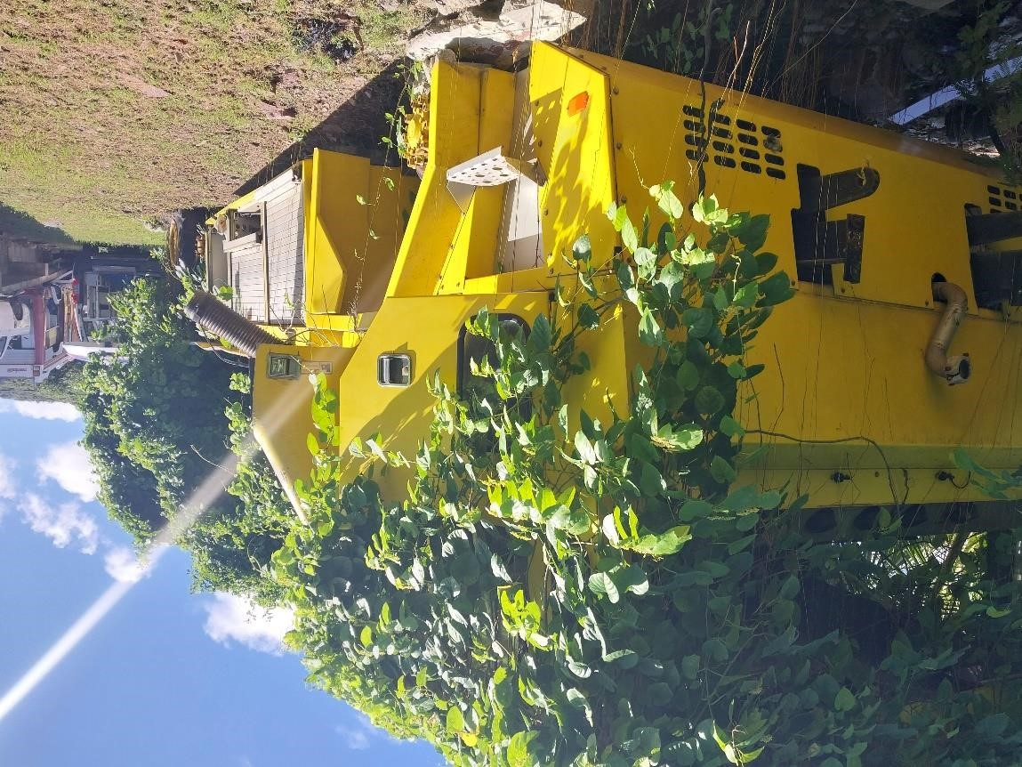

NOTICE FOR SALE OF VEHICLE

2005 Iveco Fire Truck - Registration Number SLG 953

- Offers are invited for the purchase of the above vehicle belonging to the Government of Saint Lucia. The vehicle will be sold under an open tender process and sealed offers are invited accordingly.

- Appendix (1) one of this notice contains photographs of the vehicle, and the vehicle can be viewed and inspected at the grounds of the Vieux Fort Fire Station, from Monday to Friday during the hours of 9:00 AM to 12:00 PM and 2:00 PM to 3:30 PM.

- The vehicle will be sold “as is, where is” with the purchaser being responsible for all transfer fees and any other costs.

- Bid forms can be obtained during normal working hours at the Department of Finance, 2nd Floor, Finance Administrative Centre, Pointe Seraphine, Castries. Bidders can also write to dof.fso@govt.lc to request a copy of the Bid Form.

- Bid forms must be submitted in a sealed envelope entitled:
“Tender for SLG 953
Director of Finance
Department of Finance, Constituency Development & People
Empowerment

2nd Floor, Finance Administrative Centre, Pointe Seraphine”

- Envelopes, containing completed tender documents must be submitted to the Department of Finance, 2nd Floor, Finance Administrative Centre, Pointe Seraphine no later than 4:00 pm on Tuesday August 11, 2026. Late offers will NOT be considered.

- The tender process shall become null and void if the successful bidder fails to make payment for the vehicle within five (5) business days of being informed of his or her success in the tender process. This provision will not apply if the successful bidder has provided an explanation on their inability to pay within the stipulated period, which has been accepted by the Department of Finance.

- Please note the Department of Finance reserves the right to cancel the present notice. The Department of Finance does not bind itself to accept the highest or any offer. The Department of Finance reserves the right to reject or accept any offer without giving and reason(s) thereof.

END

APPENDIX ONE
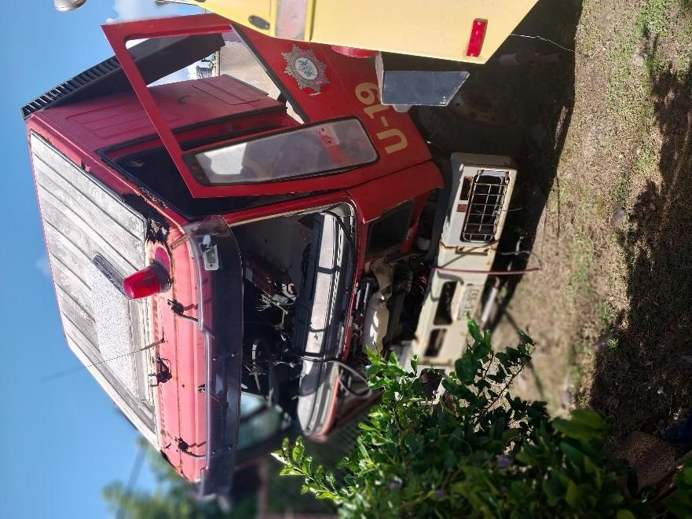

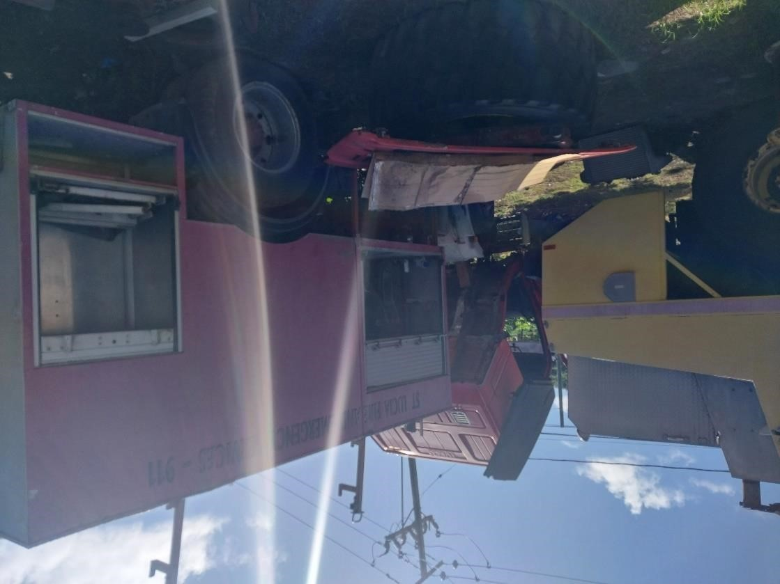

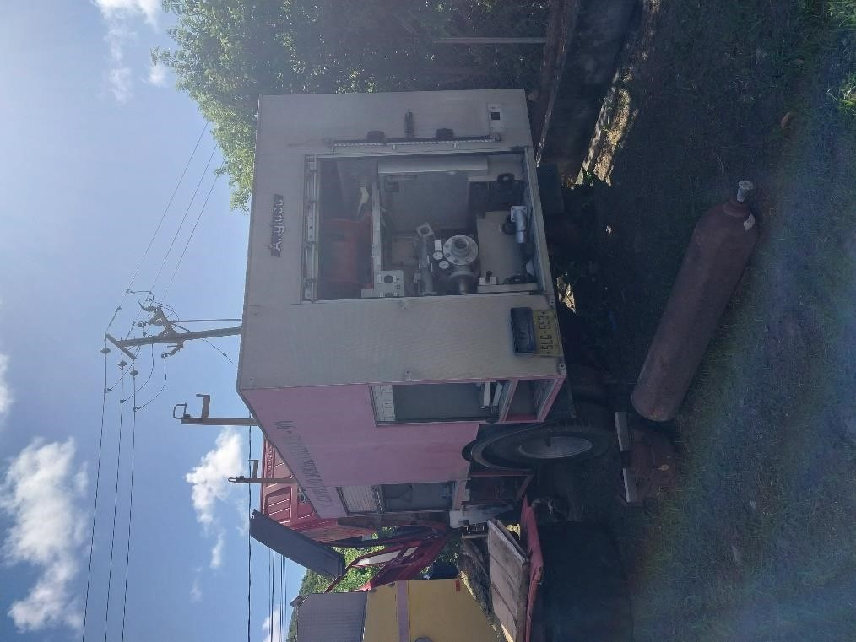

NOTICE FOR SALE OF VEHICLE

Toyota Frontier - Registration Number SLG 1092

- Offers are invited for the purchase of the above vehicle belonging to the Government of Saint Lucia. The vehicle will be sold under an open tender process and sealed offers are invited accordingly.

- Appendix (1) one of this notice contains photographs of the vehicle, and the vehicle can be viewed and inspected at the grounds of the Police Garage of the Royal Saint Lucia Police Force, La Toc, Castries, from Monday to Friday during the hours of 9:00 AM to 12:00 PM and 2:00 PM to 3:30 PM.

- The vehicle will be sold “as is, where is” with the purchaser being responsible for all transfer fees and related costs.

- Bid forms can be obtained during normal working hours at the Department of Finance, 2nd Floor, Finance Administrative Centre, Pointe Seraphine, Castries. Bidders can also write to dof.fso@govt.lc to request a copy of the Bid Form.

- Bid forms must be submitted in a sealed envelope entitled:

“Tender for SLG 1092 Director of Finance Department of Finance, Constituency Development & People Empowerment
2nd Floor, Finance Administrative Centre, Pointe Seraphine”

- Envelopes, containing completed tender documents must be submitted to the Department of Finance, 2nd Floor, Finance Administrative Centre, Pointe Seraphine no later than 4:00 pm on Tuesday August 11, 2026. Late offers will NOT be considered.

- The tender process shall become null and void if the successful bidder fails to make payment for the vehicle within five (5) business days of being informed of his or her success in the tender process. This provision will not apply if the successful bidder has provided an explanation on their inability to pay within the stipulated period, which has been accepted by the Department of Finance.

- Please note the Department of Finance reserves the right to cancel the present notice. The Department of Finance does not bind itself to accept the highest or any offer. The Department of Finance reserves the right to reject or accept any offer without giving and reason(s) thereof.

END

APPENDIX ONE

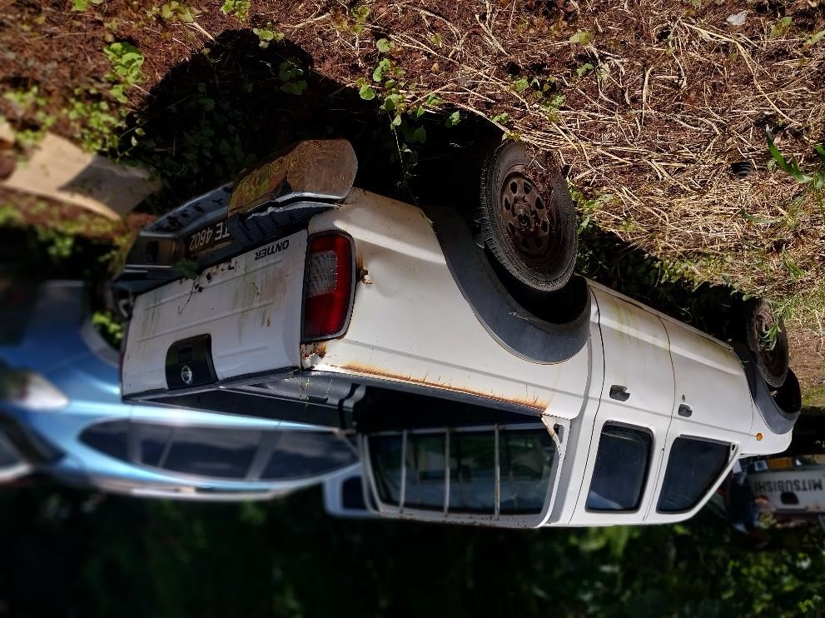

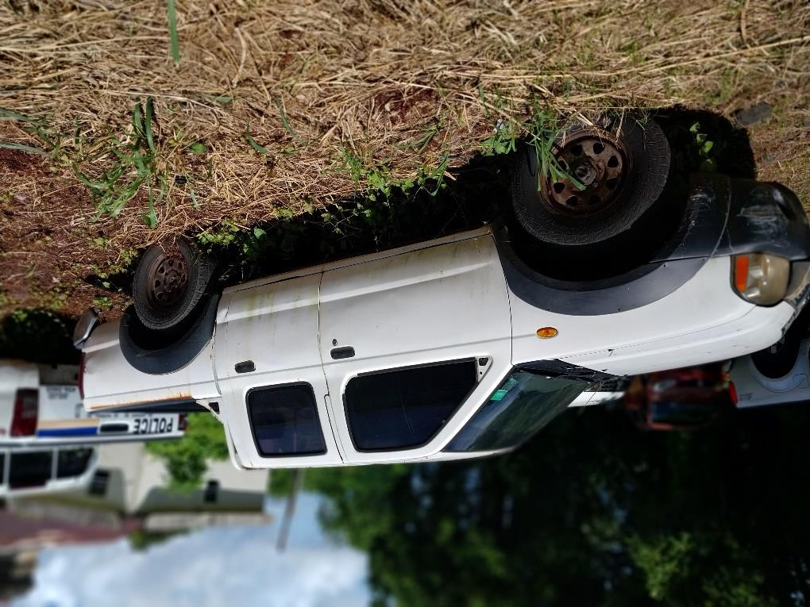
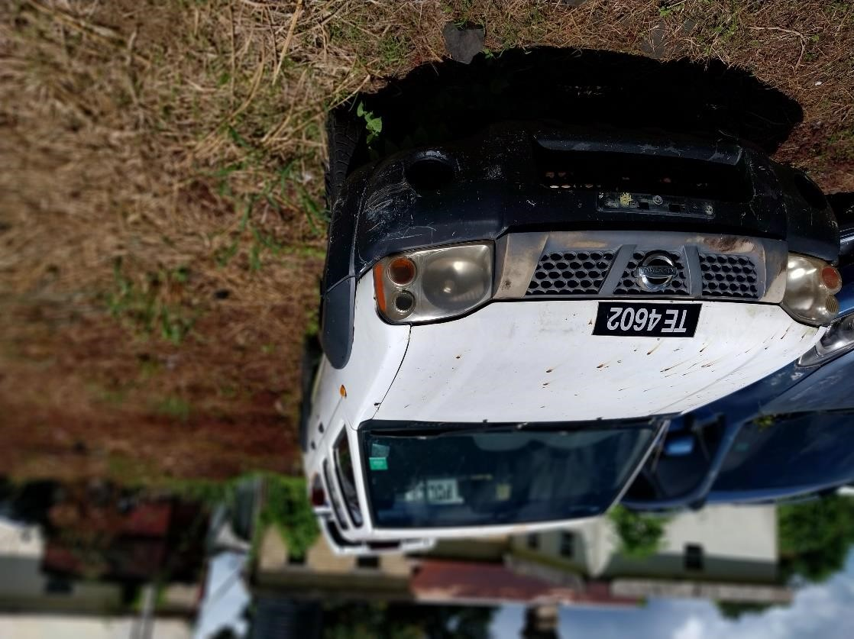

NOTICE FOR SALE OF VEHICLE

2007 Yamaha 900 Motorcycle - Registration Number SLG 2040

- Offers are invited for the purchase of the above vehicle belonging to the Government of Saint Lucia. The vehicle will be sold under an open tender process and sealed offers are invited accordingly.

- Appendix (1) one of this notice contains photographs of the vehicle, and the vehicle can be viewed and inspected at the grounds of the Police Garage of the Royal Saint Lucia Police Force, La Toc, Castries, from Monday to Friday during the hours of 9:00 AM to 12:00 PM and 2:00 PM to 3:30 PM.

- The vehicle will be sold “as is, where is” with the purchaser being responsible for all transfer fees and related costs.

- Bid forms can be obtained during normal working hours at the Department of Finance, 2nd Floor, Finance Administrative Centre, Pointe Seraphine, Castries. Bidders can also write to dof.fso@govt.lc to request a copy of the Bid Form.

- Bid forms must be submitted in a sealed envelope entitled:

“Tender for SLG 2040 Director of Finance Department of Finance, Constituency Development & People Empowerment
2nd Floor, Finance Administrative Centre, Pointe Seraphine”

- Envelopes, containing completed tender documents must be submitted to the Department of Finance, 2nd Floor, Finance Administrative Centre, Pointe Seraphine no later than 4:00 pm on Tuesday August 11, 2026. Late offers will NOT be considered.

- The tender process shall become null and void if the successful bidder fails to make payment for the vehicle within five (5) business days of being informed of his or her success in the tender process. This provision will not apply if the successful bidder has provided an explanation on their inability to pay within the stipulated period, which has been accepted by the Department of Finance.

- Please note the Department of Finance reserves the right to cancel the present notice. The Department of Finance does not bind itself to accept the highest or any offer. The Department of Finance reserves the right to reject or accept any offer without giving and reason(s) thereof.

END

APPENDIX ONE

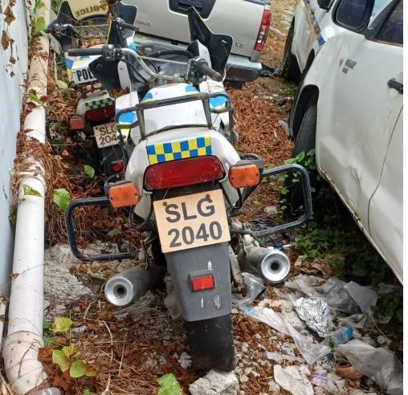

NOTICE FOR SALE OF VEHICLE

2007 Yamaha 900 Motorcycle - Registration Number SLG 2043

- Offers are invited for the purchase of the above vehicle belonging to the Government of Saint Lucia. The vehicle will be sold under an open tender process and sealed offers are invited accordingly.

- Appendix (1) one of this notice contains photographs of the vehicle, and the vehicle can be viewed and inspected at the grounds of the Police Garage of the Royal Saint Lucia Police Force, La Toc, Castries, from Monday to Friday during the hours of 9:00 AM to 12:00 PM and 2:00 PM to 3:30 PM.

- The vehicle will be sold “as is, where is” with the purchaser being responsible for all transfer fees and related costs.

- Bid forms can be obtained during normal working hours at the Department of Finance, 2nd Floor, Finance Administrative Centre, Pointe Seraphine, Castries. Bidders can also write to dof.fso@govt.lc to request a copy of the Bid Form.

- Bid forms must be submitted in a sealed envelope entitled:

“Tender for SLG 2043 Director of Finance Department of Finance, Constituency Development & People Empowerment
2nd Floor, Finance Administrative Centre, Pointe Seraphine”

- Envelopes, containing completed tender documents must be submitted to the Department of Finance, 2nd Floor, Finance Administrative Centre, Pointe Seraphine no later than 4:00 pm on Tuesday August 11, 2026. Late offers will NOT be considered.

- The tender process shall become null and void if the successful bidder fails to make payment for the vehicle within five (5) business days of being informed of his or her success in the tender process. This provision will not apply if the successful bidder has provided an explanation on their inability to pay within the stipulated period, which has been accepted by the Department of Finance.

- Please note the Department of Finance reserves the right to cancel the present notice. The Department of Finance does not bind itself to accept the highest or any offer. The Department of Finance reserves the right to reject or accept any offer without giving and reason(s) thereof.

END

APPENDIX ONE

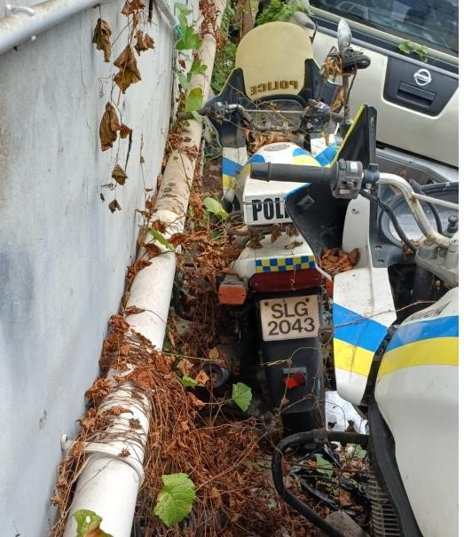

NOTICE FOR SALE OF VEHICLE

2007 Yamaha 900 Motorcycle - Registration Number SLG 2048

- Offers are invited for the purchase of the above vehicle belonging to the Government of Saint Lucia. The vehicle will be sold under an open tender process and sealed offers are invited accordingly.

- Appendix (1) one of this notice contains photographs of the vehicle, and the vehicle can be viewed and inspected at the grounds of the Police Garage of the Royal Saint Lucia Police Force, La Toc, Castries, from Monday to Friday during the hours of 9:00 AM to 12:00 PM and 2:00 PM to 3:30 PM.

- The vehicle will be sold “as is, where is” with the purchaser being responsible for all transfer fees and related costs.

- Bid forms can be obtained during normal working hours at the Department of Finance, 2nd Floor, Finance Administrative Centre, Pointe Seraphine, Castries. Bidders can also write to dof.fso@govt.lc to request a copy of the Bid Form.

- Bid forms must be submitted in a sealed envelope entitled:

“Tender for SLG 2048 Director of Finance Department of Finance, Constituency Development & People Empowerment
2nd Floor, Finance Administrative Centre, Pointe Seraphine”

- Envelopes, containing completed tender documents must be submitted to the Department of Finance, 2nd Floor, Finance Administrative Centre, Pointe Seraphine no later than 4:00 pm on Tuesday August 11, 2026. Late offers will NOT be considered.

- The tender process shall become null and void if the successful bidder fails to make payment for the vehicle within five (5) business days of being informed of his or her success in the tender process. This provision will not apply if the successful bidder has provided an explanation on their inability to pay within the stipulated period, which has been accepted by the Department of Finance.

- Please note the Department of Finance reserves the right to cancel the present notice. The Department of Finance does not bind itself to accept the highest or any offer. The Department of Finance reserves the right to reject or accept any offer without giving and reason(s) thereof.

END

APPENDIX ONE

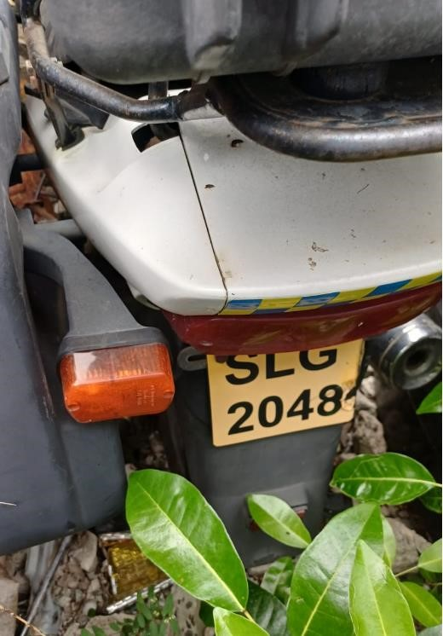

NOTICE FOR SALE OF VEHICLE

2011 Toyota Hiace - Registration Number SLG 3154

- Offers are invited for the purchase of the above vehicle belonging to the Government of Saint Lucia. The vehicle will be sold under an open tender process and sealed offers are invited accordingly.

- Appendix (1) one of this notice contains photographs of the vehicle, and the vehicle can be viewed and inspected at the grounds of the Gros-Islet Fire Station, from Monday to Friday during the hours of 9:00 AM to 12:00 PM and 2:00 PM to 3:30 PM.

- The vehicle will be sold “as is, where is” with the purchaser being responsible for all transfer fees.

- Bid forms can be obtained during normal working hours at the Department of Finance, 2nd Floor, Finance Administrative Centre, Pointe Seraphine, Castries. Bidders can also write to dof.fso@govt.lc to request a copy of the Bid Form.

- Bid forms must be submitted in a sealed envelope entitled:
“Tender for SLG 3154
Director of Finance
Department of Finance, Constituency Development & People
Empowerment

2nd Floor, Finance Administrative Centre, Pointe Seraphine”

- Envelopes, containing completed tender documents must be submitted to the Department of Finance, 2nd Floor, Finance Administrative Centre, Pointe Seraphine no later than 4:00 pm on Tuesday August 11, 2026. Late offers will NOT be considered.

- The tender process shall become null and void if the successful bidder fails to make payment for the vehicle within five (5) business days of being informed of his or her success in the tender process. This provision will not apply if the successful bidder has provided an explanation on their inability to pay within the stipulated period, which has been accepted by the Department of Finance.

- Please note the Department of Finance reserves the right to cancel the present notice. The Department of Finance does not bind itself to accept the highest or any offer. The Department of Finance reserves the right to reject or accept any offer without giving and reason(s) thereof.

END

APPENDIX ONE

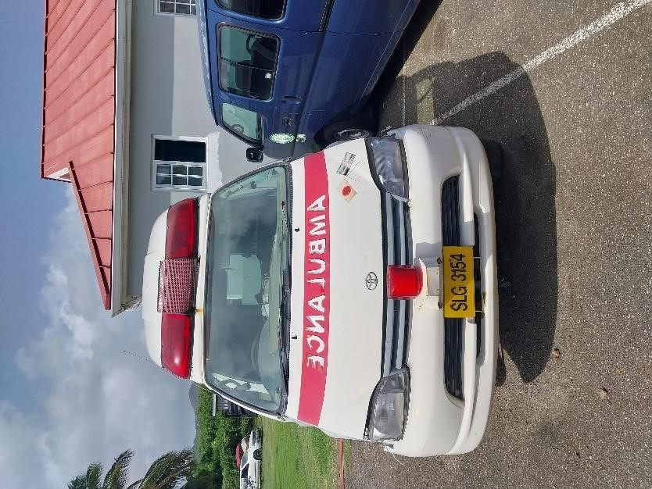

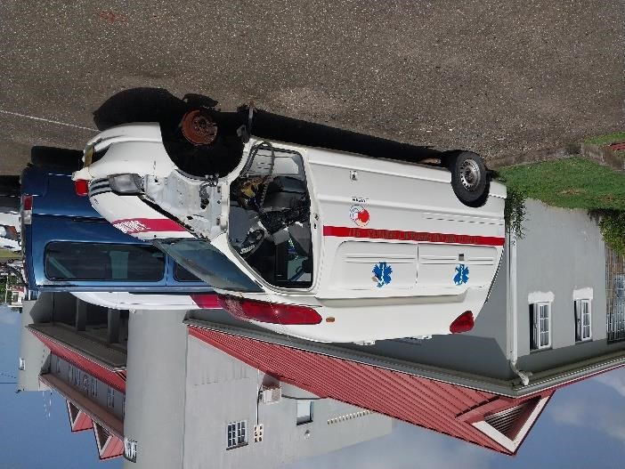

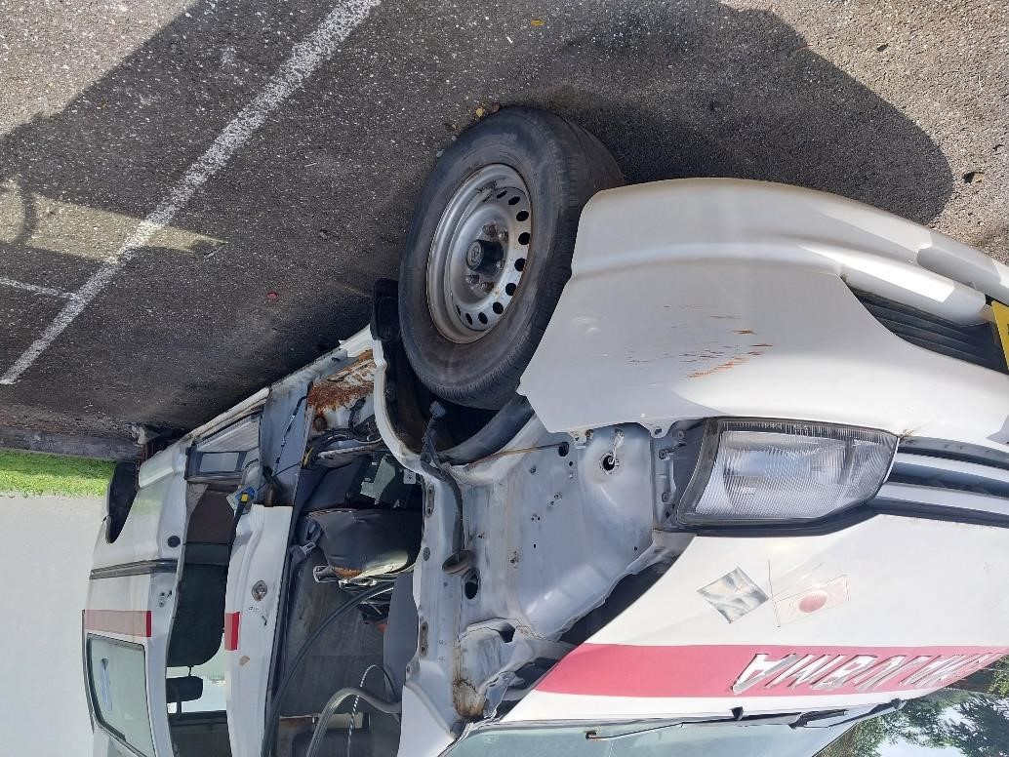
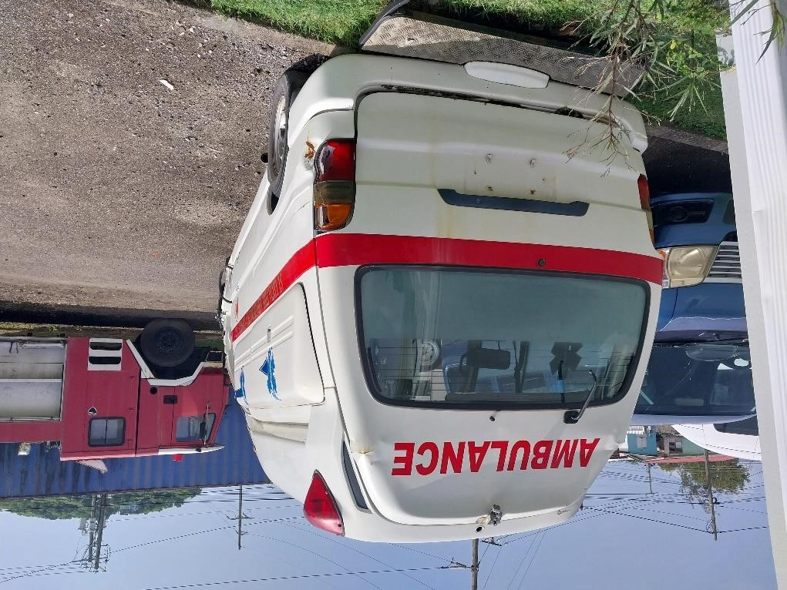

NOTICE FOR SALE OF VEHICLE

Toyota Frontier - Registration Number SLG 3169

- Offers are invited for the purchase of the above vehicle belonging to the Government of Saint Lucia. The vehicle will be sold under an open tender process and sealed offers are invited accordingly.

- Appendix (1) one of this notice contains photographs of the vehicle, and the vehicle can be viewed and inspected at the grounds of the Fix it Garage, Bexon, from Monday to Friday during the hours of 9:00 AM to 12:00 PM and 2:00 PM to 3:30 PM.

- The vehicle will be sold “as is, where is” with the purchaser being responsible for all transfer fees.

- Bid forms can be obtained during normal working hours at the Department of Finance, 2nd Floor, Finance Administrative Centre, Pointe Seraphine, Castries. Bidders can also write to dof.fso@govt.lc to request a copy of the Bid Form.

- Bid forms must be submitted in a sealed envelope entitled:

“Tender for SLG 3169 Director of Finance Department of Finance, Constituency Development & People Empowerment
2nd Floor, Finance Administrative Centre, Pointe Seraphine”

- Envelopes, containing completed tender documents must be submitted to the Department of Finance, 2nd Floor, Finance Administrative Centre, Pointe Seraphine no later than 4:00 pm on Tuesday August 11, 2026.
Late offers will NOT be considered.

- The tender process shall become null and void if the successful bidder fails to make payment for the vehicle within five (5) business days of being informed of his or her success in the tender process. This provision will not apply if the successful bidder has provided an explanation on their inability to pay within the stipulated period, which has been accepted by the Department of Finance.

- Please note the Department of Finance reserves the right to cancel the present notice. The Department of Finance does not bind itself to accept the highest or any offer. The Department of Finance reserves the right to reject or accept any offer without giving and reason(s) thereof.

END

APPENDIX ONE

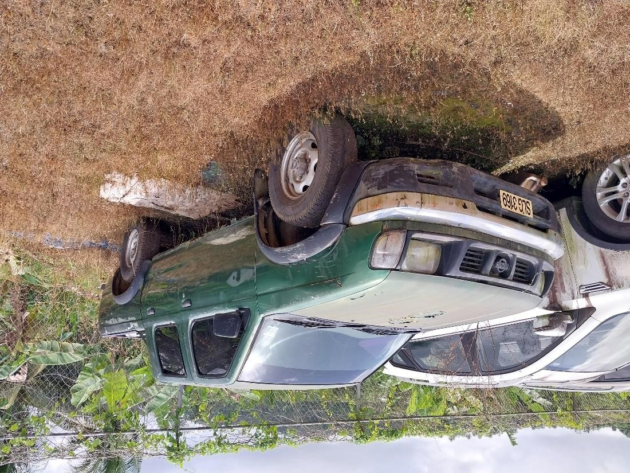


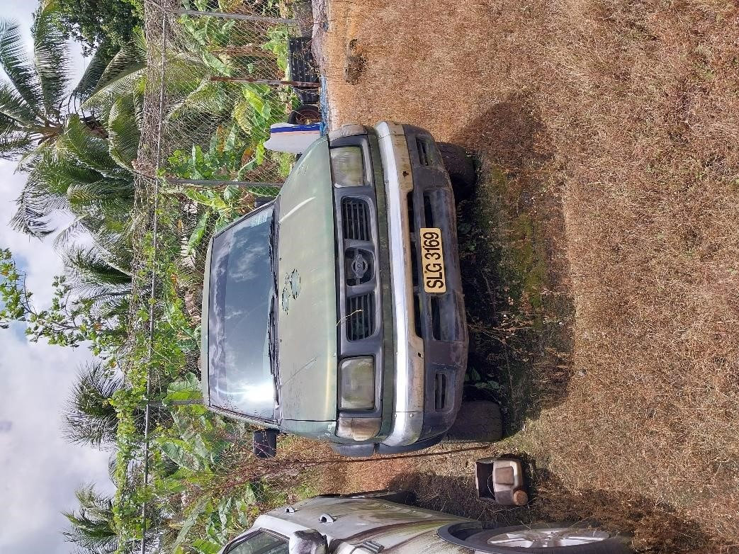

NOTICE FOR SALE OF VEHICLE

Kia Cerato - Registration Number SLG 4010

- Offers are invited for the purchase of the above vehicle belonging to the Government of Saint Lucia. The vehicle will be sold under an open tender process and sealed offers are invited accordingly.

- Appendix (1) one of this notice contains photographs of the vehicle, and the vehicle can be viewed and inspected at the grounds of the Police Garage of the Royal Saint Lucia Police Force, La Toc, Castries, from Monday to Friday during the hours of 9:00 AM to 12:00 PM and 2:00 PM to 3:30 PM.

- The vehicle will be sold “as is, where is” with the purchaser being responsible for all transfer fees and related costs.

- Bid forms can be obtained during normal working hours at the Department of Finance, 2nd Floor, Finance Administrative Centre, Pointe Seraphine, Castries. Bidders can also write to dof.fso@govt.lc to request a copy of the Bid Form.

- Bid forms must be submitted in a sealed envelope entitled:

“Tender for SLG 4010 Director of Finance Department of Finance, Constituency Development & People Empowerment
2nd Floor, Finance Administrative Centre, Pointe Seraphine”

- Envelopes, containing completed tender documents must be submitted to the Department of Finance, 2nd Floor, Finance Administrative Centre, Pointe Seraphine no later than 4:00 pm on Tuesday August 11, 2026. Late offers will NOT be considered.

- The tender process shall become null and void if the successful bidder fails to make payment for the vehicle within five (5) business days of being informed of his or her success in the tender process. This provision will not apply if the successful bidder has provided an explanation on their inability to pay within the stipulated period, which has been accepted by the Department of Finance.

- Please note the Department of Finance reserves the right to cancel the present notice. The Department of Finance does not bind itself to accept the highest or any offer. The Department of Finance reserves the right to reject or accept any offer without giving and reason(s) thereof.

END

APPENDIX ONE
