



Executed By:

The Government of St. Lucia
Ministry of Health, Wellness and Elderly Affairs

Financed By:


International Bank for Reconstruction & Development

PREPARED FOR

ENVIRONMENTAL AND SOCIAL MANAGEMENT PLAN

For the Preparation of Design, Bidding Documents
Supervision and BOQs for the Renovation of the La Guerre
Wellness Centre

Table of Contents

ACRONYMS AND ABBREVIATIONS ii
1 Introduction And Background 1
2 project description 2
2.1 Project Context 2
2.2 Project Scope 3
3 Site Specific Environmental and Social Impacts 7
4 Legal and Administrative Framework 8
5 Social and Environmental Safeguards 9
6 Potential Environmental and Social Impacts and Mitigation Measures 11
7 Project Management and Institutional Arrangements - 20 -
7.1 ESMP Implementation - 20 -
7.2 Supervision Monitoring and Reporting - 21 -
7.2.1 Supervision - Construction Phase - 21 -
7.2.2 Monitoring - 22 -
7.2.3 Reporting - 22 -
8 Stakeholder Engagement - 23 -
8.1 Publication of ESMP - 23 -
8.2 Community Engagement - 23 -
9 Grievance and Redress Mechanism - 26 -
10 ESMP Implementation Costs - 28 -
11 Conclusion - 28 -
12. Appendices - 29 -
APPENDIX A: Incident / Accidents to be reported to the World Bank - 29 -
11.1 Appendix A– Incident / Accidents to be reported to the world bank - 30 -
11.2 Appendix B - Code of Conduct for Contractor’s Personnel (ES) Form - 33 -
11.3 Appendix C -Project Environmental and Social Safeguards Inspection Weekly Checklist - 37 -
11.4 APPENDIX D- Monthly Employer’s Environmental and Social Safeguards Review Checklist - 42 -
11.5 Appendix E: E & S Quarterly Report Template - 44 -
11.6 Appendix F- SEA, SH AND GBV Grievance redress process, grievance redress registration and closure forms 45
11.7 appendix h- Site Photos 57
Appendix H: Saint Lucia SMART Health Facilities Checklist 60

ACRONYMS AND ABBREVIATIONS
BOQ | Bill of Quantities
CARPHA | Caribbean Public Health Agency
CFP | Chance Finds Procedure
CoC | Code of Conduct
C-ESMP | Contractor’s Environmental and Social Management Plan
DCA | Development Control Authority
EIA | Environmental Impact Assessment
EHD | Environmental Health Department
EMF | Environmental Management Framework
ESMP | Environmental and Social Management Plan
ESHS | Environmental Social Health and Safety
E&S | Environmental and Social
GRM | Grievance Redress Mechanism
H&S | Health and Safety
HSI | Health and Safety Index
MoHWEA | Ministry of Health Wellness and Elderly Affairs
MOE | Ministry of Equity
MSIP | Management Strategy and Implementation Plan
NEMO | National Emergency Management Organisation
OSH | Occupational Safety and Health
PAHO | Pan American Health Organisation
PIU | Project Implementation Unit
SLSWMA | St. Lucia Solid Waste Management Authority
PCR | Physical Cultural Resources
PPD | Physical Planning Department
PPE | Personal Protective Equipment
RSLPF | Royal St. Lucia Police Force
SH | Sexual Harassment
SEA | Sexual Abuse and Exploitation
TOR | Terms of Reference
USD | United States Dollars
WBG | World Bank Group

Introduction And Background
Saint Lucia is faced with limited capacity and fiscal space, as well as high levels of exposure to economic and weather shocks. The country has had limited success in adequately preparing for public health emergencies. Recent extreme weather events such as Hurricanes Irma and Maria (2017) and regional outbreaks of Chikungunya (2014), Zika (2016) and more recently COVID-19, have highlighted weaknesses in the preparedness of health systems in the Eastern Caribbean region to manage public health emergencies with Saint Lucia being no exception.
Approved in August 2019, the OECS Regional Health Project aims to improve preparedness of health systems’ capacities for public health emergencies across four countries (Dominica, Grenada, Saint Lucia, and Saint Vincent and the Grenadines) and two regional agencies (OECS Commission and the Caribbean Regional Public Health Agency (CARPHA)).
The overall project finances activities through two main components: (i) improved health facilities and laboratory capacity; and (ii) strengthened public health surveillance and emergency management. This specific project deals with component (i). The SMART Hospital Project was funded by the UK Foreign, Commonwealth & Development Office and implemented by the Pan American Health Organisation (PAHO). The project sought to develop resilient and climate-adapted healthcare facilities in the Caribbean. The tools used to assess the facilities are the Health and Safety Index (HSI) which is a series of questions when answered, provides a snapshot of the level of vulnerability of a health facility to hazard with levels rating as follows:
A - 65% -100%
B - 64%-45%
C - Below 45%

To assess the ‘greenness’ of a facility, the level of adaptation to climate change and mitigation measures for reducing its carbon footprint, the Green-checklist was utilised. The minimum green standard was set at 70%. This assessment includes an assessment of factors including water conservation, an energy audit, factors related to indoor environmental quality management, hazardous material storage and disposal and how pharmaceuticals and food services are handled. Interventions were identified and designed to address the areas of deficiency with respect to Safety and ‘Greenness’.
In order for a facility to be considered SMART, it, therefore, has to earn an alpha-numeric score of A70. The first phase of the SMART Healthcare Initiative PAHO completed two demonstration projects, one at the Georgetown Hospital in St. Vincent, and the other at the Pogson Medical Centre in St. Kitts and Nevis. Both demonstration projects aimed to establish an integrated approach to health facility design, featuring both disaster-resilient (safe) and environmentally green (green) institutions. The success of Phase I expanded to Phase II in which more islands were involved, namely Grenada, Saint Lucia, St. Vincent, and Dominica. The project started in Saint Lucia in 2013, where the various government departments were trained in the HSI and Green Tool Kit and assessed thirty-four facilities. In Saint Lucia, the results of this assessment led to the rehabilitation of thirteen (13) health facilities on the island to date. The Ministry of Health Wellness and Elderly Affairs (MoHWEA) is at the end of the Construction Phase of the Smart Health Facilities project in Saint Lucia. In July 2020, the Department conducted re-assessments of the health facilities as per the original project five (5) year cycle. This coincided with the end of the project cycle, which requires a reassessment of the facilities that were retrofitted under the SMART Project. The reassessments included the application of the health safety index (HSI) and green checklist questionnaires for thirty-two (32) additional health facilities.

project description
This section provides additional description and background information on the rehabilitation of the La Guerre Wellness Centre.

Project Context

La Guerre is a rural community in the Northeastern quadrant of Saint Lucia. In 2010, the estimated population of La Guerre was 528 persons.
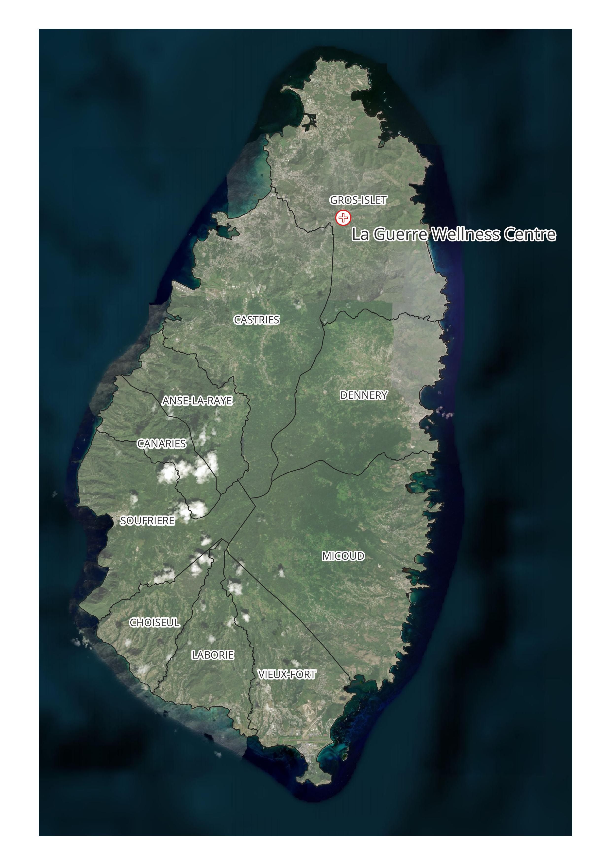
Figure 1 Location of La Guerre Wellness Centre in Saint Lucia
The community is also about 2.5 miles from Babonneau, which is considered to be the main settlement in the area having amenities including Police and Fire Stations, a Secondary School and a Wellness Centre.
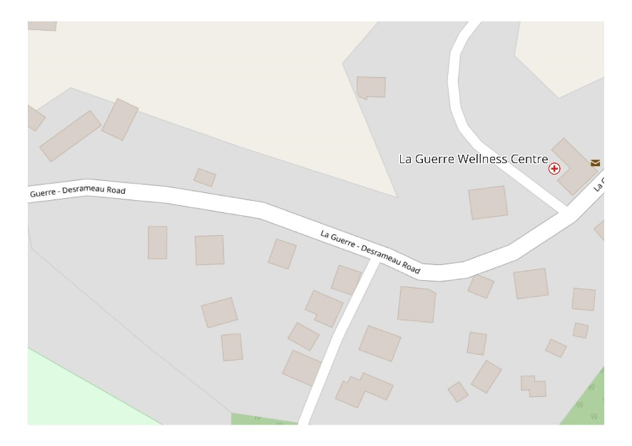
Figure 2 Location of the site within La Guerre Community
The La Guerre Wellness Centre is the only healthcare facility in the community but the Babonneau Wellness Centre is not far away. The project entails the implementation of upgrades to improve the functionality of the clinic, improve its structural soundness and make it a greener facility, by improving its energy efficiency.

Project Scope

The rehabilitation of the La Guerre Wellness Centre includes:
- Construction of new housing for the standby generator with water tanks installed on roof. The standby generator will be a 30-kW diesel generator supplied under another initiative. This diesel generator will need to be tested regularly by maintenance personnel to confirm its functionality during power outages. Based on the typical energy consumption of the facility, it is expected that the generator will be able to keep the La Guerre clinic online for 48 hours of continuous operation at 75% building load Hours, from the day tank. The generator’s supplier will provide a 5-year warranty and one year of maintenance.
- Installation of 2 new 1000-gallon rainwater tanks upon a new 4” thick concrete pad. The tanks will be fitted with a filtration system.
- Application of shatter proof film to all exterior windows and insect screening to all vent block openings. The film application will increase the tensile and break strength of existing windows and make them more resistant to shattering during storm events or from other impacts.
- Addition of steel railings to steps ramp and concrete slab to improve safety of entry and exit points.
- Painting ceilings in white to improve energy efficiency and walls to be repainted using durable latex paint.
- Repair masonry walls and ceilings and termite damage to woodwork as required to improve integrity of the structure.
- Installation of a new manually retractable awning mounted on corrosion resistant heavy duty aluminum brackets and roller tubes.
- Rewiring of the electrical and communication systems in the building including the installation of energy-efficient luminaires, fire alarm, emergency signage, data outlets
- Interior renovation and reconfiguration on the ground floor and first floor levels
- Improvements to HVAC system including the replacement of split AC units sized and positioned for optimal air circulation and cooling efficacy.
- Replacement of bathroom fixtures, retrofitting of plumbing fixtures to water efficient fixtures including demolition and replacement of sinks and water closets as needed

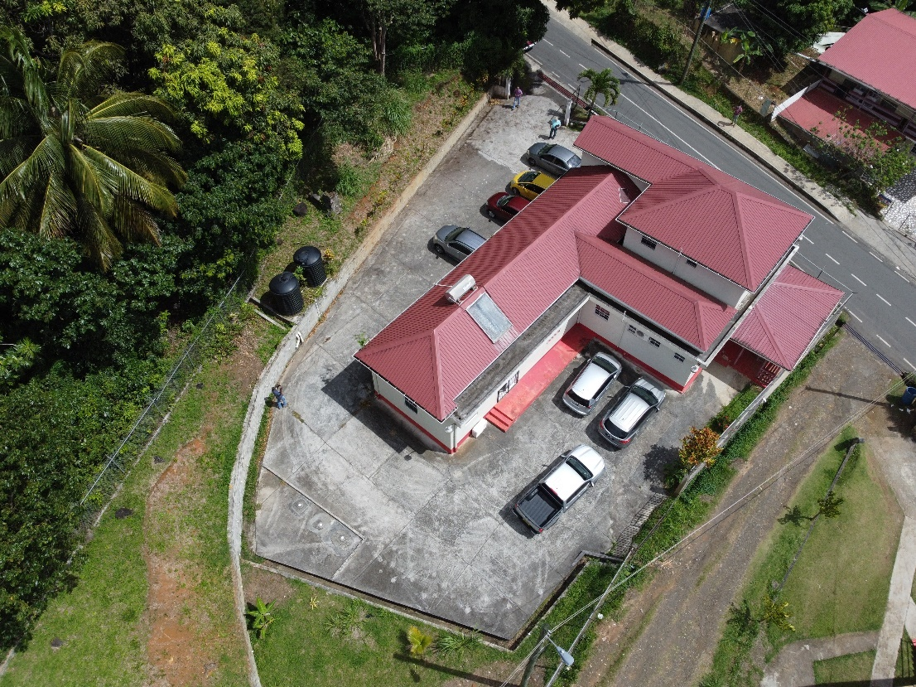

Figure 3 Aerial photo of the Site
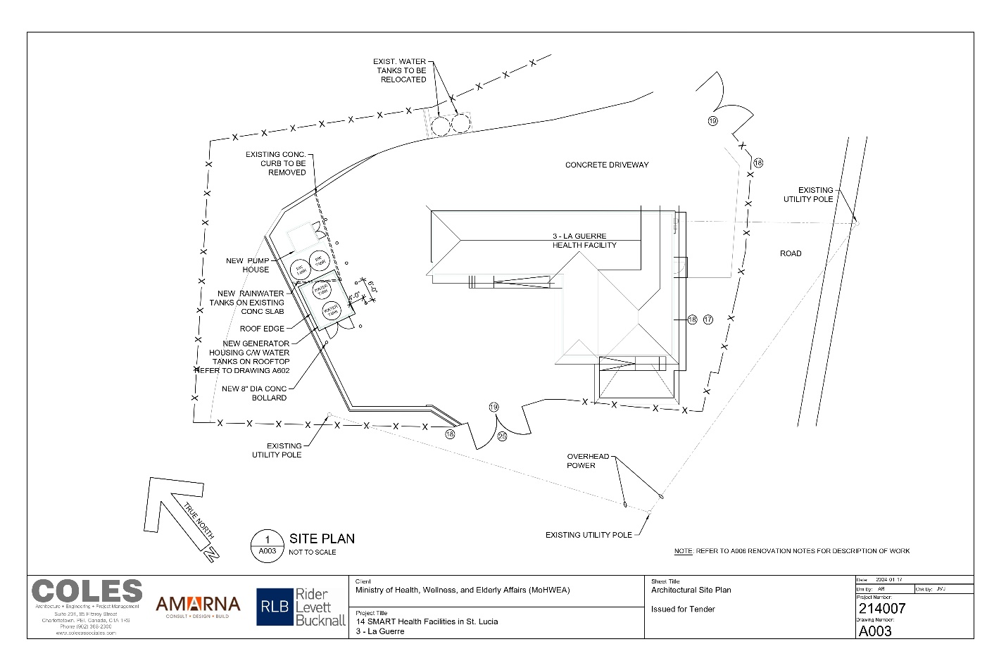

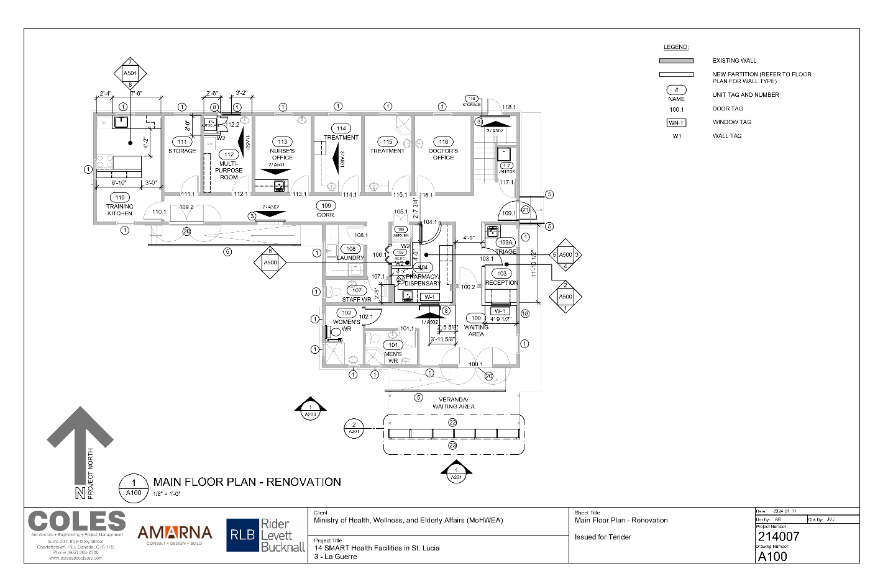
Figure 3. La Guerre Wellness Centre Ground Floor Plan
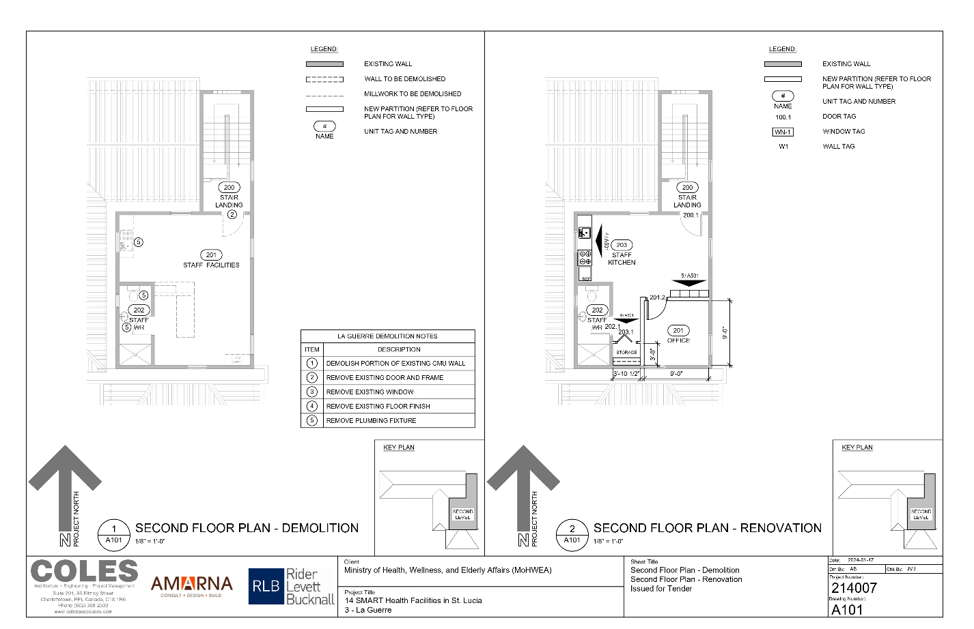
Figure 4 La Guerre Wellness Centre 1st floor plan

Site Specific Environmental and Social Impacts

The potential negative impacts of this activity are expected to be primarily the nuisance of increased noise, dust, and traffic on the community combined with the disruption of the healthcare services usually available to the community during the construction phase. Improper waste management can also become an issue, as detailed in Section 6.
Personnel involved in construction activities will be exposed to typical risks associated with undertaking construction activities including the chance of injury from falls, burns, abrasions and electrocution and becoming adversely affected by exposure to chemicals and strong chemical odours. These risks will be mitigated through the design of the works to be undertaken, construction worker training and site management procedures. In the event of an onsite incident, investigation and response plans will be executed to mitigate their impact on individuals and on the wider community.
Most of the negative impacts on the community are expected to be short term and minor. Influx of workers to the community, if required, may present issues that can be managed by the application of Codes of Conduct.
The positive impacts of this activity are expected to be, better public health outcomes as a result of an improved healthcare facility in the medium- long term, and in the short term increased economic activity related to the renovation works being undertaken at the wellness centre. This may include the employment of persons from the community as well as increased sales for food vendors, and increased revenue for truckers and other service providers.

Legal and Administrative Framework
Table 1 below, extracted from the Environmental and Social Management Framework (ESMF) shows the local legislation and World Bank policy that relate to each of the environmental and social issues.
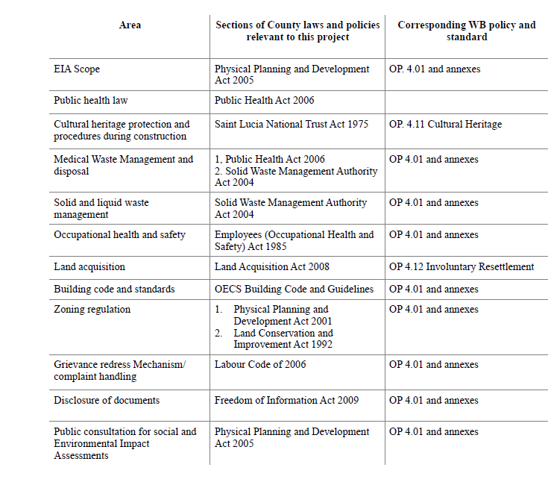
Additionally, Approval from the Development Control Authority (DCA) is required for renovation and construction works. The Guide to Obtaining Permission to Develop Land from the Physical Planning Section, which is the implementation agency for the DCA lists the following requirements for renovations.
- Letter of Intent
- One (1) copy of Location Map (topographic and LRTP map extract) with parcel clearly identified - to be obtained from the Survey and Mapping Section
- One (1) recent copy of Land Register – to be obtained from the Land Registry Section
- Notarized letter of permission from land owner(s) if applicable
- Elevations (if required)
- Details (if required)
- Engineering certification/report (where applicable)
- Architectural impressions of proposal, certified by a locally registered Architect (where applicable)
- Recommendations from Fire Department (where applicable)
- Recommendations from Public Health Department (where applicable as per Health Department Regulations)
- Electrical Certification (where applicable)
- Site Management Plan with hoarding details certified by an Engineer (where applicable)
- Permission from District Council to hoard the sidewalk (where applicable)
- Traffic Management Plan (where applicable)

Social and Environmental Safeguards
The World Bank Group (WBG) has developed Safeguards Policies that guide the development of projects including the Regional OECS Regional Health Project. Most relevant to the La Guerre clinic rehabilitation Etangs Wellness Centre Rehabilitation is the Operational Policy 4.01 (OP 4.01), which requires environmental and social assessment of any proposed project. Accordingly, the ESMF was prepared as a general guidance document and to describe the process for screening works to determine whether they can be taken forward under the project and whether an ESMP or ESHSCOPs is needed. Following this process, this Environmental and Social Management Plan (ESMP) has been prepared for the specific activity of the health centre renovation, and describes how the E&S risks will be managed throughout the design, construction and operation of the upgraded health centre.

Several additional safeguards policies cover aspects such as land acquisition, public disclosure, natural habitat, and antiquities protection, among others.
There is no possibility for involuntary resettlement of any kind during construction, since there is no land acquisition or temporary use of private lands during construction, neither is there any ongoing economic activity that will be affected at the proposed site for construction. Further the impacts of the works should be moderate and not have such adverse effects that would require relocation of any nearby groups or communities.
More information can be found in the ESMF which is disclosed on http://www.govt.lc/ or the WBG website.

The possible environmental and social impacts emanating from the project can be classified as moderate. However, these impacts can be addressed through the recommended mitigation measures, listed in tables in Sections 4 and 6 during construction, as well as continuous consultation, communication, raising of public awareness before and during the construction period.
EHS Guidelines

Environmental, Health and Safety (EHS) guidelines have also been prepared by the WBG. There are general guidelines that cover most activities related to construction projects for new facilities. Some parts of these general guidelines apply to the retrofitting activity, particularly such aspects as traffic safety, dust and noise control, worker health and safety, and control of runoff from work sites.

Of relevance to the rehabilitation are the sector-specific WBG guidelines for Healthcare Facilities, which cover waste minimization, waste segregation, handling and storage of wastes on site, transport to external facilities, and options for treatment and disposal. For more information, refer to the EHS Guidelines on the WBG website under the category of Healthcare Facilities.
The requirements of the EHS Guidelines, which focus primarily on Waste Disposal, Occupational Health and Safety and Community Health Considerations with respect to Healthcare Facilities are addressed in more detail in Section 6.

Potential Environmental and Social Impacts and Mitigation Measures
This section details the environmental and social impacts envisaged from the retrofit of the La Guerre healthcare facility. Environmental and Social Impacts can generally be classified in a number of ways including:
- Temporal: Short, medium or long term
- Direct or Indirect
- Positive or Negative
- Localised or extensive
- Magnitude: Major or Minor
Mitigation measures are presented for preventing or minimizing the identified impacts.
Table 2- List of Potential Environmental and Social Impacts and Mitigation Measures
 | Potential Environmental and Social Impact | Environmental and Social Risk | Comment | Proposed Mitigation
Flora and Fauna | None | None | The La Guerre Healthcare facility already exists and is only being renovated. | No mitigation is required onsite
Soil, Groundwater and Surface Water Resources | Soil and Groundwater -Low  Surface Water – Low | Moderate | No natural watercourses were observed around the site. However, uncontrolled runoff from the site could potentially affect surface waters downstream of the site’ | - Ensure that construction materials including aggregates, and chemicals such as paints, solvents, and stains are properly stored on site and disposed of.  - stormwater runoff protection measures such as silt fencing, straw bales, sediment ponds or pits, etc. to ensure that sediment does not leave site and impact any drains, rivers, or water bodies.
Environmental damage caused by the workforce | Damage to the environment --  Low | Low | The Contractor may not follow neither enforce the Code of Conduct (CoC) if his/her employees are in breach.  Contractor may not provide relevant training to the workforce. | The Contractor should take all steps to protect the environment on-and off-site, and to avoid damage or nuisance to persons or property arising from pollution, noise or other issues arising as a consequence of his methods of operation, including the following:  - Signing and enforcing the CoC.  - Training workers on environmental issues and measures to be taken in the event that actions to protect the environment are necessitated,  - Designating an employee to supervise and ensure environmental obligations are complied with.  - Incorporating environmental and social issues into the agenda of regular meetings with workers.  - Ordering immediate suspension or a halt to any activity which is causing, or is likely to cause significant environmental damage, and to commit to make good any such damage at his own expense, in accordance with the instructions of the relevant authorities.  - Requiring the immediate and permanent dismissal from the site of any member of the workforce who is committing acts prejudicial to the environment including theft or interference with property and offensive behaviour.  - Providing and enforce worker use of appropriate, accessible toilet facilities and of appropriate solid waste disposal facilities.
Interruption of Healthcare Service during Renovation | Moderate to Significant | Moderate | Renovation is expected to be completed in 5 months. During this period residents of La Guerre and nearby communities will be required to obtain medical services at nearby facilities, which would be the Babonneau Wellness Centre. Residents of La Guerre may be temporarily unable to walk to the clinic to receive services. The impact will be additional time taken to get to and from clinics in neighbouring communities as well as additional travel costs, thus increasing the cost of accessing healthcare for the renovation period.  This also means that the clinic will be unavailable to serve residents requiring urgent medical attention during construction.  Residents who cannot afford to travel to the health facilities in Babonneau may delay accessing medical checkups resulting in higher morbidity and comorbidity rates. | - Implement an effective communication strategy to inform the public of the dates of closure and where healthcare services can be obtained during the closure.  - Assist members of the public with offsetting the cost of transportation to Babonneau for clinical services through the provision of a shuttle service or another suitable arrangement.
Air Quality degradation from dust and emissions | Low-Moderate | Low- Moderate | Air quality in the community may be adversely affected particularly during external construction and demolition works and potentially due to the transportation of materials to and from the site. | - Vehicles transporting material to and from the site will be covered. Any accidental spills of materials on the road to and from the site will be cleared as soon as possible. In the event of oil spillage, cleanup should be conducted in conjunction with the Saint Lucia Fire Service. It should be noted that the nearest fire station is located in Babonneau.  - Aggregates stored on-site should be covered. Noxious chemical fumes are not envisaged based on the scope of work.
Noise Pollution | Moderate | Moderate | La Guerre has a combination of residential, commercial and institutional land uses. Truck trips to and from the site, the use of power tools and other noise related to construction will create some noise pollution in the community, particularly for properties adjacent to the site. | - Trucks and heavy-duty equipment should operate during regular working hours on weekdays to minimize disturbance to the public. Onsite construction activities involving air compressors, jackhammers, power-driven drills, riveting machines, excavator, diesel-powered truck, tractor or other earth-moving equipment, hand hammers on steel or iron, or any other machine, tool, device or equipment which makes loud noises will not be used outside of regular weekday working hours, except in extraordinary circumstances or with the expressed agreement of the Community.
Traffic Management | Moderate | Significant | The La Guerre Road has moderate levels of traffic daily. Large trucks and heavy-duty vehicles can damage the road surface and speed up the natural deterioration of the road surface  Heavy-duty vehicles also pose a safety risk to pedestrians and other motorists in the community.  Vehicles can also pose a hazard to personnel on the site, particularly from trucks reversing onto the site to deliver materials or pick up debris and waste. | A traffic management plan should be developed to address traffic management, onsite and within the La Guerre area. The plan should achieve the following goals:  - Reduce interactions between vehicles and pedestrians  - Minimise the number of vehicle movements in and around the site  - Ensure that all personnel on site are trained and practice traffic safety guidelines  - Reducing the need for vehicles to reverse wherever possible as reversing onsite can lead to fatal accidents  - No parking or stockpiling of materials will be allowed along the public roadway.  - No materials shall be stored so that they encroach on, or in any way adversely affect the operation of, sections of roadway which are in use by the public or result in siltation or blockage of drains.  - Contractor should plan for the temporary storage of construction materials and wastes, and the parking of construction plant within the worksite only. This will be part of the Site Management Plan.  - Parking areas for employees’ private vehicles will be located within the worksite only, in approved areas.  - Ensure that pedestrians and drivers can see potential hazards, in some cases, personnel can be assigned to traffic management tasks onsite. Onsite personnel should wear high-visibility clothes and reflective vests.  - Adequate lighting must be provided onsite particularly if work is to proceed after hours.  - Installation of proper signage and instructions.  - Compliance with all guidelines and protocols established by the Development Control Authority (DCA) the Department of Transport and Royal St. Lucia Police Force (RSLPF).
Occupational Health and Public Health and Safety | Moderate | Moderate | Construction workers on site are exposed to construction-related hazards including exposure to dust, pollutants and potential injury from falling objects, use of hand and power tools, and potential risk of electrocution. | - Ensure that all staff are trained on safety best practices on a construction site.  - Ensure that all persons entering the site have adequate PPE.  - Ensure that at a minimum the contractor adopts and enforces a Health and Safety Plan.
Exposure to VOCs | Low | Low | Painting and the use of chemicals with strong odours including paints, thinners, caulks, sealants and varnishes can have an adverse effect on the construction team and other persons traversing the site. | - Proper Use of PPE  - Scheduling painting for periods when the facility will be closed  - Use of water-based paints where possible
Hazards related to demolition | Low – Moderate | Low | Minor internal and external demolition works are planned on this site. Although the scope of demolition is not significant, best practices must be employed to reduce the chances of adverse effects on the safety of the workers and the wider community. | - Installation of proper hoarding to prevent the spread of debris and dust into the community.  - Completion of demolition works during working hours to avoid
Fire Hazards | Moderate | Low | Demolition debris including timber and drywall as well as oil-based paints, solvents and other materials are flammable under certain conditions. | - Adequate training of all staff onsite on fire safety and how fires and explosions can be avoided as well as basic fire suppression techniques.  - Potentially flammable items should be kept in cool locations away from heat, sparks or any potential igniter of the material.  - All debris, especially potentially flammable debris should be removed from the site and disposed of as per guidance from SLSWMA.
Slippage and Falling, Working at Heights | Low | Low – Moderate | Most of the construction work that will occur on this site will be at ground level. All structures on the site are also single-story structures. Some of the activities planned on this site include the construction of a small roof connecting two existing structures, the rehabilitation of existing roofing and the demolition and reconstruction of a water tank pad. | - All staff on site will receive training on reducing the risk of slippage and falls.  - Personnel will be required to wear appropriate PPE at all times.  - Scaffolding and harnesses will be utilized for working at heights.
Social Impact – Worker influx | Moderate | Low | The successful contractor is likely to bring some or all of his workforce from other communities in Saint Lucia. An influx of workers into the community compounded with the inconvenience caused by the project could lead to negative interactions with the community.  Additionally, if onsite staff are not properly screened before they are hired, the influx of staff could expose the community to dangerous individuals.  An influx of workers can place additional pressure on a community including the transportation system, water supply, sanitation system etc. This impact is expected to be minor and it is expected that the community will benefit from additional economic activity from providing meals and other amenities to the workers. | - Contractors should seek to employ skilled workers from the La Guerre community and surrounding areas as much as possible.  - All persons recruited should be vetted by ensuring that they provide a recent police certificate of character.
Community Conflict and Grievances | Low | Low | Residents may be dissatisfied if the contractor employs mainly workers from outside the community, this may result in conflict between the employees and the residents. | - Any conflict between the onsite personnel and members of the public should be reported to the PIU and the relevant authorities.  - The Contractor should assign responsibility for dealing with complaints from the general public to the site foreman or supervisor. Reports will also be accepted during consultations with stakeholders and the wider public.  - The Contractor should establish a Grievance Redress Mechanism (GRM) for the communities and workers which sets out the relevant dates, details of the complainant, the nature of the complaint, action taken, and other relevant details. The contractor should take appropriate measures to ensure  - that the site is well-secured in order to protect assets on site.  - The Contractor should develop and maintain a CoC for all personnel, including the sub-contractors for site activities. The CoC will form part of the workers’ and sub-contractor contracts. Worker training shall include sensitization on the CoC and interactions with the general public.  - The CoC will prohibit all forms of sexual exploitation and abuse and sexual harassment (SEA/SH). A template of the CoC is in Appendix B.  - The GRM will have a channel for the uptake of grievances related to SEA/SH and gender-based violence (GBV).  - Promote the GRM through ongoing community outreach and consultation  - Ensure that there is adequate stakeholder consultation.
Exposure to Biological hazard | Moderate | Moderate | Onsite staff may encounter medical waste during renovation.  Staff may also encounter other workers onsite who may present with infectious diseases including those of a respiratory nature. | - Staff are to be provided with adequate PPE and training for interactions with medical waste and other hazardous materials.  - Although COVID-19 is no longer a public health emergency, persons presenting with symptoms of respiratory illness should remain off the project site until they recover. Alternatively, based on the recommendation of the worker’s healthcare provider, the worker may be allowed to work onsite while maintaining strict social distancing and wearing appropriate PPE.

Project Management and Institutional Arrangements

ESMP Implementation

The Ministry of Health, Wellness and Elderly Affairs will have overall responsibility for the implementation of the works. The Environmental & Social Specialist from the PIU will be supported by the design and construction management firm (the Supervision Consultant) who will be responsible for the day-to-day monitoring of the construction and providing weekly reports.

Frequent meetings will be required to determine site changes, health, safety, social and environmental conditions, the adequacy of the mitigative measures, and the overall ability of the contractor to execute the works as specified and in a sustainable manner.
MOHWEA & Project Implementation Unit (PIU) will be responsible for:
- Ultimately ensuring proper management of the environmental and social risks and impacts
- Engagement with project-affected peoples and other stakeholders, monitoring and ex-post evaluations.
- Publicising / promoting the Grievance Redress Mechanism and Grievance Redress Management.
- Systematically documenting evidence of its activities and outcomes and providing information to the World Bank team as needed.
- Informing promptly the WB if incidents or accidents of the types listed in Appendix A occur.

The Supervising Consultant (SC) /Construction Management Firm will be responsible for:
- Final review of ESHS aspects of designs to ensure that they form a sound and comprehensive basis for addressing potential construction and operational ESHS.
- Preparation of ESHS Specifications for inclusion in the tender document and the subsequent works contract.
- Supervision of the contractor’s compliance with contractual obligations.
- Reviewing and approving the OHSM, Method Statements and MSIPs (collectively the C_ESMP), and requiring revisions and updates as needed.
- Ensuring that contractors are properly briefed in relation to the importance of ESHS matters during construction; and,
- Thereby ensuring that the requirements of this Environmental and Social Management Plan, including in relation to Health and Safety and the GRM requirements associated with the design and construction process are satisfactorily implemented.

Contractor’s Responsibilities
The Contractor will be responsible for complying with the ESHS provisions of the contract, including any subcontractor(s), to the satisfaction of the Supervising Consultant and PIU. The contractor prepares the OHSM and MSIPs to meet the requirements of the Contract, and Method Statements as required by the SC, to describe how they will deliver the ESHS requirements of the Contract, in terms of the tools, equipment and methods they will use. The following is a non-exhaustive list of potential ESHS issues that the contractor must address through this process:
- Permits and Approvals
- Site Security
- Terms and conditions of employment
- Establishing safe systems of work
- Noise Control
- Use and Management of Hazardous Materials, fuels, solvents and petroleum products
- Use and Management of Pesticides
- Use of Preservatives and Paint Substances
- Traffic Management
- Management of Standing Water
- Management of Solid Wastes -trash and debris
- Management of Liquid Wastes
- Management of Medical Wastes
- Training of workers, including induction training.
- Adherence to the Code of Conduct and ensuring that employees sign and follow the Code of Conduct.

Supervision Monitoring and Reporting

Supervision - Construction Phase
The contractor is responsible for ensuring that the works are carried out in accordance with the approved OHSM, MSIP and Method Statement for the works, and thereby deliver the requirements of the Contract. Day-to-day supervision and monitoring of compliance with requirements will be undertaken by the Supervision Consultant. The PIU’s Environmental and Social Specialist will perform spot checks and periodic visits, to ensure that the Supervising Consultant is performing and holding the contractor to account for delivering to requirements.
The design supervision firm will inspect the works periodically to ensure that the contractor is in compliance with approved documents. Collaborating agencies may also carry out monitoring, in connection with implementation of any of the project components, which fall under its jurisdiction.
The design supervision firm, assisted by the Supervision Consultant is required to review, implement and supervise the contract including the MSIPs, C-ESMP, and Health and Safety requirements to ensure compliance, so as to mitigate environmental and social impacts, in accordance with this ESMP. As part of the supervision of works the design supervision firm shall also function as the ESHS Supervisor with responsibilities for overseeing the implementation of the C-ESMP and MSIPs, in accordance with this ESMP.

Monitoring
Environmental and social monitoring can help determine if construction works are having an impact on the environment, and on people. This can help assess the effectiveness of mitigation measures and provide early warning of pollution, and other incidents so that corrective action can be taken. Monitoring is an essential tool in relation to environmental and social management as it provides the basis for rational management decisions regarding impact control. The monitoring programme for this project will be undertaken to check on whether mitigation and benefit enhancement measures have actually been adopted and are proving effective in practice, to provide a means whereby any unforeseen impacts can be identified, and to provide a basis for formulating appropriate additional impact control measures if these appear to be necessary.
There are two basic forms of environmental and social monitoring:
1. Compliance monitoring- which checks whether prescribed actions have been carried out, usually by means of inspection and/or enquiries; (and as described in section 7.2.1); and
2. Effects monitoring- which records the consequences of activities on one or more environmental or social components, and usually involves physical measurement of selected parameters or the execution of surveys, to establish the nature and extent of induced changes.

Reporting
The Supervision Consultant will prepare records of the site inspections and audits they have undertaken and prepare a monthly report describing the activities they have undertaken, what issues they identified (including areas where the works are not in compliance with contract requirements), what meetings, discussions and instructions have been provided to the Contractor with regard to correcting areas of ESHS non-compliance, and details of any remedies that have been applied for non-compliance with ESHS requirements. The report will also describe any informal discussions held with the residents of the community and whether/ how they are impacted by the ongoing works.
Monthly progress meetings should be convened with the PIU, the Supervision Consultant, Contractor, Environmental, Social and Health and Safety Specialists in attendance. These meetings shall include an agenda item which specifically covers environmental and social matters that discusses compliance with ESHS contractual requirements, and tracks the actions taken to bring the contract back into compliance (where necessary). Since ESHS matters under normal circumstances, form a relatively small part of the overall business to be discussed at such meetings, it is also recommended that they should be the first item on the meeting agenda.

Stakeholder Engagement

Publication of ESMP

The ESMP will be disclosed on the GoSL website at http://www.govt.lc/. A printed copy of this ESMP will be available at the offices of the MOHWEA, the PIU and at the site office.

Community Engagement

The works, in particular the external works, would require community engagement. For works ongoing within the building, there is a need to ensure that adequate means are utilized to disseminate the information.

A public town hall meeting or a series of meetings is suggested as an effective means of communicating directly with the community and obtaining immediate feedback. However, using various modalities of communication including social media posts, radio and television announcements, and notices read at church and other gatherings, may help to ensure that the information being disseminated reaches a wider audience. Virtual meetings with members of the community or key stakeholders. These engagements will be conducted in collaboration with the PIU. Table 3 below provides a listing of planned stakeholder engagements.

Table 3- Stakeholder Engagement Schedule

STAKEHOLDER CATEGORY | PROJECT MILESTONES | METHOD OF CONSULTATION | FREQUENCY AND RESPONSIBLE PARTIES
Internal:
MoHWEA  Permanent Secretary | Signing of contract | Formal Correspondence / Signing ceremony | At least one week before signing  PIU
MoHWEA  Permanent Secretary | Closure of Centre for commencement of physical implementation | Correspondence  Meeting | At least one month before closure  PIU
MoHWEA  Permanent Secretary | Physical Implementation | Progress Meetings  Site Visits | Monthly  Supervising Consultants  Contractor  PIU
 | Reopening of SMART Centre | Correspondence | TBD
Wellness Centre Staff  Nurse  Community Health Aides  Doctor  Pharmacist | Closure of Centre for commencement of physical implementation | Formal Correspondence  Meetings | At least one month before closure  PIU
 | Physical Implementation | Progress Meeting | Monthly  Supervising Consultants  Contractor  PIU
 | Reopening of SMART Centre | Correspondence | TBD
 | Reopening of SMART Centre | Correspondence | TBD
Staff of the Babonneau Wellness Centre | Closure of the La Guerre Centre and the relocation of services to Babonneau | Correspondence  Meeting | At least one month before closure  PIU
External:
Parliamentary Representative | Contract signing | Correspondence | TBD  PIU
Parliamentary Representative | Closure of Centre | Correspondence | At least two weeks before closure  PIU
Other Interested Parties | Babonneau Fire Station  Babonneau Constituency Council | Correspondence  Meetings and regular updates  Correspondence  Meetings and regular updates | PIU  Contractor  PIU  Contractor
La Guerre Residents | Start of physical implementation and Closure of Centre | Announcements on radio, television and town crier  Church Announcements  Community Meeting  Posters at the Centre prior to closure  Social media including Facebook and WhatsApp  The Government of St. Lucia Website  Press releases to Television and radio stations and newspapers including online news papers  Text blasts  Project Signboard | At least two to three weeks before closure  PIU  Contractor  Supervising Consultant
La Guerre Residents | Reopening of Centre | Announcements | TBD

Grievance and Redress Mechanism

Communities and individuals who believe that they are adversely affected by a World Bank supported project may submit complaints to the project-level GRM that is established and managed by the project. Generally, a response will be provided to the complainant within 5 business days of receipt of the complaint for low-level complaints whereas more complex or higher-level complaints will be addressed within 14 days. The figure below illustrates the grievance redress process.

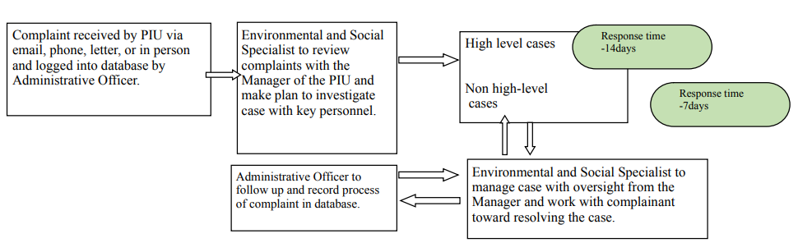

All grievances and how they are addressed will be logged into a database managed by the project implementation unit. Complaints addressed to the Supervision firm by members of the public, whether verbally or in writing should be transmitted to the PIU within 1 business day.

Grievance Redress Procedures
The table below presents the steps to be followed should a grievance arise:
Grievances from affected parties | - Grievances made verbally to the E&S Specialist (ESS) in person at stakeholder engagement meetings or to the Contractor’s personnel.  - By email to the following address- mohgrievances@govt.lc  - By Letter addressed to:  The Permanent Secretary  Grievance Redress Mechanism (GRM)  Attention to E&S Specialist HSSP & OECS Regional Health Projects  Department of Health and Wellness  2nd Floor, Sir Stanislaus Building, Waterfront, Castries  - By letter, addressed to the:  The Project Coordinator  Project Implementation Unit  OECS Regional Health Project  Sure Line Building  Vide Boutielle Highway  Castries  Saint Lucia  - By phone, at number 758-468-8830  - Or call, text or WhatsApp to 286 7815  - All GBV complaints will be handled directly by the ESS.
Uptake of Grievances | - The PIU serves as the access point for grievances
Grievance Log | - Grievances received verbally are documented, verified and signed by both parties.  - Grievances will be copied to the relevant authority
Assessment | - Grievances categorized by type.  - Determination of eligibility of grievance.  - The first assessment of the grievance is conducted by the PIU and technical officers from the pertinent Government authorities.  - Letters acknowledging the grievance is issued by the PIU  - The Social Transformation Officer (STO) for the region provides assistance with dealing with conflict resolution and grievance.  - The ESS will communicate all disputes and grievances to the PIU immediately when received. Should a dispute arise, the applicable Laws of Saint Lucia will prevail.
Resolution and Follow-up | - Development of an Implementation Plan for resolution of grievances, including timeframes in which each step is completed as stated above in the section on processing grievances.  - The signing of the Grievance Resolution Form.

Addressing Sexual Exploitation and Abuse and Sexual Harassment (SEA/SH)
The specific nature of sexual exploitation and abuse and of sexual harassment (SEA/SH) requires tailored measures for the reporting, and safe and ethical handling of such allegations. The process is detailed in Appendix

Promoting GRM Awareness
The Grievance Redress Mechanism (GRM) will be promoted through a public sensitization campaign which will include stakeholder engagement meetings and communication with stakeholders via email, WhatsApp and bulletins or flyers. The general public will be informed through public announcements through various media including the Government Information Service and website, television and radio announcements. All communication will provide contact information for the E&S Specialist, who is responsible for receiving complaints. The project signs will also provide relevant information about the implementing agency for persons who wish to register grievances.

ESMP Implementation Costs
The costs during the construction phase for complying with the ESHS requirements will be included as a subsidiary obligation of the main work activity, and not separated in the BOQ.

Conclusion
The La Guerre Wellness Centre Rehabilitation has low to moderate potential E&S impacts, not requiring a full ESIA but requires an ESMP and proper Environmental and Social Monitoring and the implementation of mitigation measures. Coordination and communication with the community will be important to the successful completion of the project without incident, as well as coordination with other authorities and institutions including but not limited to RSLPF, Fire Service and Community Based organisations in La Guerre and environs.

12. Appendices

APPENDIX A: Incident / Accidents to be reported to the World Bank

The following are incident types to be reported using the environmental and social incident response process:
Fatality: Death of a person(s) that occurs within one year of an accident/incident, including from occupational disease/illness (e.g., from exposure to chemicals/toxins).
Lost Time Injury: Injury or occupational disease/illness (e.g., from exposure to chemicals/toxins) that results in a worker requiring 3 or more days off work, or an injury or release of substance (e.g., chemicals/toxins) that results in a member of the community needing medical treatment.
Acts of Violence/Protest: Any intentional use of physical force, threatened or actual, against oneself, another person, or against a group or community, that either results in or has a high likelihood of resulting in injury, death, psychological harm, deprivation to workers or project beneficiaries, or negatively affects the safe operation of a project worksite.
Disease Outbreaks: The occurrence of a disease in excess of normal expectancy of number of cases. Disease may be communicable or may be the result of unknown etiology.
Displacement Without Due Process: The permanent or temporary displacement against the will of individuals, families, and/or communities from the homes and/or land which they occupy without the provision of, and access to, appropriate forms of legal and other protection and/or in a manner that does not comply with an approved resettlement action plan.
Child Labor: An incident of child labor occurs: (i) when a child under the age of 14 (or a higher age for employment specified by national law) is employed or engaged in connection with a project, and/or (ii) when a child over the minimum age specified in (i) and under the age of 18 is employed or engaged in connection with a project in a manner that is likely to be hazardous or interfere with the child’s education or be harmful to the child’s health or physical, mental, spiritual, moral or social development.
Forced Labor: An incident of forced labor occurs when any work or service not voluntarily performed is exacted from an individual under threat of force or penalty in connection with a project, including any kind of involuntary or compulsory labor, such as indentured labor, bonded labor, or similar labor-contracting arrangements. This also includes incidents when trafficked persons are employed in connection with a project.
Unexpected Impacts on heritage resources: An impact that occurs to a legally protected and/or internationally recognized area of cultural heritage or archaeological value, including world heritage sites or nationally protected areas not foreseen or predicted as part of project design or the environmental or social assessment.
Unexpected impacts on biodiversity resources: An impact that occurs to a legally protected and/or internationally recognized area of high biodiversity value, to a Critical Habitat, or to a Critically Endangered or Endangered species (as listed in IUCN Red List of threatened species or equivalent national approaches) that was not foreseen or predicted as part of the project design or the environmental and social assessment. This includes poaching or trafficking of Critically Endangered or Endangered species.
Environmental pollution incident: Exceedances of emission standards to land, water, or air (e.g., from chemicals/toxins) that have persisted for more than 24 hrs or have resulted in harm to the environment.
Dam failure: A sudden, rapid, and uncontrolled release of impounded water or material through overtopping or breakthrough of dam structures.
Other: Any other incident or accident that may have a significant adverse effect on the environment, the affected communities, the public, or the workers, irrespective of whether harm had occurred on that occasion. Any repeated non-compliance or recurrent minor incidents which suggest systematic failures that the task team deems needing the attention of Bank management.

Appendix A– Incident / Accidents to be reported to the world bank

B1: Incident / Accident Details

Project Site:
Date of Incident / Accident: | Time: | Date Reported: |  | Time Reported:
Reported by: | Reported to: |  | Notification Type: Email/’phone call/media notice/other
Full Name of Contractor: |  | Full Name of Subcontractor:

B2: Type of incident / Accident (please check all that apply)
Fatality ☐ Lost Time Injury ☐ Displacement Without Due Process ☐ Acts of Violence/Protest ☐ Disease Outbreaks ☐ Forced Labor ☐ Unexpected Impacts on heritage resources ☐ Unexpected impacts on biodiversity resources ☐
Environmental pollution incident ☐ structure failure ☐ Other ☐

B3: Description/Narrative of Incident / Accident
- Details of the Incident / Accident

- What were the conditions or circumstances under which the incident occurred (if known)?

- Are the basic facts of the incident clear, or are there conflicting versions? What are those versions?

- Is the incident still ongoing, or is it contained?

- Have any relevant authorities been informed? Who was informed?

B4: Actions taken to contain the incident / Accident
Short Description of Action | Responsible Party | Expected Date | Status
Have the works been suspended? Yes ☐; No ☐;

Please attach a copy of the instruction suspending the works.
B5: What support has been provided to affected people

B6: Injury Information
Injured Employee
Name: | Job Title:
Job at time of Injury:
Type of Employment
Full – time ☐ Part – time ☐ Temporary ☐ Other ☐
Length of time employed with the Company:
Length of time in current position at the time of the incident:
Description and severity of injury:

Location at the time of the incident/accident

Date and time of incident / Accident:

Appendix B - Code of Conduct for Contractor’s Personnel (ES) Form

This document is also included as part of the Request for Bids Small Works Standard Procurement Document.
Note to the Employer:
The following minimum requirements shall not be modified. The Employer may add additional requirements to address identified issues, informed by relevant environmental and social assessment.
The types of issues identified could include risks associated with: labour influx, spread of communicable diseases, and Sexual Exploitation and Abuse (SEA), Sexual Harassment (SH) etc.
Delete this Box prior to issuance of the bidding documents.

Note to the Bidder:
The minimum content of the Code of Conduct form as set out by the Employer shall not be substantially modified. However, the Bidder may add requirements as appropriate, including to take into account Contract-specific issues/risks.
The Bidder shall initial and submit the Code of Conduct form as part of its bid.
CODE OF CONDUCT FOR CONTRACTOR’S PERSONNEL
We are the Contractor, [enter name of Contractor]. We have signed a contract with [enter name of Employer] for [enter description of the Works]. These Works will be carried out at [enter the Site and other locations where the Works will be carried out]. Our contract requires us to implement measures to address environmental and social risks related to the Works, including the risks of sexual exploitation, sexual abuse and sexual harassment.
This Code of Conduct is part of our measures to deal with environmental and social risks related to the Works. It applies to all our staff, laborers and other employees at the Works Site or other places where the Works are being carried out. It also applies to the personnel of each subcontractor and any other personnel assisting us in the execution of the Works. All such persons are referred to as “Contractor’s Personnel” and are subject to this Code of Conduct.
This Code of Conduct identifies the behaviour that we require from all Contractor’s Personnel.
Our workplace is an environment where unsafe, offensive, abusive or violent behaviour will not be tolerated and where all persons should feel comfortable raising issues or concerns without fear of retaliation.

REQUIRED CONDUCT
Contractor’s Personnel shall:
- carry out their duties competently and diligently;
- comply with this Code of Conduct and all applicable laws, regulations and other requirements, including requirements to protect the health, safety and well-being of other Contractor’s Personnel and any other person;
- maintain a safe working environment including by:
  - ensuring that workplaces, machinery, equipment and processes under each person’s control are safe and without risk to health;
  - wearing required personal protective equipment;
  - using appropriate measures relating to chemical, physical and biological substances and agents; and
  - following applicable emergency operating procedures.
- report work situations that he/she believes are not safe or healthy and remove himself/herself from a work situation which he/she reasonably believes presents an imminent and serious danger to their life or health;
- treat other people with respect, and not discriminate against specific groups such as women, people with disabilities, migrant workers or children;
- not engage in Sexual Harassment, which means unwelcome sexual advances, requests for sexual favours, and other verbal or physical conduct of a sexual nature with other Contractor’s or Employer’s Personnel;
- not engage in Sexual Exploitation, which means any actual or attempted abuse of position of vulnerability, differential power or trust, for sexual purposes, including, but not limited to, profiting monetarily, socially or politically from the sexual exploitation of another;
- not engage in Sexual Abuse, which means the actual or threatened physical intrusion of a sexual nature, whether by force or under unequal or coercive conditions;
- not engage in any form of sexual activity with individuals under the age of 18, except in case of pre-existing marriage;
- complete relevant training courses that will be provided related to the environmental and social aspects of the Contract, including on health and safety matters, and Sexual Exploitation and Abuse (SEA), and Sexual Harassment (SH);
- report violations of this Code of Conduct; and
- not retaliate against any person who reports violations of this Code of Conduct, whether to us or the Employer, or who makes use of the grievance mechanism for Contractor’s Personnel or the project’s Grievance Redress Mechanism.
RAISING CONCERNS
If any person observes behaviour that he/she believes may represent a violation of this Code of Conduct, or that otherwise concerns him/her, he/she should raise the issue promptly. This can be done in either of the following ways:
- Contact [enter name of the Contractor’s Social Expert with relevant experience in handling gender-based violence, or if such person is not required under the Contract, another individual designated by the Contractor to handle these matters] in writing at this address [ ] or by telephone at [ ] or in person at [ ]; or
- Call [ ] to reach the Contractor’s hotline (if any) and leave a message.

The person’s identity will be kept confidential, unless reporting of allegations is mandated by the country law. Anonymous complaints or allegations may also be submitted and will be given all due and appropriate consideration. We take seriously all reports of possible misconduct and will investigate and take appropriate action. We will provide warm referrals to service providers that may help support the person who experienced the alleged incident, as appropriate.
There will be no retaliation against any person who raises a concern in good faith about any behaviour prohibited by this Code of Conduct. Such retaliation would be a violation of this Code of Conduct.
CONSEQUENCES OF VIOLATING THE CODE OF CONDUCT
Any violation of this Code of Conduct by Contractor’s Personnel may result in serious consequences, up to and including termination and possible referral to legal authorities.
FOR CONTRACTOR’S PERSONNEL:
I have received a copy of this Code of Conduct written in a language that I comprehend. I understand that if I have any questions about this Code of Conduct, I can contact [enter name of Contractor’s contact person with relevant experience] requesting an explanation.

Name of Contractor’s Personnel: [insert name]
Signature: __________________________________________________________
Date: (day month year): _______________________________________________
Countersignature of authorized representative of the Contractor:
Signature: ________________________________________________________
Date: (day month year): ______________________________________________

ATTACHMENT 1: Behaviours constituting Sexual Exploitation and Abuse (SEA) and behaviours constituting Sexual Harassment (SH)

ATTACHMENT 1 TO THE CODE OF CONDUCT FORM
BEHAVIORS CONSTITUTING SEXUAL EXPLOITATION AND ABUSE (SEA) AND BEHAVIORS CONSTITUTING SEXUAL HARASSMENT (SH)
The following non-exhaustive list is intended to illustrate types of prohibited behaviours:
- Examples of sexual exploitation and abuse include, but are not limited to:
- A Contractor’s Personnel tells a member of the community that he/she can get them jobs related to the work site (e.g., cooking and cleaning) in exchange for sex.
- A Contractor’s Personnel that is connecting electricity input to households says that he can connect women headed households to the grid in exchange for sex.
- A Contractor’s Personnel rapes, or otherwise sexually assaults a member of the community.
- A Contractor’s Personnel denies a person access to the Site unless he/she performs a sexual favour.
- A Contractor’s Personnel tells a person applying for employment under the Contract that he/she will only hire him/her if he/she has sex with him/her.
- Examples of sexual harassment in a work context
- Contractor’s Personnel comment on the appearance of another Contractor’s Personnel (either positive or negative) and sexual desirability.
- When a Contractor’s Personnel complains about comments made by another Contractor’s Personnel on their appearance, the other Contractor’s Personnel comment that he/she is “asking for it” because of how he/she dresses.
- Unwelcome touching of a Contractor’s or Employer’s Personnel by another Contractor’s Personnel.
- A Contractor’s Personnel tells another Contractor’s Personnel that he/she will get him/her a salary raise, or promotion if he/she sends him/her naked photographs of himself/herself.

Appendix C -Project Environmental and Social Safeguards Inspection Weekly Checklist

(This weekly checklist when filed in the Project Environmental and Social Safeguards File constitutes a Register of Environmental and Social Safeguards Effects).

This form is to be completed by the Contractor’s Nominated person(s) weekly from the start of major construction work on site. Completed forms are to be kept readily available in the Project Environmental and Social Safeguards File for the duration of construction works during which time they can be inspected by the Supervising Officer or representatives of the Government of St Vincent and the Grenadines.

Sub-Project Contract: __________________________________

Construction Phase: ________________________________

Contractor: ________________________________________

Recording Officer: _____________________________________

Designation of Recording Officer: ___________________________

Date: ____________________________________________

Any environmental actions identified are to be brought to the urgent attention of the appropriate personnel as soon as possible. A copy of this completed form is to be issued to the Supervising Engineer within two days of the date of inspection.
Environmental Issue to be considered in site inspection | YES | NO | N/A | If YES add an explanatory comment and mitigation measure
Issue: Loss of soil through soil erosion

- Has any natural vegetation outside the working width of the construction work area been removed?
- Are there any visible signs of soil erosion?
- Are excavated areas properly maintained to prevent soil erosion?
- If any sediment traps have been installed, have they become clogged and not functional?
- Are any soil retention/slope stabilisation measures required or being implemented?

Issue: Soil Contamination

- Are there any signs of soil that has been contaminated due to spillage (Petrochemical, cleaning products)?

Issue: Pollution of water courses/bodies/source through soil erosion, entry of liquid construction waste or chemicals or entry of solid construction waste into the water course/body

- Are there visible signs of increased sediment immediately downstream of construction works in any rivers, in the well or in the nearby marine environment within the project area?
- Have there been any complaints from residents or third parties regarding pollution of water sources/courses/bodies?
- Has any construction spoil been disposed of into or adjacent to a water source/course/body?
- Are any construction related fuels and chemicals stored within 10m of a water source/course/body?
- Has any fuel or chemical leaked during storage, transport to site, use on site or refuelling?
- Has any construction related solid or liquid waste entered a water source/course/body within the general project area (including construction site office)?

Issue: Prevention of negative landscape and visual impacts.

- Have any construction compounds, materials dumps, or waste disposal sites in use not been discussed and agreed with the Supervising Officer (and, if necessary, appropriately licensed with the Government of St Vincent?)?
- Are there any visible signs of scaring from excavation works that require restoration?

Issue: Management and disposal of solid and liquid construction wastes.

- Has any construction related packaging (especially cement bags) been disposed of on the side of the road, in vacant land, along river embankments or in the river channel, or at any unofficial waste disposal site along the route?
- Has any contaminated/hazardous material been found during construction?
- Is any sub-contractor’s waste being disposed of along the roadside or at an unlicensed waste disposal site along the route?

- Has any construction waste of any kind been dumped by the side of the road or along the river embankment?
- Are any liquid wastes being discharged to water courses?
- Has any liquid waste, liquid contaminant leaked unto the site, into any neighbouring lands or water source/course/body?
- Is water discharge/pumping in progress?
- Is there any Hazardous waste by products on site?

Issue: Management of construction noise and vibration.

- Is any noisy stationary plant being operated adjacent to housing? (If so, are they screened to reduce disturbance?)
- Are any noisy activities taking place before 7:00 a.m. or after 5:00 p.m. between Monday to Friday? (If so, has this working been discussed and agreed with the Supervising Engineer/Client?)
- Have there been any noise or vibration related complaints during the last week?
Issue: Dust nuisance prevention.

- Are there any houses adjacent to the construction sites being affected adversely by dust?
- Are any crops adjacent to the construction works covered with dust?
- Is there any quarry material stored on site that is uncovered or does not have hoarding and subject to dispersal by the wind?
- Are any trucks, carrying quarry materials to or from the site, transporting this material uncovered?
- Is adequate water available to damp down any dusty operations ongoing on site?
- Have there been any dust related complaints during the last week?

Issue: Air Pollution (Fumes)

- Are there any signs of high levels of exhaust/ fumes/ malodours?
- Have there been any fumes nuisance related complaints during the last week?

Issue: Dealing with archaeological finds.

- Have any potential historic artefacts been found during construction? (If so, note how these have been dealt with).

Issue: Construction traffic management.

- Is there adequate signage to inform motorists of the construction activities ahead?
- Have there been any complaints about construction traffic impacts (noise, dust, congestion)?
- Is there a designated turning/ loading/ offloading area? (If so, is there adequate signage or are a traffic management system being implemented?)
- Have there been any traffic accidents/incidents during the last week due
to the construction activity on this site? (If so, state how many and severity)

Issue: Dealing with hazardous substances.

- Have any: old drums or containers, oily sheen, materials with a strong smell or unusual colouration been exposed/damaged during construction excavations?
- Are drums containing hazardous material properly stored and adequately labelled on the site?
- Has there been any spillage during the last week? (If so, how many, what was spilled, how much and how was it managed?)

Issue: Environmental Incidents and Corrective Actions.

- Have complaints been received from the public or other third party during the last week? (If so, how many? Attach a copy of the reports)
- Has any incident leading to a threat of human health or life occurred during the last week? (If so, how many? Describe severity and attach copy of incident report)

Completed by:

Designation: Contractor’s Representative

Signed ………………………………….

Print Name: …………………………… Date: …………………………………

Designation: Client’s Supervising Officer

Action completed:

Signed ………………………………….

Print Name: …………………………… Date: ……………………………………

ENVIRONMENTAL INSPECTION AND SOCIAL SAFEGUARDS REGISTER – ADDITIONAL COMMENTS

If required, provide supporting comments relating to the specified environmental checks or on any site environmental or social safeguards matter worthy of note

Continuation Sheet No. Pages:

APPENDIX D- Monthly Employer’s Environmental and Social Safeguards Review Checklist

Month in Review:

This form is to be completed by the Employer’s Nominated person(s) monthly. Completed forms are to be kept on file in the Project Co-ordination Unit offices. A copy should be passed to the Supervising Officer for information within 48 hours.

Subproject:

Contractor:

Recording Officer:

Recording Officer Designation:

Date:

The purpose of this review is to check monthly that the Project Environmental and Social Safeguards File is being kept up to date.

Issue to be considered in the review | Yes | No | Comments and detail of any corrective actions requested
Q - Looking at the file is there evidence that the Contractor is undertaking the weekly Environmental Inspections and filing the completed Inspection Checklist?

Q – Looking at the file and the completed weekly Environmental Inspection, has the Supervising Engineer signed the completed checklists?

Q – Looking at the file is there evidence that the Contractor is maintaining the log of environmental incidents/complaints? (It is possible that there may be very few or no complaints of this project so this form may in reality not be used. If there are no complaints at the time of review write this in the comments box.)

Q – Looking at the file is there evidence that any Corrective Action Requests (CAR) which have been issued have been signed off as completed by the originator of that CAR?

Q – Looking at the file is there evidence that any Social Safeguards or Grievances have been recorded?

MONTHLY EMPLOYER’S ENVIRONMENTAL AND SOCAL SAFEGUARDS REGISTER REVIEW – ADDITIONAL COMMENTS

If required, provide supporting comments relating to specific points above.

Continuation Sheet No. Pages:

Review completed by:

Designation: Employer’s Representative

Signed ………………………………….

Print Name: …………………………… Date: …………………………………

Designation: Contractor’s Representative

Signed ………………………………….

Print Name: …………………………… Date: …………………………………

Appendix E: E & S Quarterly Report Template

Environmental and Social Quarterly Report
[Date ]

A. Summary
B. Context
C. Sub-projects and Program Activities
D. Environmental Management Actions Items
E. Status of the Grievance Redress Mechanism
F. Conclusions and Recommendations

Appendix F- SEA, SH AND GBV Grievance redress process, grievance redress registration and closure forms

Addressing Sexual Exploitation and Abuse and Sexual Harassment (SEA/SH)
The specific nature of sexual exploitation and abuse and of sexual harassment (SEA/SH) requires tailored measures for the reporting, and safe and ethical handling of such allegations. A survivor-centred approach aims to ensure that anyone who has been the target of SEA/SH is treated with dignity, and that the person’s rights, privacy, needs and wishes are respected and prioritized in any and all interactions.
The project’s E&S Specialist will be responsible for dealing with any SEA/SH issues, should they arise. A list of SEA/SH service providers will be kept available by the project. The GM should assist SEA/SH survivors by referring them to Services Provider(s) for support immediately after receiving a complaint directly from a survivor. A list of service providers is found in Table 4 below.
To address SEA/SH, the project will follow the guidance provided on the World Bank Technical Note “Addressing Sexual Exploitation and Abuse and Sexual Harassment (SEA/SH) in Investment Project Financing Involving Civil Works”. This GM will follow the official WB definitions described on the Technical Note as shown below:
Sexual Abuse (SEA) is an actual or threatened physical intrusion of a sexual nature, whether by force or under unequal or coercive conditions
Sexual Exploitation (SE) refers to any actual or attempted abuse of a position of vulnerability, differential power, or trust, for sexual purposes, including, but not limited to, profiting monetarily, socially or politically from the sexual exploitation of another.
Sexual harassment (SH) Sexual Harassment (SH) is any unwelcome sexual advance, request for sexual favour, verbal or physical conduct or gesture of a sexual nature, or any other behaviour of a sexual nature that might reasonably be expected or be perceived to cause offense or humiliation to another, when such conduct interferes with work, is made a condition of employment or creates an intimidating, hostile or offensive work environment.
Sexual Exploitation and Abuse and Sexual Harassment (SEA/SH) service provider
An organization offering specific services for SEA/SH survivors, such as health services, psychosocial support, shelter, legal aid, safety/security services, etc.
Survivor-cantered approach
The survivor-centred approach is based on a set of principles and skills designed to guide professionals—regardless of their role—in their engagement with survivors (predominantly women and girls but also men and boys) who have experienced sexual or other forms of violence. The survivor-centred approach aims to create a supportive environment in which the survivor´s interests are respected and prioritized, and in which the survivor is treated with dignity and respect. The approach helps to promote the survivor´s recovery and ability to identify and express needs and wishes, as well as to reinforce the survivor´s capacity to make decisions about possible interventions.
The E&S Specialist and PIU will receive sensitization training on the survivor-centred approach.
SEA/SH grievances can be received through any of the available channels and will be considered level 3 grievances investigated and addressed by the GRC. A list of SEA/SH service providers will be kept available by the Project. Additionally, if an incident occurs, it will be reported as appropriate, keeping the anonymity and confidentiality of the complainant and applying the survivor-centred approach. Any cases of SEA/SH brought through the GM will be documented but remain closed/sealed to maintain the confidentiality of the survivor. The WB will be notified as soon as the Project Manager and the E&S specialist learn about the complaint.
If a SEA/SH related incident occurs, it will be reported through the GM, as appropriate and keeping the survivor information confidential. Specifically, following steps will be taken once an incident occurs:

ACTION 1: complaint intake and REFERRAL
If the survivor gives consent, the E&S specialist fills in a complaints form excluding any information that can identify the survivor:
- The nature of the allegation (what the complainant says in her/his own words without direct questioning)
- If the alleged perpetrator was/is, to the survivor’s best knowledge, associated with the project (yes/no)
- The survivor’s age and/or sex (if disclosed); and,
- If the survivor was referred to services
If the survivor does not want to provide written consent, her consent can be verbally received. If needed or desired by the survivor, the PIU E&S Specialist refers her/him to relevant SEA/SH service providers, identified in the mapping of SEA/SH service providers and according to preestablished and confidential referral procedures. The survivor’s consent must be documented even if it is received verbally. The service providers will be able to direct survivors to other service providers in case the survivor wishes to access other services. The PIU safeguards specialist will keep the survivor informed about any actions taken by the perpetrator employer. If the survivor has been referred to the relevant SEA/SH service providers, received adequate assistance, and no longer requires support; and if appropriate actions have been taken against the perpetrator or if the survivor does not wish to submit an official grievance with the employer, the PIU Safeguards Specialist can close the case.

ACTION 2: INCIDENT REPORTING
The PIU E&S Specialist needs to report the anonymized SEA/SH incident as soon as it becomes known, to the Project Manager who will in turn inform the World Bank Task Team Leader (TTL) or directly to the TTL.
Complaint Forms and other detailed information should be filed in a safe location by the PIU Safeguards Specialist. Neither the PIU E&S specialist nor the Project Manager should seek additional information from the survivor.
SEA/SH incident reporting is not subject to survivors’ consent but the PIU E&S Specialist needs to provide ongoing feedback to the survivor at several points in time: (1) when the grievance is received; (2) when the case is reported to PIU and WB; (3) when the verification commences or when a determination is made that there is an insufficient basis to proceed; and (4) when the verification concludes or when any outcomes are achieved or disciplinary action taken.
As long as the SEA/SH remains open the PIU Safeguards Specialist and/or Project Manager should update the World Bank TTL on the measures taken to close the incident.

ACTION 3: GRIEVANCE VERIFICATION AND INVESTIGATION
Each SEA/SH incident should be verified to determine if it was related to the WB financed project. The PIU E&S specialist should form a SEA/SH verification committee comprised by her/him, one member of the PIU, one member of a local service provider and a representative of the contractor (if relevant). The PIU E&S Specialist should notify the SEA/SH Committee of the incident within 24 hours of its creation. The SEA/SH verification committee will consider the SEA/SH allegation to determine the likelihood that the grievance is related to the project.
If after the committee review, SEA/SH allegation is confirmed and it is determined that it is linked to a project, the verification committee discusses appropriate actions to be recommended to the appropriate party i.e., the employer of the perpetrator, which could be the PIU or a contractor. The PIU will ask contractors to take appropriate action. The committee reports the incident to the perpetrator’s employers to implement the remedy/disciplinary action in accordance with local labour legislation, the employment contract of the perpetrator, and their codes of conduct as per the standard procurement documents.
For SEA/SH incidents where the survivor did not consent to an investigation, the appropriate steps should be taken to ensure the survivor is referred to/made aware of available services and that the project mitigation measures are reviewed to determine if they remain adequate and appropriate or if they require strengthening.
If the survivor is interested in seeking redress and wishes to submit an official complaint with the employer, or with entities in the St. Lucian legal system, the PIU Safeguards Specialist should provide linkages to the relevant institutions. Ensuring due legal process is up to the police and the courts, not the SEA/SH verification committee. Unlike other types of issues, the PIU E&S Specialist does not conduct investigations, make any announcements, or judge the veracity of an allegation.
Any cases of SEA/SH brought through the GM will be documented but remain closed/sealed to maintain the confidentiality of the survivor. Here, the GM will primarily serve to:
- Refer complainants to the SEA/SH Services Provider; and
- Record the resolution of the complaint
The GM will also immediately notify both the Implementing Agency and the World Bank of any SEA/SH complaints WITH THE CONSENT OF THE SURVIVOR.

Grievance Redress Mechanism (GRM) for Labour
As part of the Labour Management Procedure (LMP), grievances that relate to project workers will be handled by a separate grievance redress mechanism from that of other project-related grievances. The grievance redress mechanism (GRM) will provide all direct workers and contracted workers (and, where relevant, their organizations) with channels to raise workplace concerns. Such workers, including community workers, will be informed of the grievance redress mechanism at the time of recruitment and the measures put in place to protect them against reprisal for its use. Measures will be put in place to make the grievance redress mechanism easily accessible to all such project workers. Community workers can access the GM via local NGOs, project officers, or the Environmental and Social Safeguards Team.
The Grievance Redress Mechanism (GRM) in the LMP also makes clear procedures for the handling of Sexual Exploitation and Abuse (SEA) and Sexual Harassment (SH) grievances. Complaints can be made in person, in writing, verbally over the phone, by fax, email or any other media. Concerns can be raised anonymously and/or to a person other than an immediate supervisor.
The Project Coordinator (PC) and the Social Safeguards Focal Point and Social Safeguards Specialist assigned to the project will be designated as the key officers in charge of labour grievances resolution.

Table 4. St. Lucia GBV Service Providers
Service Providers | Service Provided | Address | Telephone | Other
Attorney General | Case Management | 2nd Floor Francis Compton Building, Waterfront, Castries | 468-3202
Office of the Director of Public Prosecution | Case Management |  | 452-3636  468-3185  468-3017 | slucps@gmail.com
Family Court | Case Management | Peynier Street, Castries | 468-3308 | familycourt.slu@gmail.com
Criminal Investigations Department | Case Management | Castries  Vieux Fort | 456-3770  456-3817  456-3926
Vulnerable Persons Unit | Case Management  Investigates sexual offences against minors, women and men. | Vulnerable Persons Team South  North | 456-3908  456-4050  4051  4052
St. Lucia Against Human Trafficking | Provides human trafficking victims and survivors with access to critical support and services to get help and stay safe. | Ministry of Home Affairs, Justice and National Security  1st Floor Sir Stanislaus Bldg. Waterfront Castries | 468-3754 | police@antitraffickingslu.org
Department of Gender Affairs | Psychosocial Support  Livelihood Support | Ground Floor Georgian Court Bldg. John Compton Highway, Castries | 716-3123 | gender.relations@govt.lc
Abuse Hotline | Psychosocial Support |  | 202
St. Lucia Crisis Centre | Psychological Support  Livelihood Support  Assistance with basic needs such as food and shelter | 107 Chausse Road, Castries | 453-1521  712-7574 | stluciacrisis@gmail.com
Women’s Support Centre | Legal Aid  Psychological Support  Livelihood Support  Assistance with basic needs such as food and shelter |  | 458-4470 | WSCCENTER2001@GMAIL.COM
Raise your Voice St. Lucia Inc | Psychological Support  Livelihood Support | Manoel Street, Castries | 726-0473 487-2329 | raiseyourvoiceslu@gmail.com  https://ryvslu.org/
Positive Reactions Over Secrets and Fears (PROSAF) | Psychological Support | PO Box 973 Castries | 724-9991 | info@prosafe.org  https://prosaf.org
United and Strong | Assistance for LGBTI persons | P.O. BOX 772 Castries, | 450-0976 | unitedandstrongstlucia@yahoo.com  www.facebook.com/Unitedandstrongstlucia/
St. Lucia Planned Parenthood Association | Sex education counselling  Sexual and reproductive health services | 52 John Compton Highway | 452-4335  Hotline:  459-7933  WhatsApp:  722-1234 | slppa758@gmail.com
OKEU Hospital | Medical Health Services | Castries | 458-6500
St. Jude Hospital | Medical Health Services | Vieux Fort | 454- 6041
La Guerre Health Centre | Medical Health Services | La Guerre | 468-7741
Castries Health Centre | Medical Health Services | Chaussee Road Castries | 452-4416
Gros Islet Polyclinic | Medical Health Services | Gros Islet | 450-9661
Babonneau Health Centre | Medical Health Services | Babonneau, Castries | 468-7722
National Mental Wellness Centre | Psychological Support | Castries | 458-2713  453-0069

Complaints Form Template

Complaint Number: [Number]

CONFIDENTIAL Complaints Form
DO NOT FILL IN IF SEA/SH SURVIVOR DOES NOT CONSENT
OECS Regional Health Project and Saint Lucia Health System Strengthening Project

Please complete this form to report a problem or file a complaint with the OECS Regional Health Project and Saint Lucia Health System Strengthening Project. After you fill the form, tear off and keep the receipt at the bottom and put the form in the complaints box.
Program
- What program are you complaining about? Please tick the correct box. OECS Regional Health Project (explain project activities briefly)
Saint Lucia Health System Strengthening Project (explain project activities briefly) Other

Details of Complaint
- Today’s date: Day Month Year
- Parish:
- Sex of person complaining (M/F): 5. Age of person complaining:

Please tell us about your complaint so the program can investigate. Please include as much information as possible.

Personal Details (Optional) PLEASE NOTE THAT YOU HAVE THE RIGHT TO REMAIN ANONYMOUS AND NOT PROVIDE PERSONAL DETAILS.

If you would like to receive a response from the program about your complaint, please fill in your details below. If you do not fill in these details, you will remain unknown and the program will not be able to contact you.
6. First Name: 7. Last Name:
DO NOT FILL IN IN THE CASE OF SEA/SH GRIEVANCES
8. Parish: 9. Mobile number:
10. Mediator for affected person:
11. Civil organization / Service Organization:

Receipt: Complaint Number: [Same number as above]
Date received:
Person receiving the complaint:

Grievance Registers

DO NOT FILL IN IN THE CASE OF SEA/SH GRIEVANCES Page Number: [Number]
OECS Regional Health Project
Saint Lucia Health System Strengthening Project
 | IDENTIFICATION OF PERSON / ENTITY |  |  | NATURE OF THE REQUEST / COMPLAINT |  |  | REQUEST/ COMPLAINT PROCESSING
Log | Name (and | Contact Details | Incident | Information request / | Received by | Response | Date of request / | Action Taken (under | Date
# | age) of the |  | date | complaint |  | provided / action | incident response | review, investigation, | Closed
 | complainant |  |  |  |  | taken |  | closed)

FILL IN ONLY FOR SEA/SH INCIDENTS
OECS Regional Health Project
Saint Lucia Health System Strengthening Project
Nature of the allegation(what the complainant | Was the alleged perpetrator was/is, | Survivor’s age and/or sex | Was the
says in her/his own words without direct | to the survivor’s best knowledge, | (if disclosed) | survivor
questioning) | associated with the project |  | referred to
 | (yes/no) |  | services?

Meeting Record Format
Subproject: ............................................ Community: .................... Location: ................... …………........
Date of the Meeting: …………………………….. Complaint Register No: ……………………………….. Venue of meeting: ……………………………………..
Details of Participants:
Complainant | Project/Government
Summary of Grievance: ………………………………………………………………………………………………………………………
……………………………………………………………………………………………………………………………………………………………
…………………………………………………………………………………………………………………………………………………………… Notes on Discussion: …………………………………………………………………………………………………………………………
……………………………………………………………………………………………………………………………………………………………
……………………………………………………………………………………………………………………………………………………………
……………………………………………………………………………………………………………………………………………………………

Decisions taken / Recommendations: ……………………………………………………………………………………………….
……………………………………………………………………………………………………………………………………………………………
……………………………………………………………………………………………………………………………………………………………
……………………………………………………………………………………………………………………………………………………………
Issue Solved / Unsolved Signature of Chairperson of the meeting:
Name of Chairperson: …………………………………………… Signature :……………………………..
Date: ………………………………………. (DD/MM/YYYY)

Grievance Closure Form
Subproject: ................................ Community:.................... Location: ...........................

Result of Grievance Redressal
- Registration No.:
- Name of Complainant:
- Date of Complaint:
- Summary of the Complaint:
- Summary of Resolution:
- Date of Redressal of the Grievance: (dd– mm – yyyy)
Signature of the Complainant in acceptance of the Solution to his /her Grievance Name:……………………………………………………………………………………….

National ID number: ………………………………..
Signature of Permanent Secretary or Project Manager: …………………………………………
Name: …………………………….………………………………………………………..….
Place: ……………………………………………………...…………………………………..
Date:(dd –mm – yyyy): ………………………………………..

appendix h- Site Photos

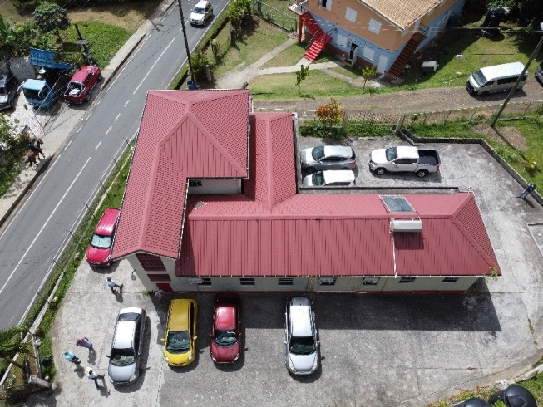 | 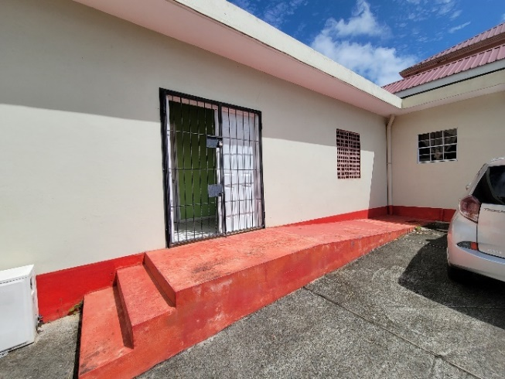
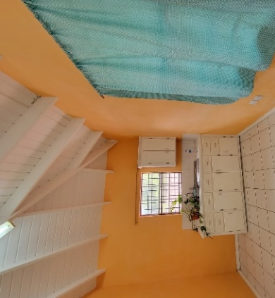 | 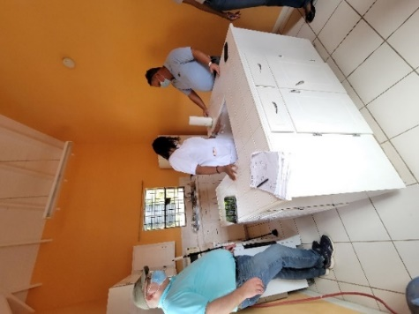
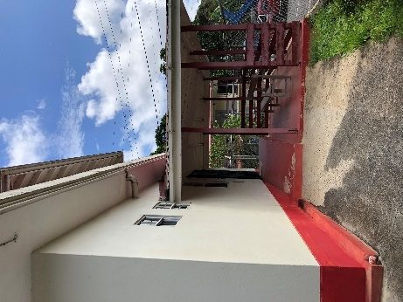 | 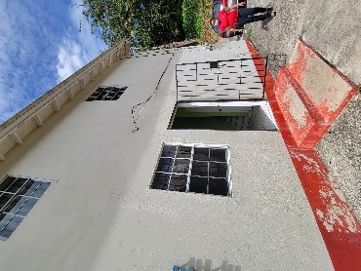
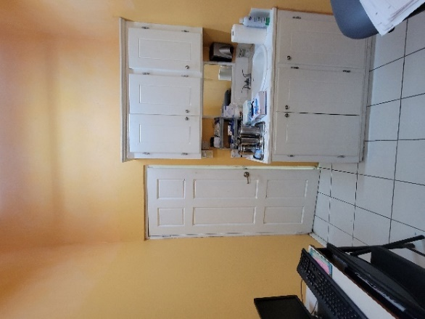 | 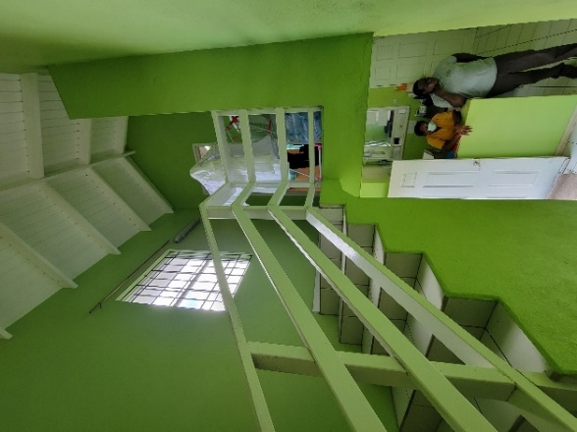
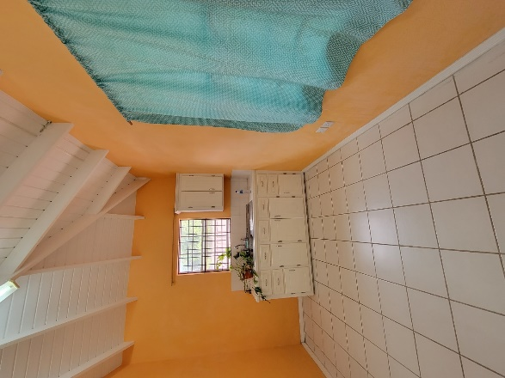

Appendix H: Saint Lucia SMART Health Facilities Checklist

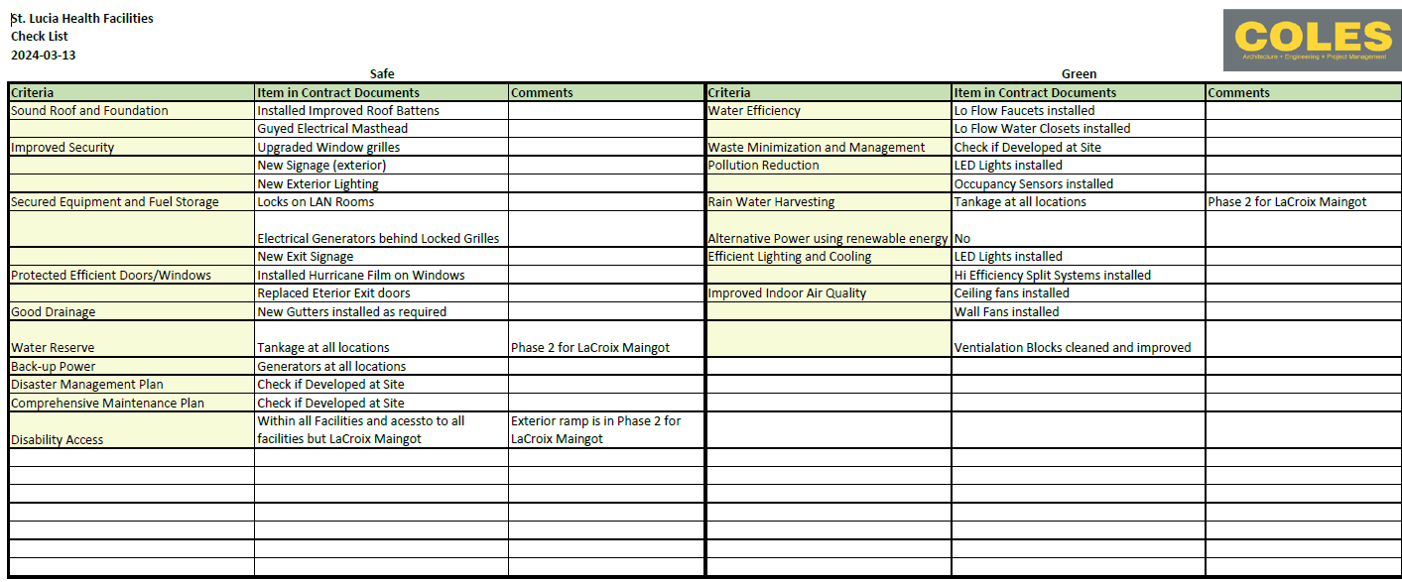

https://documents1.worldbank.org/curated/en/157871484635724258/pdf/112110-WP-Final-General-EHS-Guidelines.pdf
https://documents1.worldbank.org/curated/en/118311496115696454/pdf/115328-WP-ENGLISH-Health-Care-Facilities-PUBLIC.pdf
The survivor-centred approach is based on a set of principles and skills designed to guide professionals—regardless of their role—in their engagement with survivors (predominantly women and girls but also men and boys) who have experienced sexual or other forms of violence. The survivor centred approach aims to create a supportive environment in which the survivor’s interests are respected and prioritized, and in which the survivor is treated with dignity and respect. The approach helps to promote the survivor’s recovery and ability to identify and express needs and wishes, as well as to reinforce the survivor’s capacity to make decisions about possible interventions.
Project actors are: (a) people employed or engaged directly by the Borrower (including the project proponent and the project implementing agencies) to work specifically in relation to the project (direct workers); (b) people employed or engaged through third parties (Project staff, subcontractors, brokers, agents or intermediaries) to perform work related to core functions of the project, regardless of location (contracted workers); (c) people employed or engaged by the Borrower’s primary suppliers (primary supply workers); and (d) people employed or engaged in providing community labour such as voluntary services or participation in project activities and processes (community workers).

