

Government of Saint Lucia

Department of Health and Wellness


Disaster Vulnerability Reduction Project
(DVRP)

TERMS OF REFERENCE

FOR CONSULTING SERVICES
ENHANCEMENT OF SAINT LUCIA’S ENVIRONMENTAL HEALTH INFORMATION SYSTEM (EHIS)
Phase 2: Optimal System Design and Module Requirements for the EHIS

June 18, 2020
Terms of Reference

ENHANCEMENT OF SAINT LUCIA’S ENVIRONMENTAL HEALTH INFORMATION SYSTEM (ESHIS): Phase 2: Optimal System Design and Module Requirements for the EHIS

1.0 Background

Saint Lucia is a Small Island Developing State (SIDS) which faces many development challenges that include limited geographic space; an open, vulnerable economy; fragile ecosystems; limited human and institutional capacity; and vulnerability to natural phenomena, such as extreme weather, epidemics and pandemics. The onset of climate change has increased the frequency with which hydrometeorological climatic events occur with two extreme events (Hurricane Tomas, October 2010, and the Christmas Eve Trough, December 2013) striking the island within the last ten years and has also increased certain health threats.

Saint Lucia developed a Strategic Programme for Climate Resilience (SPCR), funded by the Pilot Programme for Climate Resilience (PPCR), which is currently being implemented. Saint Lucia’s strategic programme areas are closely interwoven with the broader fabric of disaster risk reduction (DRR). Thus, co-financing under the PPCR is being achieved through a synergistic blend, with financial resources made available under the national and regional components of the Disaster Vulnerability Reduction Project (DVRP) which allows for up-scaling SPCR implementation activities. Two major outcomes expected from Saint Lucia’s DVRP include: 1) capacity built to identify and monitor climate risk at the national level; and, 2) reduced vulnerability of key sectors, assets and people to natural disasters.

The Department of Economic Development, Transport and Civil Aviation is responsible for the implementation of the DVRP while the Department of Sustainable Development and the Department of Infrastructure, Ports and Energy (DIPE) provide technical support towards implementation of the Project. The Project Coordination Unit (PCU) is responsible for the fiduciary aspects of the Project.

Context

There is a well-established link between changing climate variables, including temperature, rainfall patterns and dust clouds, and health impacts. For instance, in the Caribbean there have been observed increases in the incidence of childhood asthma rates and certain vector and water-borne diseases such as dengue fever and leptospirosis. There is evidence that changing weather patterns have shortened the breeding cycles of mosquitos and lengthened the transmission seasons of diseases such as dengue, zika and chikungunya, causing the control and management of these to be extremely challenging for the health system. Studies also suggest that climate change poses great danger for the evolution of novel viruses that could compromise vaccination programmes and jeopardize public health. Furthermore, climate change also affects social and environmental determinants of health, such as access to safe drinking water, nutritious food production and safe shelter.

Better understanding these connections and developing adaptive measures, including to protect the population from epidemics and pandemics, requires robust databases and surveillance and information systems that can be queried and subjected to statistical, geospatial and epidemiological analysis.

The Department of Health’s Health Management Information Management Unit (HMIU) has developed a national health information system, the Saint Lucia Health Information System (SLUHIS), which is used across the Saint Lucia Public Health Service. Separate from the SLUHIS, the HMIU also maintains a system for the Environmental Health Division - the Environmental Health Information System (EHIS).

The EHIS is intended to capture data on all aspects of the environment that may affect human health, in line with the programmatic areas of the country’s environmental health system, including the:
- Food Safety Programme,
- Water Quality, Institutional Hygiene and Disaster Management Programme,
- Vector Control Programme,
- Port Health Surveillance Programme and
- Wastewater and Complaints Programme

Under the 10th European Development Fund (EDF), GFA Consulting Group GmbH was contracted to provide assistance with the development of what is now the Environmental Health Information System (EHIS) using the District Health Information Software (DHIS2) package.

Under that project, the following EHIS modules and functionality were completed:

Food Safety Module
- Registration of Food Establishments
  - Applications
  - Inspections
  - Issuance of Licenses
  - Scheduling of Inspections

- Registration of Slaughterhouses
  - Applications
  - Inspections
  - Issuance of Licenses
  - Scheduling of Inspections

- Recording of Escalations and Outcomes of non-compliance by Food Establishments and Slaughterhouses to Public Health Board
- Recording of Penalties to Food Establishments and Slaughterhouses
- Recording of Food Condemnation
- Registration of Food Handlers
- Recording of Issuance of Licenses to Food Handlers
- Recording of Mass Events
  - Applications
  - Approvals
  - Onsite Monitoring
  - Concessionaires

Water Quality Module
- Registration of Swimming Pools
  - Applications
  - Inspections
  - Issuance of Licenses
  - Escalations to Public Health Board
  - Penalties
  - Scheduling of Inspections

- Registration of Wastewater Treatment Plants
  - Applications
  - Inspections
  - Issuance of Licenses
  - Escalations to Public Health Board
  - Penalties
  - Scheduling of Inspections

- Registration of Water Bottling Plants
  - Applications
  - Inspections
  - Issuance of Licenses
  - Escalations to Public Health Board
  - Penalties
  - Scheduling of Inspections

- Registration of Water Truck Receptacles
  - Applications
  - Inspections
  - Escalations to Public Health Board
  - Penalties
  - Scheduling of Inspections

Following the completion of the project under the 10th EDF, in 2017 draft requirements (as contained in Appendix 1) were developed by the HMIU for the following additional modules of the EHIS which were never developed due to limited in-house capacity in the DHIS2 platform:

- Vector Control Module
- Port Health Surveillance Module
- Complaints Management Module

Since the initial development of the EHIS and the subsequent development of requirements for additional modules there have been amendments to the Public Health Act which have resulted in changes to the institutional framework of the primary users of the EHIS and expanded environmental health programme areas. For instance, surveillance and monitoring is now required for beauty and wellness establishments as well as offensive trades (e.g. car garages, carpentry shops etc.) and sewage trucks must be licensed.

These changes have triggered the need for a comprehensive review of the design of the EHIS (existing and proposed modules) to ensure it best supports the requirements of the revised institutional framework and programmatic areas.

In addition, the need for the following enhancements to the EHIS have been recognized:

- Integration of the EHIS and SLUHIS to facilitate sharing of relevant data between the two systems
- Standardization of shared data fields and determination of common identification fields to facilitate linkages between the EHIS and other information systems or databases (for example the Advanced Passenger Tracking Programme) managed by external agencies such as the Immigration Department, Customs and Excise Department, the Saint Lucia Air and Seaports Authority (SLASPA) and the Saint Lucia Meteorological Services that are critical for tracking and analyzing infectious diseases and vector borne diseases and for maintaining port health
- Enhancement of user friendliness and workflow in specific areas (to be identified by the Client)
- Enhancement of the design and functionality of the existing and proposed modules to better support statistical analysis as well as Geographic Information Systems (GIS) geospatial and epidemiological analyses, including consideration of how climate variables influence disease and environmental health risks.

As such, the Government of Saint Lucia (GoSL) seeks a qualified consulting firm to build upon previous work and enhance the EHIS in keeping with the needs identified above.

This Phase 2 Consultancy complements work under a separate Phase 1 consultancy to enhance Saint Lucia’s EHIS which covers:
- Debugging the existing Food Safety and Water Quality modules, and
- Integrating the full DHIS2 COVID-19 Surveillance Digital Data Package into the existing EHIS to support Saint Lucia’s national response to the COVID-19 pandemic.

2.0 Overall Objective

The overall objective of this consultancy is to develop the optimal system design and write the requirements for all system modules to guide the future development of Saint Lucia’s Environmental Health Information System (EHIS) in a manner that conforms to the current legislative and institutional environment, facilitates data sharing and better supports statistical, geospatial and epidemiological analyses.

3.0 Scope of Services

In general, the scope of services includes:

- conducting a comprehensive assessment of the needs of the EHIS in order to:
- fully support the expanded environmental health programmatic areas based on the new Public Health Act,
- integrate the EHIS and SLUHIS to facilitate data sharing,
- facilitate linkages between the EHIS and information systems/databases managed by external agencies and,
- increase user friendliness and
- better support statistical, geospatial and epidemiological analyses

- assessing identified needs against the existing and proposed EHIS modules, and based on this assessment, developing the optimal system design for the EHIS and a full set of requirements for all system modules defined to meet the needs.

Specific Tasks

Task 1 – Conduct a Comprehensive Assessment of the Needs of the EHIS

The Consultant shall conduct a comprehensive assessment of the needs of the EHIS through a combination of a desk top review and an Inception Mission, including a series of stakeholder consultations, interviews and one-on-one agency meetings/interactions as agreed between the Consultant and the Client. If travel restrictions due to COVID-19 prevent an in-country Inception Mission, the consultations, interviews and meetings/interactions can be convened virtually.

In keeping with the need for certain enhancements to the EHIS, as identified in the background section of these Terms of Reference, the assessment shall involve:

- review of the current legislative and institutional framework for environmental health as the basis for understanding the needs of the EHIS
- an assessment of the business objectives, processes, and standard operating procedures of the primary EHIS users as it relates to the use and sustainability of the EHIS
- review of the existing EHIS, including developed modules and draft requirements for some proposed modules (as contained in Appendix 1)
- determination of the data sharing needs between the EHIS and SLUHIS in consultation with the Health Management Information Unit (HMIU), the Division of Environmental Health, Epidemiology Unit and any other stakeholders identified by the Client
- determination of the data sharing needs between the EHIS and information systems/databases managed by external agencies such as the Immigration Department, Customs and Excise Department, the Saint Lucia Air and Seaports Authority (SLASPA) and the Saint Lucia Meteorological Services that are critical for tracking and analyzing infectious diseases and vector borne diseases and for maintaining port health. The determination will be made through consultation with all relevant agencies,
- identification of the Client’s desires for enhancement of user friendliness and workflow in specific areas, and
- identification of system design features and functionality needed to better support statistical, geospatial and epidemiological analyses based on user needs identified during consultations.

The results of the assessment shall be presented in an EHIS Needs Assessment Report.

Task 2 - Develop the Optimal System Design for the EHIS and a Complete Set of Requirements for System Modules

Based on the assessment in Task 1 and in consultation with the Health Management Information Unit (HMIU), the Division of Environmental Health, Epidemiology Unit, Saint Lucia Bureau of Standards, Ministry of Tourism, Saint Lucia Solid Waste Management Authority and other identified stakeholders, the Consultant shall develop the optimal system design for the EHIS and a complete set of requirements for all modules defined within the system to fully meet the needs of the EHIS.

In developing the optimal system design and complete set of requirements, the Consultant shall be sure to meet the needs for enhancement of the EHIS as identified in the Background section of these Terms of Reference. The Consultant shall also ensure that the system is designed to best support the following business cases and any others identified by the assessment during Task 1:

- Support the Ministry’s One Patient One Record Policy;
- Integration of hydrometeorological data with the vector control module to facilitate epidemiological analyses, models and projections;
- Notification of clusters of reported vector-borne diseases;
- Enhanced ability to track relation between vector control measures and health outcomes and side effects – example use of chemical control measures, such as fogging, and reduced adult mosquito populations versus side effects such as asthma, COPD and cancers;
- Integration of climate-based analyses with health-related data - example exploring linkages between respiratory health cases and the Sahara Dust;
- Notification and alert system for when persons who have been certified as food handlers or other regulated professionals have been referred to or presented at a medical clinic and diagnosed with any work-related condition that may pose a public health concern;
- Quick and accurate identification of food service personnel in the medical system through support of the One Patient One Record Policy;
- Verification that a food handlers’ semi-annual medical examination was conducted by a licensed/registered medical practitioner as per legal requirement

In respect of integration of the EHIS with the SLUHIS, integration will retain both systems but will allow data and information to be shared/exchanged between the systems seamlessly. As such, the Consultant shall:
- Assess the EHIS and the SLUHIS for their capability to communicate with external systems
- Determine and define the best communication protocols to be used between the two systems

The optimal system design and requirements for the EHIS shall be presented in a System Design Report, including:
- a summary of the existing EHIS and its needs in order to meet present user requirements,
- a description of the proposed optimal system design for the EHIS, including its various modules and how they interrelate,
- a detailed mapping of the proposed optimal design and modifications of the EHIS,
- requirements for all system modules following a template/format agreed with the Client, and
- a discussion of how the proposed EHIS design and module requirements are best suited to meet the needed enhancements to the EHIS as set out in Background section of these Terms of Reference and the businesses cases determined.

Task 3 – Final Reporting

The Consultant shall submit a Final Report summarizing outcomes of the consultancy (including trainings), discussing implementation challenges and providing recommendations for next steps.

4.0 Deliverables

# | Deliverable | Timeline  (from start of contract)
Task 1
1 | EHIS Needs Assessment Report | Month 2.5
Task 2
2 | EHIS System Design Report | Month 7
Task 3
3 | Final Report | Month 8.5

5.0 REPORTING

All reports and other deliverables shall be submitted electronically in English in Microsoft Word, PDF or other relevant formats. Client comments on each deliverable should be submitted to the Consultant within two weeks of submission of each deliverable. The final version of each deliverable addressing Client comments must be submitted.

In addition to electronic copies, two (2) printed copies of each final approved report shall be submitted. All reports, documents and data collected relevant to the Consultant’s services shall become the property of the Government of Saint Lucia.

6.0 Working Arrangements and Logistics

The Client is the Department of Economic Development, Transport and Civil Aviation (DEDTCA) with the Department of Health and Wellness’ Health Management Information Unit (HMIU) serving as the Client’s representative. In its role, the HMIU will:

- Ensure timely review of reports submitted by the Consultant and facilitate the provision of feedback within two weeks of receipt of reports, unless otherwise agreed

- Initiate the consultation and cooperation of other agencies required to provide support to the Consultant for realization of the relevant aspects of the assignment

- Facilitate access to the existing EHIS and all relevant documents in a timely manner to facilitate the Comprehensive Assessment of the Needs of the EHIS

The Consultant will:
- Execute the tasks outlined in Section 3 above with due diligence and efficiency and in accordance with the highest standards of professional competence, ethics and integrity.
- Be responsible for the collection and analysis of all data and information required for the timely completion of the assignment.

- Submit reports and other deliverables within the timeframes stipulated in these Terms of Reference

- Submit all underlying datasets and source files used in the consultancy in agreed formats

- Be responsible for the provision of software, equipment, materials and transportation required to undertake the consultancy

- Execute the services in accordance with the laws, customs and practices of Saint Lucia and use the appropriate international/regional standards for preparation of technical information.

6.0 DURATION

The consultancy shall be conducted over a period not more than 9.5 months (41 weeks). The person-months for the team of experts is expected to not exceed 4.5 person-months.

- Qualifications

In general, the consulting firm must have:

- At least 10 years of experience in software engineering for health applications

- Successfully completed at least one similar assignment during the past 10-15 years; that is development of requirements for an Environmental Health Information System using the DHIS2 platform

The consulting firm must provide a team of experts with the skills mix required to fulfill the scope of services presented above. All experts must have:

  - the ability to work effectively and efficiently in a team
  - strong time management skills and demonstrated ability to meet project deadlines
  - excellent analytical skills
  - excellent verbal and written communication skills in English
  - excellent work ethic, including being self-driven, innovative, resourceful and having a high level of integrity

The team of experts must at a minimum include the following Key Experts:

Health Sector Business Analyst

The Health Sector Business Analyst shall be responsible for leading the Comprehensive Assessment of the Needs of the EHIS with technical support from the Software Engineer. The Health Sector Business Analyst shall also lead the development of the optimal system design for the EHIS and a complete set of requirements for system modules working collaboratively with the Software Engineer.

The Health Sector Business Analyst must have the following minimum qualifications:

Academic
- At least a bachelor’s degree in Public Health, Environmental Health or a related field, and
- Professional qualification in Business Analysis or Information Science

Experience and Skills
- At least 10 years of experience as a Business Analyst in the health sector is required
- Demonstrated knowledge in the Environmental Health field is required
- At least 5 years of experience in developing information systems to support improved Environmental Health data management and operations is required
- Successful completion of a similar assignment during the past 10-15 years, that is development of an Environmental Health Information System, is desired
- Proven record of writing analytical and technical reports, including normative documents and standards in the field of health informatization. At least one reference document is required;
- Proficiency in advanced research methodologies is required
- Strong analytical and problem-solving skills is required
- Familiarity with the DHIS2 platform is considered a benefit

Software Engineer

The Software Engineer shall be responsible for providing technical support to the Comprehensive Assessment of the Needs of the EHIS as needed and shall work collaboratively with the Health Sector Business Analyst to develop the optimal system design for the EHIS and a complete set of requirements for system modules.

The Software Engineer must have the following minimum qualifications:

Academic
- Bachelor's degree in Information Systems or Software Engineering; a Post-graduate degree would be considered an advantage;

Experience and Skills

General professional experience:
- At least 10 years of experience in the field of information technologies;
- At least 5 years of experience in e-Health data analytics systems development, design and implementation;
- At least 3 years of experience in business process reengineering

Specific professional experience:
- Experience in functional review/systems analysis and development of the requirements of integrated health information systems
- Proven record of writing analytical and technical reports;
- Fluency in English

Specific technical experience:
- Experience in the following is required:
  - DHIS2 platform
  - Java development (Java/J2EE)
  - Javascript frameworks (any of React, Angular, Prototype or similar).
  - Java enterprise frameworks such as Spring and Hibernate
  - Web and mobile technologies (PHP, HTML5, CSS, Servlets, JSP, jQuery,)
  - Design and development of Web APIs, in particular REST Web APIs and JSON
  - Open source development IDEs such as Eclipse
  - Advanced relational database design, management and configuration. Experience in PostgreSQL would be an advantage
  - Data replication techniques using database management systems;
  - SQL and ORM tools (Hibernate)
  - Linux, UNIX and Scripting
  - Service-oriented architecture services (SOA), event-driven architecture, Web services and other integration techniques
  - a unified language (Unified Modeling Language), the business process model and notation (BPMN);
  - Test-driven development with mock objects / unit tests or other testing framework;
  - Reporting engines such as BIRT, Jasper Reports or Crystal;
  - Implementing HL7 data exchange protocols.

APPENDIX I
Draft Requirements for the Vector Control, Port Health and Complaints Management Modules of the Environmental Health Information System

NHMIS Unit
Functional Specification Document
Version 1.2
Draft

Public Health - Port Health

Author
Last change: | 25 March 2020
Status: | Draft
Version: | 1.2

Document approved by:

Name | Signature | Role
 |  | Project Manager

Version history

Date | Version | Change description | Author
11.08.2016 | 1.0 | Initial version of the document prepared by HMIS team | Kevin Harris
12.09.2016 | 1.1 | General changes after EH review | Kevin Harris
20.04.2017 | 1.2 | Reformating of the document to the standard | Hynek Kruzik

Introduction

Environmental Health is part of the Public Health Module and as such is concerned with all aspects of the environment that may affect human health. Environmental Health, as it is captured by the National Health Information System of Saint Lucia has both a patient-related and non-patient-related component. The Department is made up of five (5) units, namely:

- Food Safety,
- Institutional Hygiene and Complaint,
- Water and Waste Management,
- Port Health,
- Vector Control.

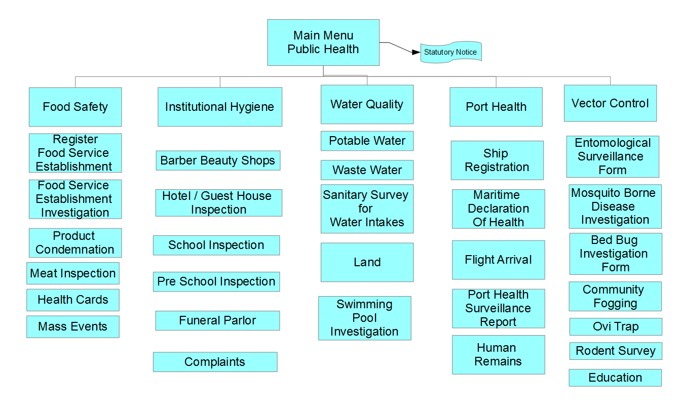
Figure 1 - Environmental Health Process Break-down Structure

Scope of the document

This document describes functional specification of the Public Health module in the area of the Port Health.

Port Health Unit

The Port Health Unit is responsible for the registration and inspection of all vessels entering St. Lucia via any of the ports. They are also responsible for monitoring that these vessels are sanitized and ensuring that persons entering the country are screened and are not carriers of any known disease which are concern for public health. They are also mandated to ensure that any waste or recycled goods being taken off these vessels follow regulations. Main activities (processes) of the Port Health Unit are sketched in the Figure 2.

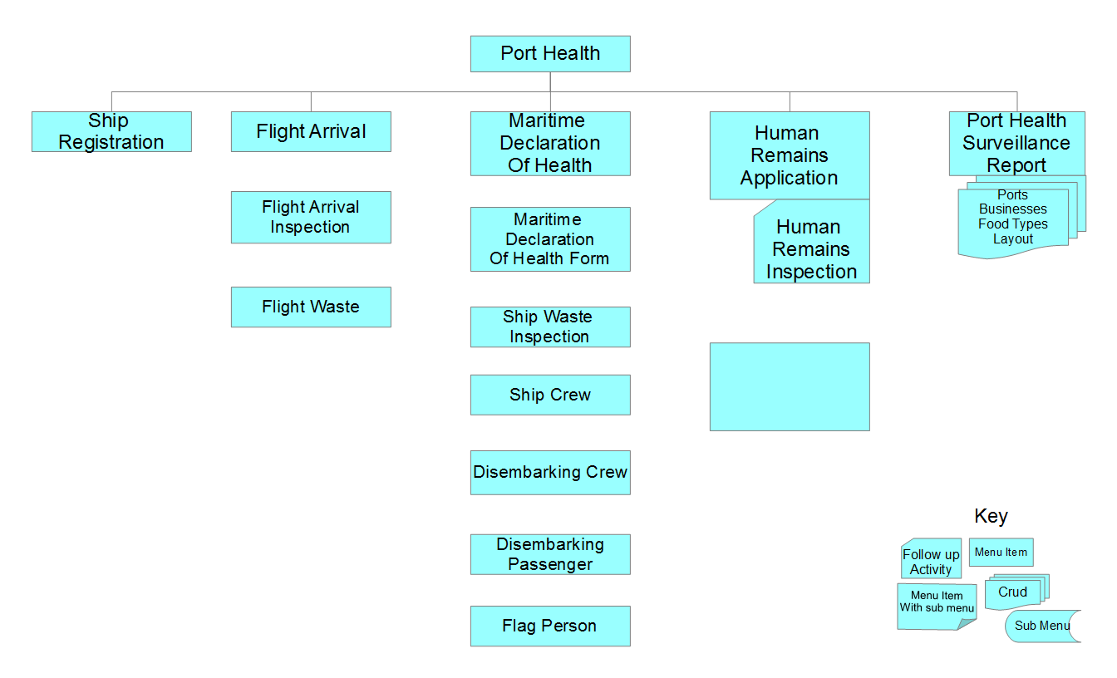
Figure 2 – Port Health Process Break Down Structure

Port Health Tasks

Ship/Craft Registration

Every ship/vessel coming to St. Lucia must be inspected. To facilitate an efficient inspection procedure, registration of each ship is necessary. It is not efficient nor necessary to register aircraft at this time as the physical aircraft changes very often and would mean that for a particular flight number a new registration of an aircraft would need to be done every time and that physical aircraft may never return to the island.

The following details are needed for a ship registration:

- Ship name
- Ship type (Cruise, yacht, Cargo){list should be user configurable}
- I.M.O. Number
- Ship registration date
- Port of registration
- Overall length(m)
- Beam
- Breath moulded
- Gross tonnage
- Owner/operator
- Agent

Maritime Declaration of Health

Every ship making a call to port must present a “Maritime Declaration of Health” which is a standard form used internationally and filled by the arriving ship. The system should record the following as outlined in figure 3.

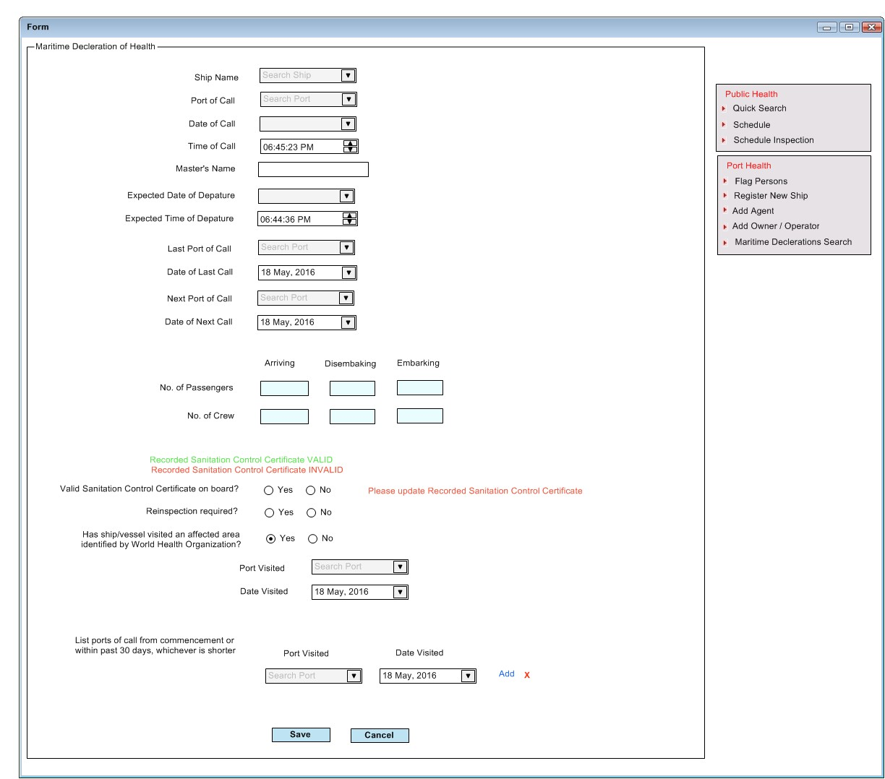
Figure 3 – Maritime Declaration of Health Form
The second part of the form consists of a series of health questions which have to be answered. If the answer to any of the questions is yes, then the particulars are recorded on a separate form for each passenger or crew member affected. See figures 4 & 5

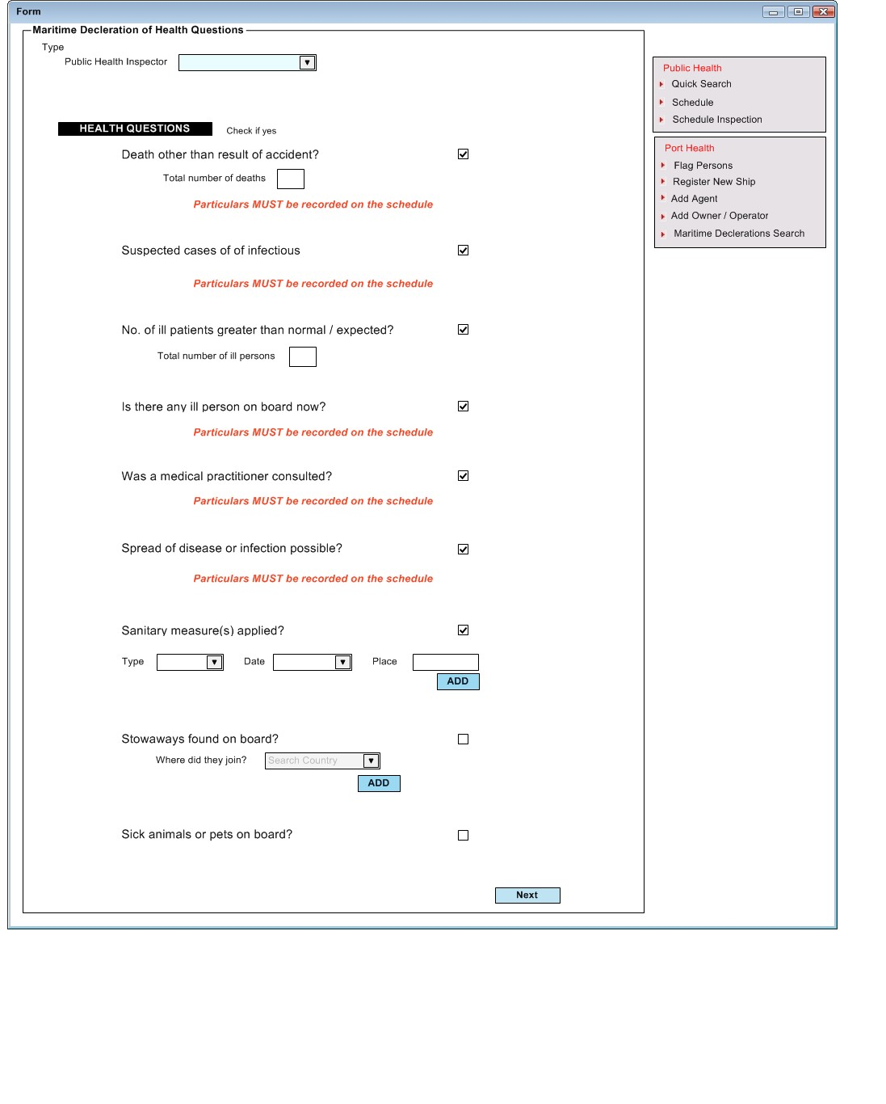
Figure 4– Maritime Declaration of Health Questions

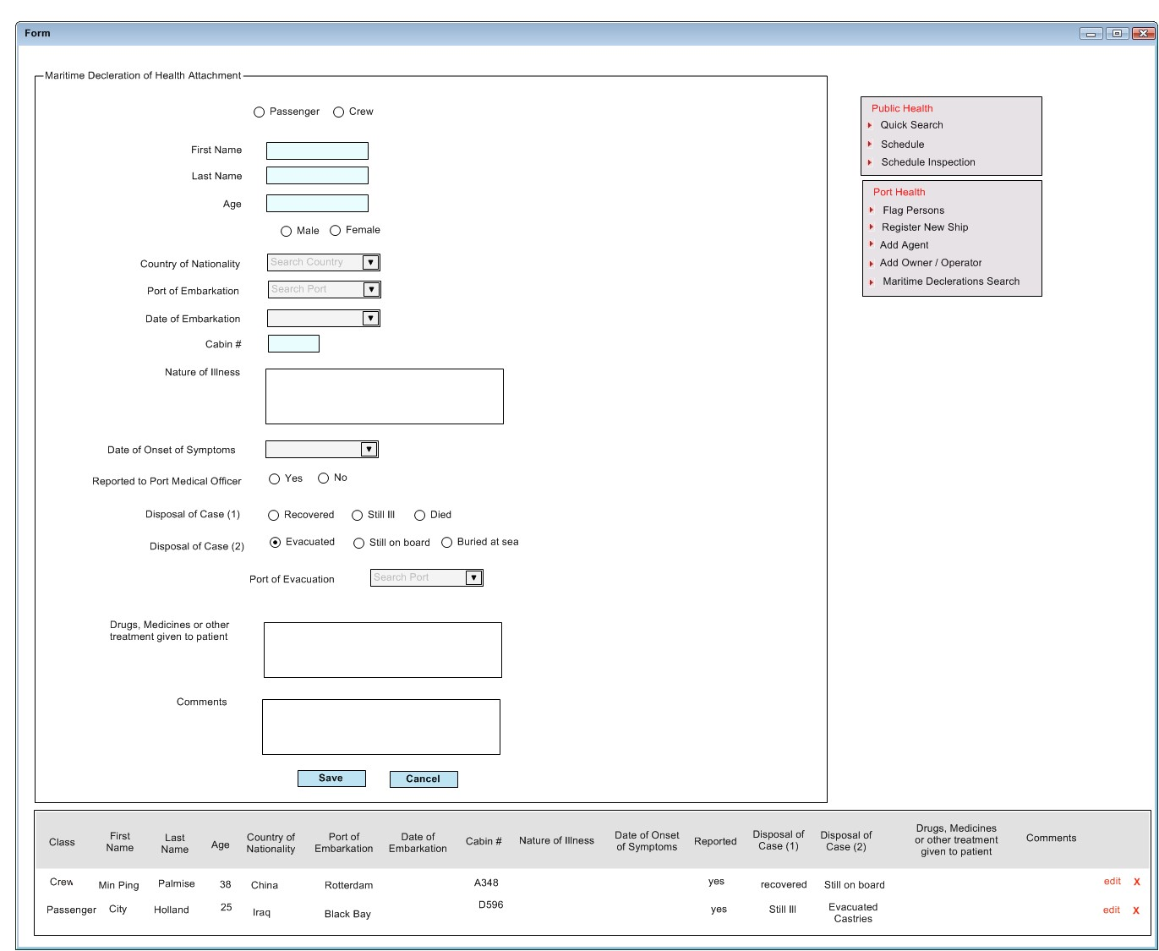
Figure 5– Maritime Declaration of Health Questions Attachment

Immunization Records

Every passenger and crew member must be vaccinated against any pre determined illness before he/she can disembark. Any person not vaccinated can obtain a vaccination in St. Lucia. A record is taken for each nationality on the ship of the persons’ vaccination status. The system should record the following as outlined in figure 6
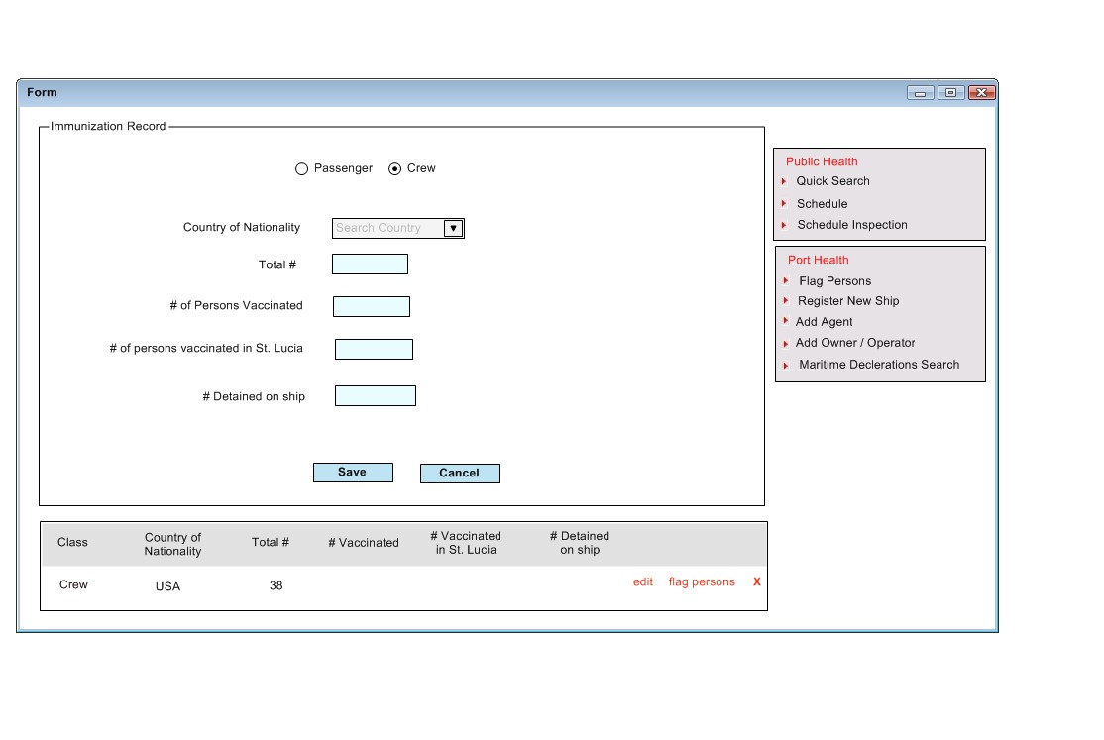
Figure 6– Immunization Record

Disembarking Passengers & Crew

All persons who are disembarking the vessel and will not be returning, has to be identified and their details recorded as follows:

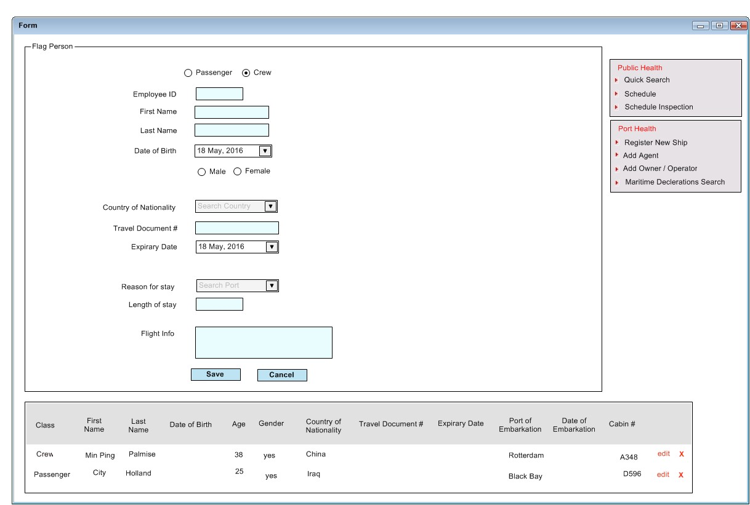

Ship Waste Inspection

Any waste being disposed of by any vessel must be declared and approved by the solid waste management authority. The Environmental Health Department is responsible for ensuring that items intended for recycling, disposal or that are donations, are recorded and any restricted item or items are flagged. Information collected is as follows:

- Quantity (in pallets)
- Item Type (e.g. scrap metal, plastic, tin can) {list should be user configurable}
- The local contractor who receives the goods {list should be user configurable}
- The Quantity approved
- The quantity rejected
- The quantity restricted

Human Remains

Any human remains being imported must be recorded and examined by a port health officer. After a successful examination the remains are approved and released to a registered funeral home or other responsible party (such as medical schools). The following details need to be recorded for any deceased person being brought into St. Lucia:

- Name of Port Health Inspector
- Date of arrival of remains
- Date of examination of remains
- First Name of the deceased
- Last Name of the deceased
- Gender of the deceased
- Port of origin
- Port of arrival
- Ship/aircraft number
- Funeral home or entity consigned to
- Proposed internment date
- Approved (yes, no)
- Any other notes necessary

Vessel Sanitation Inspection

All ships must carry a valid “Sanitation Control Exemption Certificate”. At present St. Lucia has submitted an application to become one of the authorized ports to conduct the licensing inspection and issue the certificate. As a consequence, the system will need to record the following as indicated in the screen shot below.

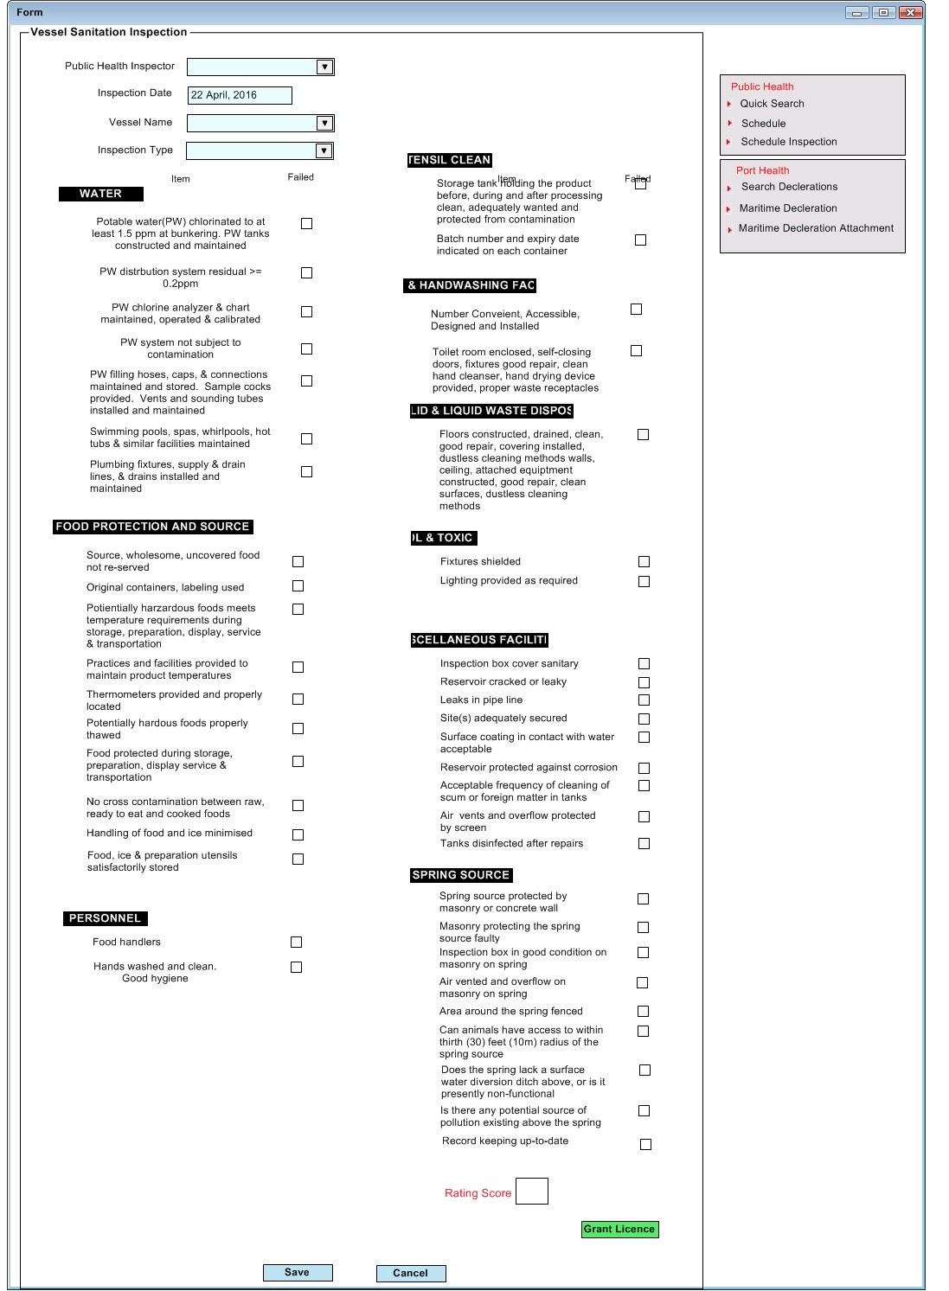

NHMIS Unit

Version 1.2
Draft

Public Health -Vector Control

Author | K. Harris
Last change: | 1 November 2016
Status: | DraftUser Field Status =
Version: | 1.2

Document approved by:

Name | Signature | Role
 |  | Project Manager

Version history

Date | Version | Change description | Author
29.7.2016 | 1.0 | Initial version of the document prepared by HMIS team | Kevin Harris
12.09.2016 | 1.1 | Minor changes after review by EH. | Kevin Harris
16.09.2016 | 1.2 | Document review, comments added. | Hynek Kruzik

- Contents
1 Introduction 3
1.1 Scope of the document 3
1.2 Vector Control Unit 4
2 Description of the Vector Control Process 5
2.1 Entomological Surveillance 5
2.2 Community Fogging 6
2.3 Bedbug Investigations 6
2.4 Vector Borne Case Investigations 7
2.5 Ovi-Trapping 8
2.6 Rodent Survey 9
2.7 Community Education 11

Introduction

Environmental Health is part of the Public Health Module and as such is concerned with all aspects of the environment that may affect human health. Environmental Health, as it is captured by the National Health Information System of Saint Lucia has both a patient-related and non-patient-related component. The Department is made up of five (5) units, namely:
- Food Safety,
- Occupational Hygiene and Complaint,
- Water and Waste Management,
- Port Health,
- Vector Control.

Figure 1 - Environmental Health Process Break-down Structure

Scope of the document

This document describes functional specification of the Public Health module in the area of the Vector Control.

Vector Control Unit

The Vector Control Unit’s responsibilities/activities are:

- Routine Entomological Surveillance
  - Community Education
  - Fogging
- Routine Ovi-Trapping
- Routine Rodent Surveillance
- Attend to Reported Complaints
  - Complaints of
    - Bedbugs
    - Mosquitos
    - Termites
    - Ants
    - Flies
    - Rodents
  - Treatment
    - Spraying
    - Baiting

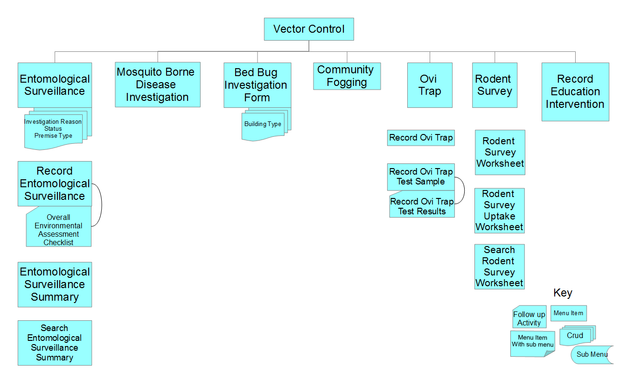
Figure 2 – Vector Control Structure Break Down

Description of the Vector Control Process

Entomological Surveillance

For entomological surveillance officers conduct daily assessment and treatment of containers which are potential breeding areas for vectors. The system should capture and store for each survey:

- Locality (Community)
- Zone – outside cities
- Block – most probably refers to cities only
- The Name of the officer
- Date of survey
- Where the survey took place i.e. community
- The type of premise inspected
  - Public
  - Private
- Reason for survey
  - routine,
  - outbreak investigation etc.
- If the premises were closed (i.e. fenced)
- Types of containers found (list should be multi select and user configurable)
  - drums,
  - tank,
  - tyre,
  - plant in water
- For each container type if it is positive. (If there was mosquito breeding found the premise is a positive)
- Record a count of how many of each containers were found
- Record how many containers (I total or by type of the container) were treated
- What was found in the treated containers (list should be multi select and user configurable)
  - F.A.,
  - F.A.N.,
  - culex,
  - bactivec,
  - other
- If the containers were covered
- Record the status of a survey as complete or incomplete (a complete inspection means the officer was able to inspect around the property despite the fact that the home owner was not at home).

If possible the officer would also ask members of the household the following questions as part of their educational impact surveillance:

- Do you know any diseases spread by mosquitoes?
- Do you know where mosquitoes can breed in and around your home?
- Do you perform regular inspection for mosquito breeding sites in and around your home?

Entomological surveillance is scheduled and the system will need to allow scheduling of entomological surveillance.

Community Fogging

EH Officers conduct routine community fogging, but fogging may be triggered by an investigation or outbreak. The system should capture and store:

- The community where the fogging is taking place
- The reason for fogging (list should be user configurable)
  - routine,
  - case investigation
  - outbreak
- The type of fogging performed (list should be user configurable)
  - thermal fog
  - ultra-low volume
- The type of insecticide used
- The volume of insecticide used (units and amounts? Unit = liter)
- Start and End Date and time
- General Remarks

Fogging operations are scheduled and the system will need to allow scheduling of fogging operations.

Bedbug Investigations

Bedbug investigations are triggered from complaints. As a result, any inspection and treatment must be linked to the initiating complaint. Bedbugs is the term used but the investigation and treatment also includes flees and termites. For bedbug investigations the system should capture and store:

- Type of investigation
  - bedbug,
  - flee,
  - termite,
  - flies
- Type of premise (list should be user configurable)
  - Private household,
  - institution,
  - business,
  - school,
  - health facility,
  - library
- Address of premise (district, community, address line 1)
- Level of infestation (list should be user configurable)
  - heavy,
  - moderate,
  - light
- Indicator of infestation (list should be multi select and user configurable)
  - eggs,
  - egg shells
  - nymph skins,
  - odor,
  - excretion marks,
  - live bugs,
  - dead bugs,
  - presence of nymphs
- Room/area inspected (list should be multi select and user configurable)
  - bedroom,
  - kitchen,
  - living room,
  - classroom,
  - walls,
  - frames of furniture,
  - behind furniture
- Recommendation (spraying, cleaning, other[other should be free text)

Bedbug investigations operations are scheduled and the system will need to allow scheduling, treatment or re-inspections of Bedbug investigations.

Vector Borne Case Investigations

Vector borne case investigations are triggered from outbreaks and/or a confirmed or suspected vector-borne disease diagnosis. These investigations should be linked to other associated investigations such as entomological surveillance, rodent surveys and bedbug investigations. The system should capture and store:

- Investigation type
  - entomological surveillance,
  - rodent surveys and
  - bedbug investigations
- The disease being investigated (dengue, chikungunya, zika, other) (list should be user configurable)
- The case status (suspected or confirmed)
- Patient Name
- Patient ID (shared ID within healthcare)
- Address (district, community, address line 1)
- Breeding Site Status (active, potential)
- Type of mosquito (ades, culex or anopheles) – user configurable
- Development Stage (eggs, larvea, pupa or adults)
- Location
  - indoor and/or
  - outdoor
- Infestation Evidence
  - rodent droppings,
  - mousy smell,
  - rub marks,
  - presence of live or dead rats,
  - rodent entrances)
- Travel history (list of communities/countries frequently and/or recently visited and date of last visit)
- Individual health status (fully recovered, partly recovered, currently ill)
- Person(s) in close proximity who are ill (name and location)
- Remarks

Ovi-Trapping

Ovi-trapping is a process where traps are set at specific locations, as a means of collecting the eggs of vectors for analysis. Eggs are collected and when a total of 3000 eggs are collected, they are sent to a lab/agency for analysis and resistance testing. In the trap setting and collection phase the system should capture and store:

- The community where the trap is placed
- The officer setting the trap
- The Ovi-trap code – all traps used
- The specific location of the ovi-trap (GPS location if possible, as well as a written description of the location such as “on left side of mirror in master bedroom”)
- Type of eggs found
  - culex,
  - aedes aegypti,
  - other
- The number of eggs found for each type
- If the paddle was missing at the time of collection
- The status of the trap at the time of collection
  - missing,
  - broken,
  - tipped,
  - dry,
  - flooded
- The placement date
- The collection date
- The officer collecting the ovi-trap
- Remarks

The system should also display a running total for the number of eggs of each type collected.

At the test sample export stage, the system should record and allow to be printed on a label the following:
- Date sample sent
- Courier Service used
- Total number of eggs
- Egg type
- Package/tracking ID
- Name of agency/lab being sent to

When Test Results are returned the following is recorded:

- Sensitivity per stage
- Sample Development Stage (larval, Adult)
- Chemical Tested and whether there was resistance (list should user configurable)

Ovi-trapping and traps collecting are scheduled and the system will need to allow scheduling of Ovi-trapping operations.

Rodent Survey

A rodent survey involves two processes, the laying of the bait for which a record is kept and the filling of an uptake sheet when the site(s) is visited and results recorded. The location to be treated is divided into block and each block is assigned to an officer. The officer records for each block the following:

- Date
- Community
- Zone
- Block
- Name of the inspector making the initial survey
- Premises
  - Street/block
- Signs of rodent infestation (list should be multi select)
  - Burrows
  - Runways
  - Nests
  - Rub marks
  - Gnawing
  - Droppings,
  - Odor,
  - Live/dead rodents
- Harborages o (list should be multi select and user configurable)
  - Overgrown vegetation
  - Abandon buildings
  - Dumps of waste
- Feeding places (list should be multi select and user configurable)
  - unprotected food scraps/waste
  - warehouse
- Prevalence reported (mutliselect)
  - mice
  - rats
- Type of premise
  - residential,
  - commercial,
  - industrial,
  - vacant lot
- The exact location or point where the bait was laid
- Record total weight of the baits used in grams (for mice and rats).
- The weight of a block in grams of bait laid
- And the number of blocks of that weight laid.
- Rodent type bait (rat, mice)-multiselect
- Remarks

Indicators:
- Total premises inspected
- Total premises positive (based on Signs of rodent filed)
- Total rodenticide used
- Officer signature
- Supervisor signature

On return to the site the officer completes an uptake sheet and records the following for the respective block:

- Date
- Officer name (who returned to the site)
- The amount taken
- The amount replenished
- The number of dead rats/mice found
- The number of live rats/mice found
- Remarks

Rodent survey is scheduled and the system will need to allow scheduling of rodent surveillance operations.

Community Education

A simple capture form is required to record the following as part of records for community education:

- Date
- Who requested the intervention
- Institution
- Address
  - district,
  - community,
  - address line 1
- Description
- Activities conducted
- Indication of if any material was distributed
- Supervising Officer

NHMIS Unit

Version 1.11
Draft

Public Health – Complaints Management

Author | Denise Auguste
Last change: | 14 September 2016
Status: | DraftUser Field Status =
Version: | 1.1

Document approved by:

Name | Signature | Role
 |  | Project Manager

Version history

Date | Version | Change description | Author
11.08.2016 | 1.0 | Initial preparation of requirements by HMIS team | Denise Auguste
13.09.2016 | 1.1 | Updated after review from Environmental Health agent | Hynek Kruzik

Complaints Investigation
This unit is responsible for inspecting licensable establishments that are non-food establishments. These include barbershops, schools, apartments, funeral parlours etc. This unit is also responsible for investigating and/or referring complaints that are made to the department.

Complaints Investigation

This unit is responsible for investigating of complaints made to the Environmental health Department. A complaint can be received by phone, walk-in, notification from foreign agent etc. Every complaint made to the department must be investigated within 72 hours. Complaints may be forwarded to the relevant unit or a joint inspection with relevant unit may be carried out. For each complaint the unit records the following:
- Date
- Complainant Name
- Address of Complainant
- Address of nuisance
- Direction details
- Details of Complaint
- Receiving Officer
- Nature of complaint(see list below)
  - Waste water complaint
  - Deflective effluent systems(septic tanks or soakaways)
  - Animal rearing
  - Mosquito breeding
  - Offensive odour
  - Pest infestation
  - Mold infestation
  - Overgrown vegetation
  - Excreta disposal
  - Offensive trade
  - Fumes emissions(furniture/ vehicle spraying)
  - Charcoal making
  - Dead animals
  - Indiscriminate dumping
  - Noise
  - Indoor air quality
  - Rodent infestation
  - other

A complaint is investigated to determine whether it is a “public health” complaint or not. At the initial investigation by the officer the following is captured:
- Investigating officer
- Date
- Initial Findings
- Action Taken
- Reinspection
  - Reinspection date
  - Findings on Reinspection

On return to the office the officer prepares a report outlining the following:
See figure below:
- From
- To
- Date
- Complaint
- Date of Investigation
- Locality
- Direction details
- Complainant
- Findings
- Conclusion
- Recommendation

If the complaint is deemed a valid public health complaint, the officer assesses the nuisance to determine if further inspection is required. If warranted the officer will forward to relevant unit( food safety, vector control…. ) within the department in order for a more comprehensive inspection to be carried out. The officer also prepares a report of findings. The information in the findings will include a summary of inspection, regulation violated, test if any were carried out and recommendations made. An investigation will be closed once the issues raised are addressed and there is no longer a threat to public health. The officer must be able to track an investigation status even when it has been referred to another unit and must inform complainant of the status of the investigation. Statuses for investigation are:
- Notice served pending re inspection for compliance
- Investigation on hold pending test results to determine way forward
- Complaint referred to other agency
- Complaint forwarded to the Public Health Board for action as result of non-compliance

In some cases a follow-up inspection is schedule depending on the nature of the complaint/violation. The follow-up visit is a scheduled activity.

If the complaint is deemed a non-public health matter then it may forwarded to an external entity for action and the complainant informed

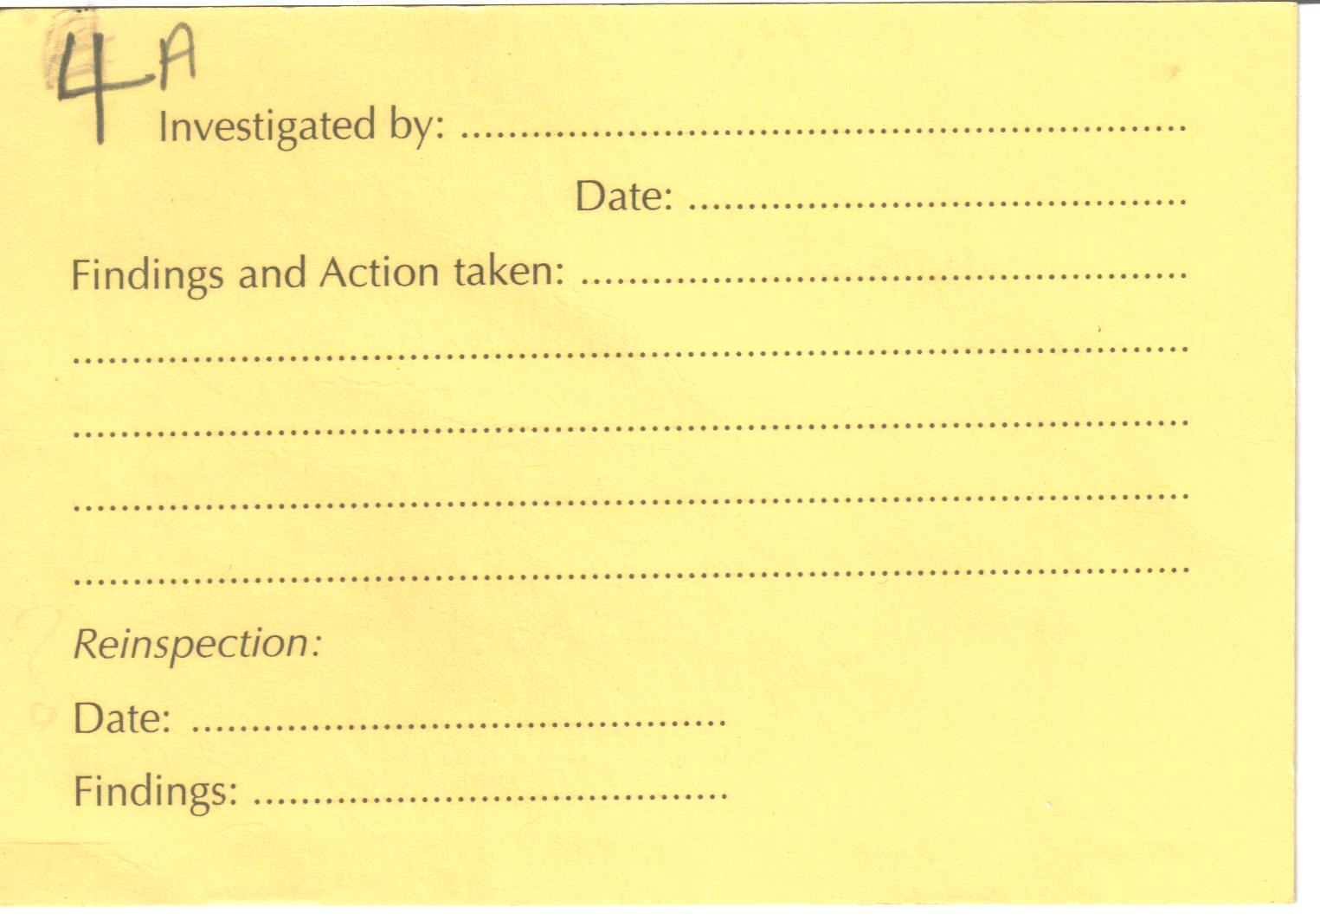
Figure 1- Complaint Form(front)

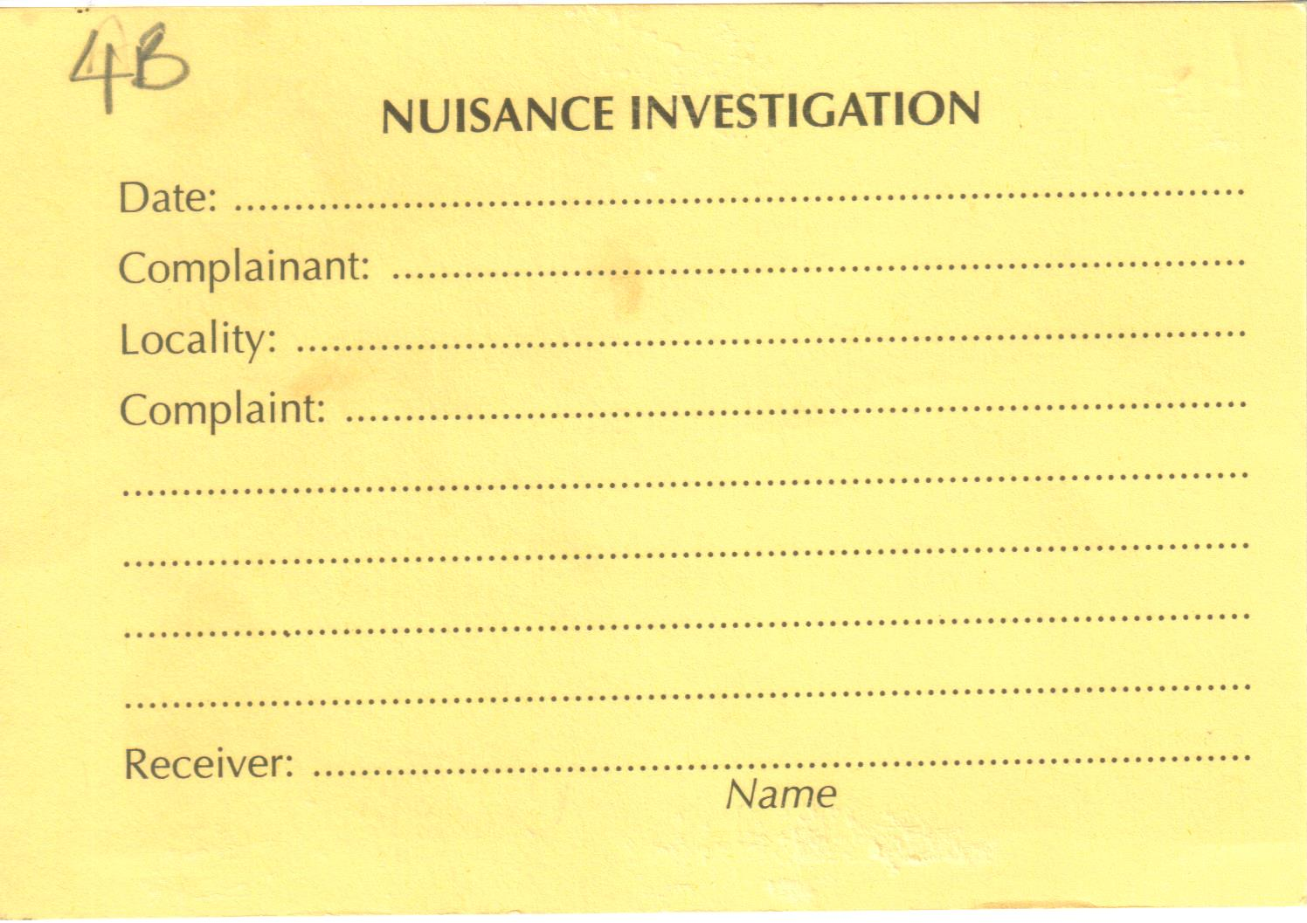
Figure 2-Complaint Form (Back)

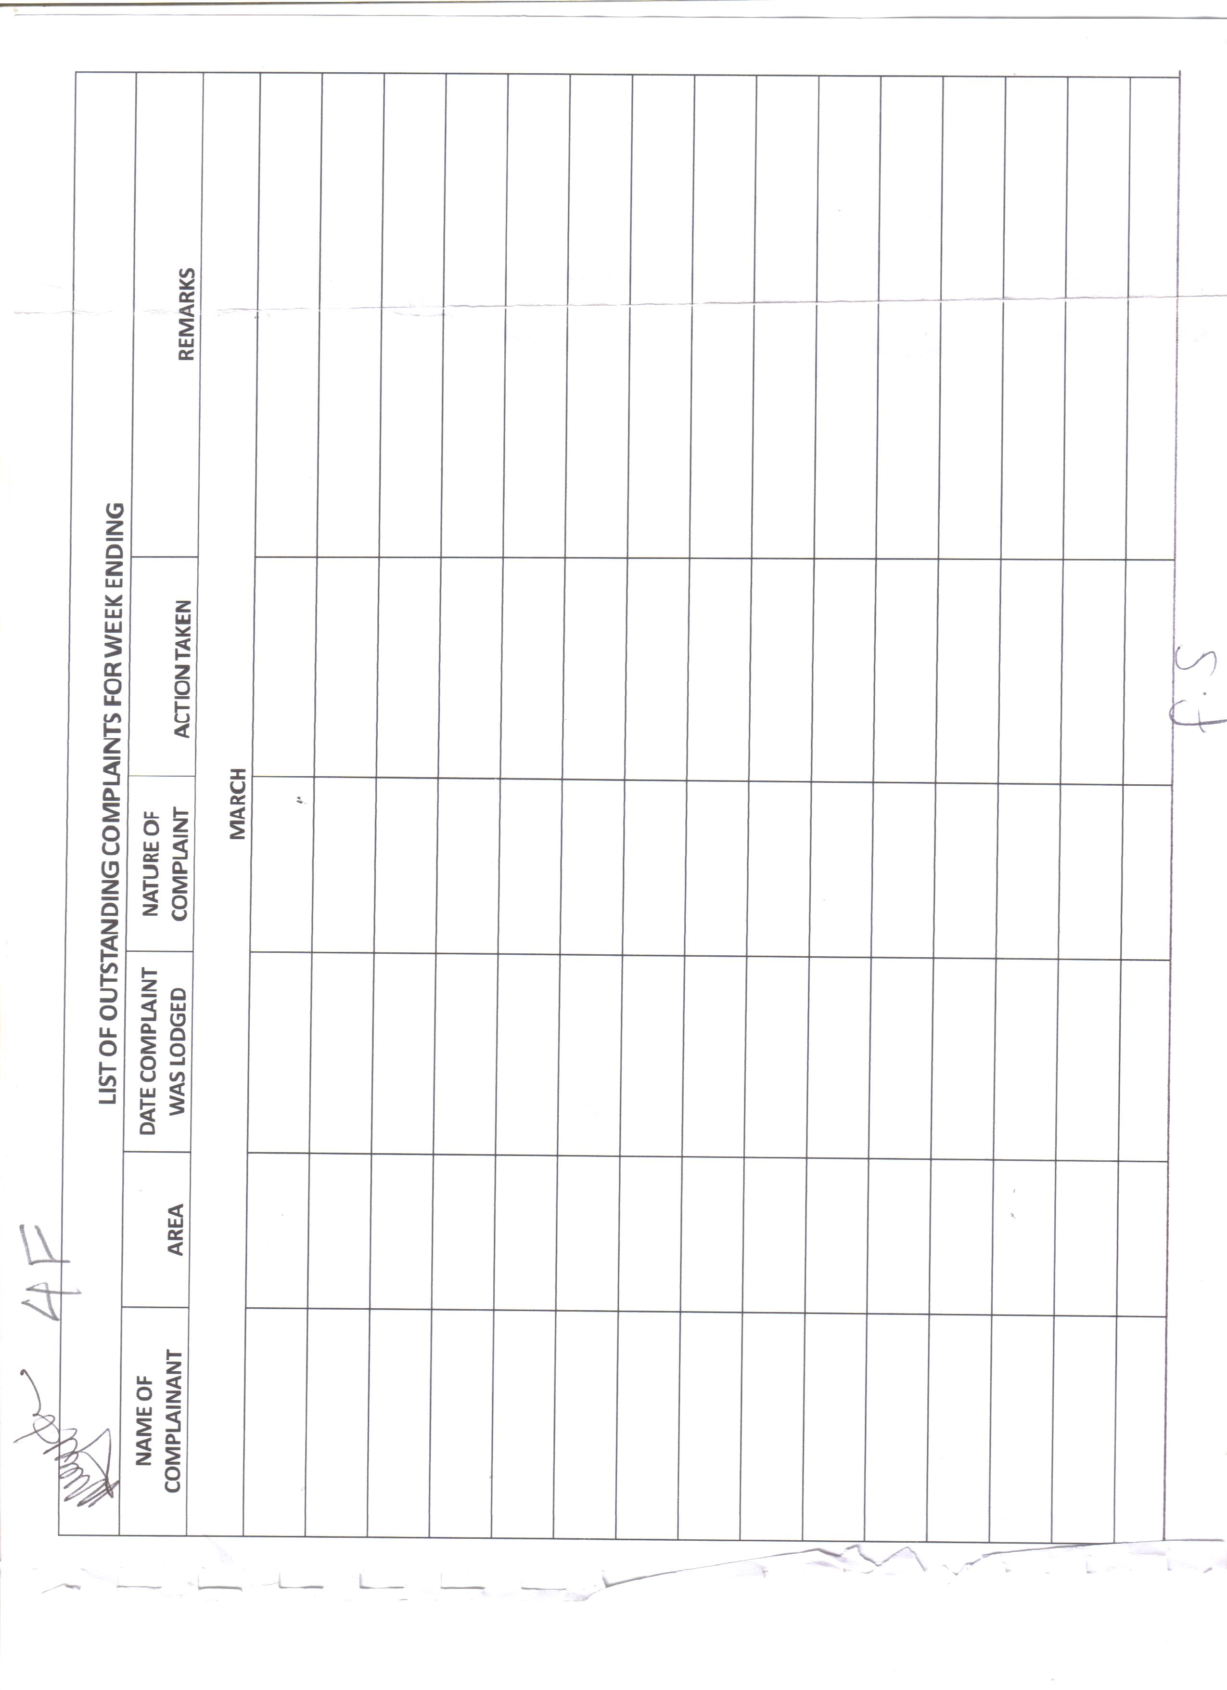figure 3- Complaint Weekly report

Intimation Notice

In events where a nuisance reported/investigated is in violation of the Public Health Act, if the owner of the property or dwelling is not present at the time of the inspection an intimation notice is left on the property informing the owner of findings and recommended action. On revisit the officer may leave another intimation notice for the owner if no action from the first recommendation is taken. The officer will note the number of notices left and the number of times he/she has visited the location. At any time the officer may choose to escalate for board action.

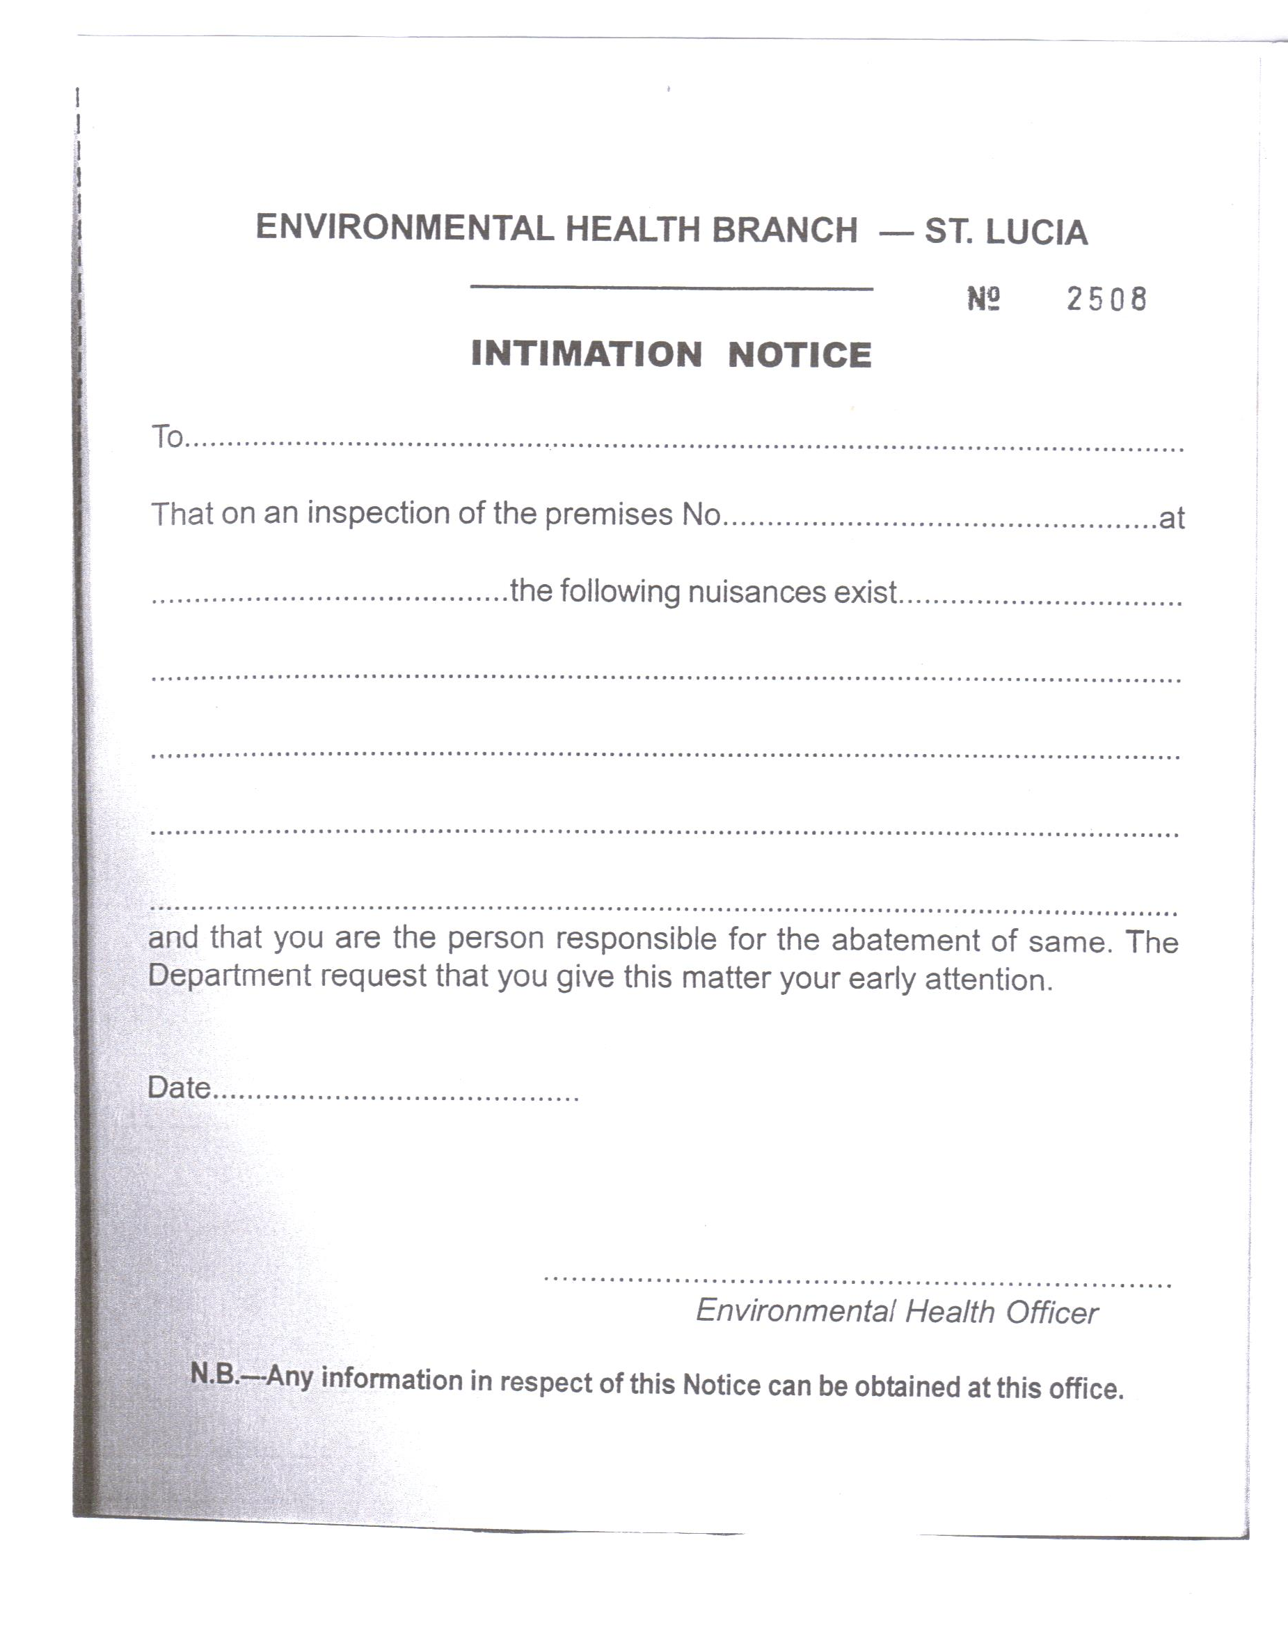
Figure 1- Intimation Notice

PPCR/SC.8/5. Meeting of the PPCR Sub-Committee: Cape Town, South Africa. 28-29 June 2011
Tabachnick, W. J. Climate Change and the Arboviruses: Lessons from the Evolution of the Dengue and Yellow Fever Viruses. Annual Review of Virology 2016 3:1, 125-145

