________________________________________________________________

DISASTER VULNERABILITY REDUCTION PROJECT (DVRP)

ENVIRONMENTAL ASSESSMENT (EA)
&
ENVIRONMENTAL MANAGEMENT FRAMEWORK (EMF)

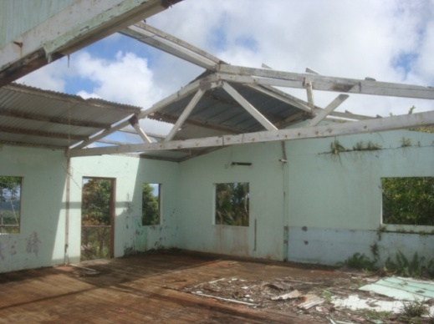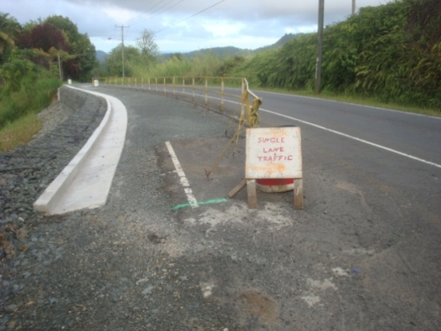
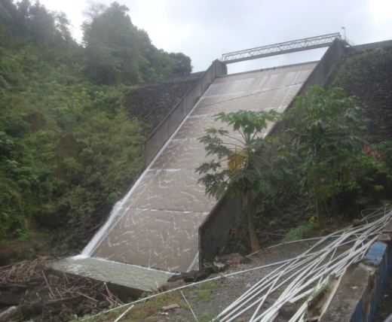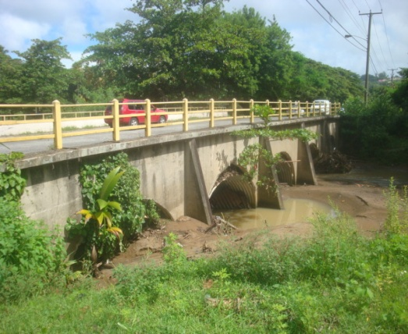

December 2013, Revised March 2016

Project Coordination Unit
Department of Planning and National Development
Ministry of Finance, Economic Affairs and Social Security
5st Floor, Conway Business Centre, Waterfront, Castries,
Saint Lucia
Tel.:758-468-5816 ● Fax:758-453-0417 ● E-mail: slupcu@gosl.gov.lc

LIST OF ACRONYMS AND ABBREVIATIONS

CARPHA | Caribbean Public Health Agency (formerly CEHI)
CCE | Caribbean Consulting Engineers
CEHI | Caribbean Environmental Health Institute
DCA | Development Control Authority
EIA | Environmental Impact Assessment
EMF | Environmental Management Framework
EMP | Environmental Management Plan
GFLC | George F.L. Charles Airport
GOSL | Government of Saint Lucia
HIA | Hewanorra International Airport
MAFF | Ministry of Agriculture Forestry and Fisheries
MAFPFRD | Ministry of Agriculture , Food Production, Fisheries, and Rural Development (formerly Ministry of Agriculture Forestry and Fisheries)
MET | Meteorological Services
MFEA | Ministry of Finance & Economic Affairs
MHWHSGR | Ministry of Health, Wellness, Human Services, and Gender Relations
MIPST | Ministry of Infrastructure, Port Services, and Transport
MOE | Ministry of Education
MOST | Ministry of Social transformation and Local Government
MPDHUR | Ministry of Physical Development, Housing, and Urban Renewal.
MSDEST | Ministry of Sustainable Development, Energy, Science, and Technology
MTLGCE | Ministry of Transformation, Local Government, and Community Empowerment
NEMO | National Emergency Management Organization
OP | Operational Policy
PCU | Project Coordinating Unit
PPS | Physical Planning Section
SDE | Sustainable Development and Environment Unit
SLASPA | Saint Lucia Air and Sea Ports Authority
SLDB | Saint Lucia Development Bank
SLFES | Saint Lucia Fire and Emergency Services
SLSWMA | Saint Lucia Solid Waste Management Authority
STLNT | Saint Lucia National Trust
WASCO | Water and Sewerage Company Incorporated
WRMA | Water Resources Management Authority

TABLE OF CONTENTS

1.0 INTRODUCTION AND PROJECT DESCRIPTION 6
1.1 Introduction and Project Description 6
1.2 Background 8
1.3 List and Description Of Sub-projects 8
1.4 Potential Future Sub-projects 16
2.0 LEGAL AND REGULATORY FRAMEWORK 17
2.1 Regulatory Framework 17
2.2 World Bank Safeguard Policies 22
2.3 Review of Relevant Legislation 26
2.4 Environmental Management Capacities 27
3.0 DESCRIPTION OF EXISTING ENVIRONMENT 29
3.1 St.Lucia General context 29
3.2 Geology 29
3.3 Topography 29
3.4 Climate 31
3.5 Human Settlement 31
3.6 Geohazards 31
4.0 PROJECTED IMPACTS 35
4.1 Analysis of Projected Impacts 35
4.1.1 Positive Impacts 46
4.1.2 Negative Impacts 46
5.0 MITIGATIVE MEASURES 50
5.1 Mitigative Measures 50
6.0 SCREENING PROCEDURES 55
6.1 Screening Processes 55
6.2 Local Permitting 56
6.3 Screening Criteria and Checklists 56
6.3.1 Relatively Complex Sub-projects 57
6.3.2 Relatively Simple Sub-projects 59
6.4 Emergency Procedures 59
7.0 ENVIRONMENTAL MANAGEMENT PLAN 61
7.1 Mitigative Measures 61
7.2 Environmental Contracting Clauses ..............................................................................59
7.3 Supervision, Monitoring, and Reporting 67
8.0 Disclosure and Consultation ...................................................................................................64

TECHNICAL REFERENCES
ANNEXES

LIST OF FIGURES AND TABLES

Figures |  |  |  | Page
1  2  3 | Location Map of Saint Lucia  Relief Map of Saint Lucia  Areas Affected by Hurricane Tomas 2010 – Central to north of Island |  | ......................................................  ......................................................  ...................................................... | 29  29  32
4 | Areas Affected by Hurricane Tomas 2010 – Central to south of Island |  | ..................................................... | 33
Tables

1  2 | List of Approved DVRP Sub-projects provided by PCU  Agencies with Environmental Management Responsibilities |  | .....................................................  ...................................................... | 9  17
3 | Impact Matrix of List of Projects initially provided by the PCU |  | ..................................................... | 34
4  5  6 | Impact Areas and Mitigation Measures  Identification of Complex/Sensitive Sub-projects or Activities  Standard Minimum Elements of the Environmental Management Plan (EMP) |  | .....................................................  ......................................................  ....................................................... | 46  53  56

LIST OF ANNEXES
1. Disclosure and Consultation

2. Project Site Photographs
3. Fact Gathering Interviews and Meetings
4. List of Participants Attending the Multi-stakeholder Consultation / World Bank Safeguards Seminar
5. Schedule 3 of the Physical Planning and Development Act of 2001- PERMITTED Development

6. Schedule 4 of the Physical Planning and Development Act of 2001 Projects requiring an EIA
7. DVRP Agency Questionnaire

8. Project Screening Form from Development Control Authority

9. Sample Terms-of-Reference for Subproject EIS

10. Environmental Contract Clauses

1.0 INTRODUCTION AND PROJECT DESCRIPTION

1.1 Introduction and Project Description

The World Bank is providing a Credit to the Government of Saint Lucia (GoSL) in the amount of United States thirty-two million dollars (US$41M) towards a Disaster Vulnerability Reduction Project (DVRP) which is co-financed with a Pilot Programme for Climate Resilience (PPCR) Loan (US$15M) and Grant (US$12M). The IDA credit finances vulnerability reduction and post-disaster reconstruction activities in the health, education and infrastructure sectors throughout the island, while the PPCR resources are used to effect transformational change to establish long-term climate resilience. Innovative approaches are piloted to realize such change and draw lessons learned for future replicability within Saint Lucia and internationally.

The DVRP which aims to measurably reduce vulnerability to natural hazards and climate change impacts in Saint Lucia includes various activities related to institutional strengthening and training as well as the execution of various civil works to retrofit or protect national assets. More specifically, the proposed project will consist of five components, namely: (1) Risk Reduction and Adaptation Measures; (2) Technical Assistance for Improved Assessment and Application of Disaster and Climate Risk Information in Decision-Making; (3) Climate Adaptation Financing Facility (CAFF); (4) Contingent Emergency Response Component (CERC); and (5) Project Management and Implementation Support.

The DVRP was declared effective by the World Bank on November 13, 2014 and is being implemented over a five (5) year period which ends December 31, 2019,

Currently, there is a proposal to seek additional financing (AF) in the amount of USD 8 million equivalent (EUR 5.74 million and SDR 1.16 million (USD 1.62 million equivalent) to scale up project activities under components 1 and 5, which would enhance the development impact and results of the DVRP. AF activities would be financed by a grant from the European Development Fund (EDF) as well as recommitted IDA funds from the recently closed Hurricane Tomas Emergency Recovery Loan (P125205, Cr 48710-LC). Upon approval of the proposed AF, the total financing of the Project would increase from USD 68 million to approximately USD 76 million equivalent.

According to the Bank’s Environmental Assessment (EA) Policy (Operational Policy OP 4.01), the DVR project is classified as Category B, meaning that environmental impacts for the type of work anticipated under the project are expected to be moderate in nature and can be managed through the application of appropriate engineering and management measures.

This Environmental Management Framework (EMF) updates and expands on the previously prepared EMF, which provides screening methods and procedures for the application of Bank safeguards, including guidance on the scope of studies necessary to complete for each subproject, criteria for triggering additional studies in the case of complex or significant activities, and a generic Environmental Management Plan (EMP) for use in simple situations where activities need no additional assessment. It is likely that the majority of works will be relatively minor in nature and involve simple civil works where the environmental impacts are limited to the construction phase, requiring only the application of a standardized generic EMP. However, any exceptions will be identified during screening in the EMF, and subject to additional assessment work.

Project works will be undertaken throughout the island. Works contemplated relate to, inter alia the rehabilitation and reconstruction of existing road infrastructure, retrofitting of key health and education facilities and new facility construction, geotechnical studies and engineering supervision for slope stabilization along critical road segments and river defense works. The possible project locations have been field-checked by World Bank staff have been inventoried and assessed in preliminary form through this EMF safeguards instrument which also includes a top-level Environmental Assessment (EA) to describe the environmental impacts of the project on a program-wide level. In addition, this EMF includes an EMP with environmental safeguards to guide the implementation of relatively simple civil works for which no additional assessment would be required.

This EMF is the appropriate environmental management tool to be used for future subprojects as detailed information on particular specific sub-projects under the DVRP and its AF have yet to be fully defined. General guidelines have been provided to assist in identifying potential impacts, mitigate potential negative impacts, statutory administration, and responsibilities as best as possible. An EMP with standard mitigation management measures has also been prepared and should be incorporated into the civil works contract as clauses to guide the contractor and to also form a basis for monitoring during implementation. Any additional detailed mitigation measures developed by specific studies (EIAs) for complex or sensitive subproject activities, or any additional environmental requirements imposed by St. Vincentian law and regulations, would also be translated into performance requirements for the contractors through civil works contracting clauses and verified by monitoring during implementation.

1.2 Background

An important issue confronting Saint Lucia’s development is the vulnerability of its population and economy to natural disasters, which can seriously impact the productive sectors of the economy, such as agriculture and tourism, with particularly severe effects on communities and households. Natural disasters impose large costs on the country’s fragile economy and exacerbate poverty levels.

The island's natural resource base is crucial to the future of the country’s economy and must be considered in any national resilience building program or plan. Development pressures and systemic deficiencies have resulted in substantial damage of critical infrastructure, housing, and livelihoods, during disasters. Poor land use planning and associated squatter developments, deforestation and developments in disaster prone areas have exacerbated vulnerabilities to climate change impacts and in particular climate related disasters. Most of the island’s major human settlements, and associated infrastructure (telecommunications, roads, airports and seaports), are located along the narrow coastal belt and are at direct risk from extreme weather activity, sea level rise and storm surges, rain-induced landslides on steep slopes, and flooding and inundation, posing threats to livelihoods and socio-economic activity.

Areas of bare soil exposed by landslides are highly susceptible to erosion; and with even moderate rain can directly affect already damaged water intakes and result in heavy siltation which can cause widespread flooding, and downstream effects on the marine environment. The scale and complexity of the landslides and debris flows have posed enormous challenges to Saint Lucia as the rehabilitation solutions and cost of landslide rehabilitation outstripped local capacity in terms of technical expertise and finance.

Individual project activities with potentially significant environmental impacts will likely focus on small to mid-sized civil works to be executed under the proposed project. Works activities include retrofitting of structures to improve disaster resilience, road works and bridge construction/rehabilitation including the possibility of road realignment, sea defenses, and building improvements and new construction. Several specific individual subprojects have already been identified and prioritized. A number of other possible subprojects have not yet been specifically identified, but the types of activities and civil works are known.

Potential environmental effects include impacts on natural habitat and to physical cultural resources. Permitting requirements under Saint Lucian environmental law must be fulfilled, and the World Bank safeguard policies must be followed for environmental assessment (OP/BP 4.01), natural habitats (OP/BP 4.04), and physical cultural resources (OP/BP 4.11) as applicable.

1.3 List and Description of Sub-projects

The following is a brief description of the approved sub project activities provided by the Project Coordinating Unit (PCU). Further detailed descriptions of each are provided in sections 1.3.1 through 1.3.20.

Table 1. List of Approved DVRP Sub-projects provided by PCU

 | DVRP Sub-project | Agency
1 | The Retrofitting of 4 Community Centers/ Emergency Shelters | MOST
2 | Associated Works following Feasibility Study for the development of the Millet Intake within the John Compton Dam Raw Water Supply System | WASCO
3 | Installation of Meters for Non-Revenue Water (NRW) Programme | WASCO
4 | Civil Works for Optimization of the meteorological and Hydrological Monitoring Network | MET
5 | Civil Works for Strengthening Sea Level Monitoring Network | MET
6 | Improved Drainage Systems in Flood Prone Areas Island-wide (various small contracts island-wide) | MIPST
7 | Land Stabilization & Road Rehabilitation Post Tomas (4 packages) | MIPST
8 | Rehabilitation of Choc Bridge | MIPST
9 | Rehabilitation of Venus-Anse La Raye Road | MIPST
10 | Construction of Bridge to replace the existing Piaye Bridge (MIPST) | MIPST
11 | Marchand River Bank Stabilization (Several packages) | MIPST
12 | Associated Works following Comprehensive Flood Protection Study of Hewanorra International Airport its Environs and George F.L Charles Airport and its Environs and associated works | SLASPA
13 | Integrated Slopes, Landslides and Riverbank Stabilization Project (various small contracts island-wide) | Forestry Division MOA
14 | Rehabilitation of Soufriere Hospital Ministry of Health | MOH
15 | Construction of Dennery Polyclinic | MOH
16 | Construction of Dennery Infant School | MOE
17 | Rehabilitation and Retrofitting of Dennery Primary School | MOE
18 | Construction of Choisuel Secondary School
22 | National Hazard Mitigation Program Grass Roots Projects (Various activities TBD) | NEMO

Site visits were conducted on 1st, 2nd, 3^{rd,} 16th May, 5th July, and 25th August, 2013 to many of the sites. Photographs to supplement the identification of these subprojects below are provided in the attached Appendix 2. The list of persons interviewed for this project as well as those at the first multi stakeholders’ consultation is presented in Appendices 3 and 4 for reference. As part of the preparation for the Additional Financing, additional site visits were made in June 2014 and November 2015, and discussions were held with stakeholders and agencies regarding the sub-projects during the site visits.

1. The Retrofitting of 4 Community Centers/ Emergency Shelters (MOST)

A number of community centres have been identified for improvement to function as effective emergency shelters. Within this project there are only three of the community centres that are being addressed at the moment. These are Roblot, La Fargue, and Piaye. These community centres are supposed to act as emergency centres in the event of a disaster but their present dilapidated conditions do not allow for this. This project is to rehabilitate these centers in order to upgrade them so they can function effectively as emergency shelters.

The Roblot Community centre lost its roof during Hurricane Tomas and no works have been done to this building which has been exposed to the rain for the past years. The timber walls and floor shows signs of dilapidation and termite infestation. The attached photos in Appendix 2 are self explanatory. The Ministry is opting for demolition of the structure rather than rehabilitation. The La Fargue community centre appeared to have recently been rehabilitated and appeared to be in sound condition. The Piaye Community center requires replacement of the roof which is poorly connected to timbers which are termite infested. The walls have no ring beams and are separated by timber columns. Extensive renovation is required. Refer to photos in Appendix 2. The community centre at Blanchard was mentioned but no project details were forthcoming. This could be a future project.

2. Associated Works following Feasibility Study for the development of the Millet Intake within the John Compton Dam Raw Water Supply System)

The Millet Intake is a diversion dam constructed on an elevated tributary of the Millet River. The intake diverts water through the same transmission line to the same treatment plant via gravity. There is no raw water storage and the yield from the Millet Intake fluctuates tremendously depending on the, wet or dry, season of the year. Over the years, the yield from the intake has varied from approximately 27,277m³ [6,000,000 imperial gallons] to approximately 4,546m³ [1,000,000 imperial gallons] per day. While the catchment properties have remained the same, damage to the intake caused by Hurricane Tomas and siltation are the main causes for this variation/shortfall.

Therefore, this proposal is for the reestablishment of the Millet Intake as the primary source of raw water. This will enable adequate redundancy into the system which is critical for reducing the risk to disasters. Also, with the Millet Intake as the primary supply and the John Compton Dam being secondary, there will be a significant reduction in the power consumption at the John Compton Dam because of the reduced volume of water to be pumped.

3. Installation of Meters for Non-Revenue Water (NRW) Programme (WASCO)

This sub-project would involve the procurement and installation of special meters that would allow WASCO to better monitor the supply of water in their distribution system. There have been a number of leaks within the distribution system and the result has been a loss of potential revenue for the company. These meters would assist in leak detection.

4. Civil Works for Optimization of the Meteorological and Hydrological Monitoring Network (MET)

This sub project is a joint project with Water Resources Management Authority (WRMA) and the Meteorological Department to enable installation of monitoring devices such as rain gages, as well as check dams and control structures within streambeds, to monitor meteorological and hydrological stations along river banks. The program is to be Island wide and includes communities of Chateau Belair, Soufriere; Colombette, Soufriere; Bouton, Soufriere; Bordelais, Dennery; and other sites to be identified in Dennery.

5. Civil Works for Strengthening Sea Level Monitoring Network (MET)

This sub project is a joint project with Water Resources Management Authority and the Meteorological Department to enable installation monitoring devices for monitoring of marine conditions in some coastal areas.

6. Improved Drainage Systems in Flood Prone Areas Island-wide (various small contracts island-wide) (MIPST)

The proposed works by the Ministry of Infrastructure, Ports, Services, and Transport (MIPST) are to be conducted within the Bois d’Orange water shed in Gros Islet, and the Back a Dere watershed in Vieux Fort. The Beausejour area will not be included in this project. The proposed flood mitigation works may involve the construction of river walls, installation of gabion baskets, construction of retraining of rivers, and other similar works. A consultancy is presently being prepared for an assessment study to be undertaken and to prepare designs and cost estimates for the proposed works.

7. Land Stabilization & Road Rehabilitation Post Tomas (4 packages) (MIPST)

This sub project will involve various construction components, including works on the Venus – Anse La Raye bypass link road which was blocked by nine landslides during Hurricane Tomas. At present there are no plans to construct any bridges and detailed designs are still to be determined. There may be some retaining walls to be constructed to provide slope stabilization and protection for the road infrastructure. Roads at Bois Cahet in Castries, Tet Chemin, and Morne du Don where tension cracks have been observed in the road are also being considered for civil works under this project.

8. Rehabilitation of Choc Bridge (MIPST)

Rehabilitation works are proposed for the Choc Bridge between Castries and Gros Islet which will involve the construction of a new bridge with new lanes and support footings. A bypass route has already been identified in preparation for the commencement of work on the bridge when that occurs. The design consultant has submitted the designs to the Ministry for review. The final design option is to be determined. A hydraulic study is still to be conducted.

9. Rehabilitation of Venus-Anse La Raye Road (MIPST)

The Venus – Anse La Raye Road also suffered significant damages resulting from two major landslides in areas with deep lower slopes as well as a poorly designed road foundations. As a result, the road has become impassable by motor vehicles. The Additional Financing will finance the rehabilitation (and possible path realignment) of approximately 8.2 km of tertiary road, which serves as (a) the only connection between the two communities, (b) main access route between the residential community and the Anse la Raye Primary School, and (c) only access to a WASCO storage tank and secondary treatment plant. Soil erosion, unstable slopes and silting of the drainage systems have contributed to the increased risk during the rainy season and will be fully taken into account in project design and works.

10. Rehabilitation of Piaye Bridge (MIPST)

The Piaye Bridge is 24.38m long with a 4.2m road width. It has been destroyed twice in the last 30 years: first by Tropical Storm Debby in 1994; and recently by the December 2013 floods that affected the entire island. During the passage of the Trough December 2013 the Piaye Bridge was washed away and access was closed for fifteen (15) days. To relieve the situation and to provide access a temporary, single lane bailey bridge was installed which became operational on January 6, 2014. The existing (damaged) bridge has not been replaced and its structure is highly vulnerable to climate change events. According to MIPST personnel, the bridge is at high risk from rainfall events of 25-year recurrence period or higher. Future weather related events included tropical storms can further cause deterioration to the infrastructure as well.

The bridge is situated on the major road infrastructure and is the main link that connects the southern and western parts of the Island in particular Laborie to Vieux Fort along the Highway. The proposed intervention under the Additional Financing consists of the construction of: (a) a two-lane bridge to accommodate vehicular and pedestrian traffic; (b) river embankment and riverbed protection works; and, (c) bridge approach works. The intervention aims to increase resilience, hydraulic capacity and road safety for the motoring public and pedestrians alike.

11. Marchand River Bank Stabilization (Several packages) MIPST

The stabilization works will extend from the Adelaide Home to the back of the Marchand Market and will involve among others the construction of a number of retaining walls. The Ministry has prepared detailed designs supported by environmental and social safeguards assessments.

12. Associated Works following Comprehensive Flood Protection Study of Hewanorra International Airport its Environs and George F.L Charles Airport and its Environs and associated works (SLASPA)

Saint Lucia has two airports: the Hewanorra International Airport (HIA), located in the south of the island, Vieux-Fort and the George F. L. Charles Airport (GFLCA) located in Castries, the Capital of Saint Lucia. Both Airports are operated by the Saint Lucia Air and Sea Ports Authority (SLASPA).

HIA is located along the southern coast of the island in the town of Vieux Fort, and is bounded to the east by the Atlantic Ocean and to the west by the La Tourney River while
George F. L. Charles Airport (GFLCA) is located in the north-western side of Saint Lucia. GFLCA is primarily utilized for regional travel throughout the Caribbean and is an ideal gateway to the country’s business centre while HIA is the country’s principal international airport. GFLCA is situated just north of the entrance to Port Castries and is bounded to the north by the Caribbean Sea.

Both airports are susceptible to periodic flooding during heavy rainfall events, which interrupt airport operations. This was quite evident following the passage of Hurricane Tomas in October 2010 and the Trough of December 24, 2013, where the airports’ airfields and surrounding compounds were inundated. Flooding at HIA was as a result of flood waters from the La Tourney River which left a deposit of silt and debris. At GFLCA the flooding was caused by excessive rainfall and storm surge from Vigie Beach. As a consequence of these situations, operations at both airports were suspended, albeit for a few hours at GFLCA and a few days at HIA, whilst cleanup operations ensued. At the HIA plans are ahead for the expansion of the Terminal Building and aircraft parking apron. However, the area identified for these investments are also susceptible to flooding events as well.

The works to be executed will depend on the results / outcome of a pre-feasibility analysis of engineering mitigation and drainage options to be designed to protect the airports’ facilities from these periodic flooding events.

13. Integrated Slopes, Landslides and Riverbank Stabilization Project (various small contracts island-wide) Forestry Division MOA

This sub project entails civil works using various methodologies including planting and bioengineering techniques aimed to stabilize river banks and areas prone to landslide in the following Watersheds: Canaries, Anse La Raye, Vieux Fort, Troumassee, Soufriere and Canelles. Capacity building activities will also be included as part of this activity. Implementation of this sub project will also assist in reducing siltation and sedimentation of intakes as well as coastal areas.

14. Rehabilitation of Soufriere Hospital Ministry of Health (MOH)

The Soufriere Hospital built in 1946 is the main facility providing emergency care to the western parts of the Island from Canaries to Choiseul. In 1985 the Kirby Lamontagne Wing was built, and in 2005 renovations was made to the wing to facilitate the Mental Ward. In 2010 minor renovations was also done to the hospital which included offices for Clinical Care as well as repair to the roof.

The Soufriere Hospital was affected by the passage of Hurricane Tomas in 2010 and its condition was further exacerbated by the December 2013 Trough. In addition, the building is in a flood zone in the vicinity of the river and therefore its basement facilities are especially affected. During and following the passage of Hurricane Tomas the Hospital surroundings were flooded and clients could not access services as the entrance area was impassable.

Therefore under the Project a detailed vulnerability assessment including hydraulic and flood risk assessments will be undertaken. Option designs based on the following scenarios will be presented a) relocation of services b) rehabilitation / reconstruction at the existing site taking into consideration the potential hazards and measures for mitigation.

15. Construction of Dennery Polyclinic (MOH)

The site identified for the proposed work is the Bois Jolie at Denney and site preparation works were completed in 2015. The site has been identified and it lies to the east of an existing Seventh Day Adventist church and south of a residential development. Access is via an internal loop road from the Castries Vieux Fort highway. A detailed EIA was done for this project which identified potential positive and negative impacts and mitigative measures where necessary.

16. Construction of Dennery Infant School (MOE)

A site for the new school building near the Dennery Police Compound has been identified for the construction of this new school. Detailed designs have been done and the Bidding Documents have been issued. Consideration must be given for the construction of an access road as the school will be sited on the existing access used by the Dennery Primary School and residents.

17. Rehabilitation and Retrofitting of Dennery Primary School (MOE)

Detailed designs are required to inform the rehabilitation works.

18. Construction of Choisuel Secondary School (MOE)

The Choiseul Secondary School located in the Choiseul Village comprises five stand alone buildings, which have been alphabetically labelled A to E. The school is among the many schools that were severely damaged as a result of Hurricane Tomas in 2010. The building blocks B and C which formed the initial school facility were constructed in 1971. The remaining buildings, (Blocks A, D & E) were constructed in the subsequent 36 years.

In addition to the stresses of severe service loading, the tremors of November 2007 and the Hurricane of 2010 has had debilitating effects on the aged blocks, B and C. Consequently, significant vibrations were observed in these two blocks. The report from a structural assessment of blocks B and C, commissioned in June 2011, concluded that the two blocks were structurally unsafe and that catastrophic collapse is possible under extreme loading. In 2011 the MIPST commissioned the preparation of architectural and structural designs (Choiseul Secondary Preliminary Design Report; October 2011).

Based on the outcome of this consultancy detailed designs were prepared and the tender document issued for the construction of two new blocks at the existing site owned by the GOSL.

19. National Hazard Mitigation Program Grass Roots Projects (Various activities TBD) (NEMO)

This activity is being reconsidered by NEMO

1.4 Potential Future Sub-projects

Proposed interventions by most Agencies including SLASPA will depend on available funding and will require collaboration and discussions among all stakeholders. For the Ministry of Social Transformation the Piaye and Roblot Community Centres have been identified as the priority.

Based on discussions National Emergency Management Organization (NEMO), it is recommended that the detailed plan be prepared to inform the sub projects.

2.0 LEGAL AND REGULATORY FRAMEWORK

2.1 Regulatory Framework

In Saint Lucia a number of Government and statutory agencies have responsibility for environmental management in one form or another under various pieces of legislation. Some agencies find themselves operating in grey areas or executing responsibilities that could better be managed under one agency with the relevant legal mandate. As an example, the national responsibility for landslide rehabilitation is disjointed, with the main responsibility for road and settlement falling with the Ministry of Infrastructure, while the responsibility for landslides occurring in the Forest Reserve being that of the Forestry Department. Landslides occurring on private forested lands remain the responsibility of private owners while the Ministry of Agriculture through its engineering division provided some support to farmers whose farms or feeder roads were affected by landslides.

The following provides a general overview of the agencies, laws and regulations pertaining to various sections that have relevance to environmental management and as well as to disaster mitigation. They cover such areas as environmental, land use, water management, domestic, commercial, and hazardous waste management, historical and cultural patrimony, public health, and disaster response. The varied environmental management efforts have generally been fragmented and stymied in many cases by a lack of coordinated efforts, clear or absent empowering legislation or regulations, and financial and technical resources.

Table 2 below summarizes a number of pertinent agencies, their responsibilities, and enabling legislation.

Table 2. Agencies with Environmental Management Responsibilities

Agency | Responsibility | Legislation
Ministry of Physical Development, Housing, and Urban Renewal | This Ministry has responsibility through the functions of its various departments/ sections which impact directly on the management of the country’s natural resources. The Physical Planning section is the technical arm of the Development Control Authority (DCA). The Ministry is also responsible for the implementation of the Saint Lucia Building Codes and guidelines which are supposed to provide guides for best construction practices. | The Physical Planning and Development Act No 21of 2001
Development Control Authority | The Board of the Development Control Authority the power to review and decide on development proposals that are brought to it by its technical secretariat, the Physical Section of the Ministry of Physical Development. The relevant Act provides the legislated authority to make provision for the development of land, the assessment of the environmental impacts of development, the grant of permission to develop land and for other powers to regulate the use of land, and for related matters. | The Physical Planning and Development Act No 21 of 2001 (amended 2005) which superseded the 1971 Land Interim Development Control Act.  Amendments to the 1971 Land Interim Development Control Act
Ministry of Health, Wellness, Human Services, and Gender Relations | Through its Environmental Health Department, it has the responsibility for reviewing plans, monitoring and enforcing public health and sanitation regulations and practices, and promoting public awareness on matters relating to public health and the environment. These include practices that affect health such as food preparation, sanitation, solid waste management, liquid and solid waste disposal, dust and air pollution, water quality, some occupational health and safety matters. | Public Health Act of 1975 and attendant Regulations to present.  No. 10, 11, 12, 13, 14, 15, 16, 18, 20, 21, and 22 of 1978]: Public Health [Nuisances] Regulations.  Public Health [Offensive Trades] Regulations:  Public Health [Communicable and Notifiable Disease]  Regulations:  Public Health [Water Quality Control] Regulations:  Public Health [Apartment Houses, Guest Houses and Hotels]  Regulations:  Public Health [Swimming Pools] Regulations:  Public Health [Disposal of Offensive Matter] Regulations:  Public Health [Sewage and Disposal of Sewage and Liquid  Industrial Waste Works] Regulations
Pesticides Control Board (in the Ministry of Agriculture) | Pesticides Control Board in the Ministry of Agriculture and is responsible for monitoring the importation and use of various chemical substances. | The Pesticides and Toxic Chemicals Control Act 1975
Saint Lucia National Trust | This statutory body has responsibility for the conservation and management of buildings and objects of historical and architectural value as well as areas of natural and scientific importance. The Trust is responsible for protecting and promoting the patrimony of the country. It manages the Pigeon Island National Landmark, the Praslin Protected Landscape, and the Maria island and Frigate Island Nature reserves. | National Trust Act 1975
Saint Lucia Solid Waste Management Authority | A statutory authority with the responsibility for providing a coordinated and integrated systematic approach to collection, treatment, disposal, and recycling of wastes including hazardous wastes. The Authority is also responsible for the management of two sanitary disposal sites, one in the north at Deglos, and the other in the south in Vieux Fort. , | The St. Lucia Solid Waste Management Authority Act No 8 of 2004,  Amendment of No 10 of 2007
Ministry of Agriculture , Food Production, Fisheries, and Rural Development (formerly Ministry of Agriculture Forestry and Fisheries) | This Ministry has wide ranging management responsibilities relating to the conservation and management. The Forestry Department is responsible for terrestrial ecosystems and resources, flora and fauna in particular legislated reserves on public or private lands such as forest reserve and water catchment areas, water abstraction, and public awareness. The Fisheries Department has similar responsible for the coastal marine environment and is heavily involved in education of fishers. They also have some responsibilities for some riverine environments. | Forest Soil and Water Conservation Ordinance 1946 (amended in 1957 and 1983)  Fisheries Act 1984  Wildlife Protection Act 1964
Ministry of Infrastructure, Port Services, and Transport | This Ministry is primarily responsible for the provision and maintenance of major infrastructure (roads and drains) within the state. It also issues licences for the extraction of sand from beach areas. The Ministry is responsible for the provision and management of technical services in the areas of communications, meteorology, transport, electrical safety, roads, hydraulic and building infrastructure, and utilities.  The Chief Engineer represents the Ministry on the Development Control Authority and the National Emergency  Management Advisory Committee (NEMAC). | Motor Vehicle and road Traffic Act 2003  Beach Protection Ordinance 1963
Sustainable Development, Energy, Science and Technology | The Ministry of Public Service, Sustainable Development, Energy, Science and Technology is the government body responsible for the following-up of the international commitments signed by Saint Lucia related with environmental issues, including the Climate Change Convention (UNFCC). The Sustainable Development, Energy, Science and Technology Section oversees all matters relating to sustainable development within the country and ensure that the various protocols are adhered to. It is the lead environmental agency in the country and spearheads the National Environmental Policy (NEP), National environmental Management strategy (NEMS), the national Climate Change Committee (NCCC), and other initiatives related to biodiversity, marine and terrestrial pollution, energy efficiency, sustainable development and environment.
The Caribbean Environmental Health Institute (CEHI), now called Caribbean Public Health Authority- now CARPHA | The Caribbean Environmental Health Institute, now called Caribbean Public Health Authority (CARPHA), is a regional CARICOM institution and a lead agency in matters related to water quality and water pollution control. It has been involved in testing for and quantifying various inputs into the coastal waters of the island and establishing monitoring and controls especially as part of water quality monitoring programmes. It collaborates with the Ministry of Health performing testing and analysis for that ministry as well as other ministries, agencies, and the private sector who may wish to employ its technical services. This organization is has a well equipped laboratory to assist its functions. The Ministry of Health relies on the Caribbean Environmental Health Institute (CEHI) to perform many of its analytical functions. CEHI also provides technical assistance and support to water resource management initiatives.
The National Emergency Management Office (NEMO) | The role of the National Emergency Management Organisation [NEMO] is to develop, test and implement adequate measures to protect the population of Saint Lucia from the physical, social, environmental and economic effects of both natural and man- made disasters from Hurricanes, to landslides, to oil spills and fires. Its responsibility is to ensure the efficient functioning of preparedness, prevention, mitigation and response actions. NEMO is responsible for preparing and managing the National Emergency Management Plan. NEMO is the chair of the National emergency Management Advisory Committee which convenes whenever there is a national emergency. | Disaster Management Act No. 30 of 2006  Emergency Powers (Disasters) Act No. 5 of 1995
Saint Lucia National Trust | The Trust is a statutory body established in 1975 and is charged with protecting and promoting natural and cultural heritage and manages sites such as the historical Pigeon Island National Landmark and the Maria Islands Nature Reserve. The Trust has developed the System Plan for Saint Lucia, and is also trying to document and preserve the Architectural Heritage of Saint Lucia. While the Trust is a referral agency for The DCA, and also in the vocal manner in which it voices its opinion on matters where it believes the matter of national heritage or preservation has threatened. | The St.Lucia National Trust Act of 1975
The Archaeological and Historical Society | The Archaeological and Historical Society is an NGO founded in 1954. It is custodian of many of Saint Lucia’s archaeological and historical collections and is supposed to serve as a “Preserver of Records”. The area of preservation of historical buildings and sites has remained a grey one between the Society and the Trust, and this has caused some conflict at times. The Society also promotes itself as the custodian of underwater archaeological sites as well.
Water and Sewerage Company Limited (WASCO) | WASCO is responsible for the provision of potable water to the country, provision and management of potable water infrastructure, along with sewerage management / waste water services. The company is responsible for the management of the John Compton Dam and a number of intakes around the country. | Water and Sewage Act 2005 with amendment in 2008
Labour Department -Occupational Health and Safety Section | This department is responsible for standards of occupational health and safety in places of employment and providing inspection of food handling premises. | Employees [Occupational Health and Safety] Act, No. 10, 1985.

2.2 World Bank Safeguard Policies

The World Bank projects and activities are governed by Operational Policies (OP), which are designed to ensure that the projects are economically, financially, socially and environmentally sound. The Bank has specific safeguard policies, which include Environmental Assessments and policies designed to prevent unintended adverse effects on third parties and the environment. These specific safeguard policies address natural habitats, pest management, cultural property, involuntary resettlement, indigenous peoples, safety of dams, projects on international waterways and projects in disputed areas.

The World Bank's environmental assessment policy and recommended processing are used to identify, avoid, and mitigate the potential negative environmental impacts associated with Bank lending operations and are described in the Bank’s Operational Policy (OP)/Bank Procedure (BP) 4.01: Environmental Assessment. This policy is considered to be the umbrella policy for the Bank's environmental 'safeguard policies' which among others include: Natural Habitats (OP 4.04), Forests (OP 4.36), Pest Management (OP 4.09), Physical Cultural Resources (OP 4.11), and Safety of Dams (OP 4.37).

Under OP4.01 the Bank will undertake environmental screening of each proposed project to determine the appropriate extent and type of EA required. Proposed projects are classified into one of four categories, depending on the type, location, sensitivity, and scale of the project and the nature and magnitude of its potential environmental impacts:

- Category A: A proposed project is classified as Category A if it is likely to have significant adverse environmental impacts that are sensitive, diverse, or unprecedented. These impacts may affect an area broader than the sites or facilities subject to physical works. EA for a Category A project examines the project's potential negative and positive environmental impacts, compares them with those of feasible alternatives (including the "without project" situation), and recommends any measures needed to prevent, minimize, mitigate, or compensate for adverse impacts and improve environmental performance. For a Category A project, the borrower is responsible for preparing a report, normally an EIA (or a suitably comprehensive regional or sectoral EA) that includes, as necessary, elements of the other instruments referred to above.

- Category B: A proposed project is classified as Category B if its potential adverse environmental impacts on human populations or environmentally important areas--including wetlands, forests, grasslands, and other natural habitats--are less adverse than those of Category A projects. These impacts are site-specific; few if any of them are irreversible; and in most cases mitigatory measures can be designed more readily than for Category A projects. The scope of EA for a Category B project may vary from project to project, but it is narrower than that of Category A EA. Like Category A EA, it examines the project's potential negative and positive environmental impacts and recommends any measures needed to prevent, minimize, mitigate, or compensate for adverse impacts and improve environmental performance. The findings and results of Category B EA are described in the project documentation (Project Appraisal Document and Project Information Document).

- Category C: A proposed project is classified as Category C if it is likely to have minimal or no adverse environmental impacts. Beyond screening, no further EA action is required for a Category C project.

- Category FI: A proposed project is classified as Category FI if it involves investment of Bank funds through a financial intermediary, in subprojects that may result in adverse environmental impacts.

After review of the project and its components, the overall DVRP project has not been deemed to have any major negative environmental impacts but because of the presence of the civil works with minor to moderate impacts, the project has been classified as a Category B project. The implementation of appropriate mitigative and management measures will assist in reducing any potential negative impacts from the various project components.

The World Bank Safeguard Policy OP 4.01 for Environmental Assessment (EA) is triggered, and requires that an Environmental Management Framework (EMF) be prepared along with an Environmental Management Plan (EMP) to guide recommended measures. The assessment aspect (EA) of this report provides a general overview of potential project impacts, the EMF provides guidelines and strategies for evaluating potential impact of future projects, and the EMP provides mitigation measures, as discussed later in this report.

The other World Bank Safeguard Policies dealing with natural habitats, physical cultural resources, pest management, and forests may possibly apply to projects in the future of the DVRP program, so they are described briefly below:

- Operational Policy 4.04 on Natural Habitats seeks to ensure that World Bank-supported infrastructure and other development projects take into account the conservation of biodiversity, as well as the numerous environmental services and products which natural habitats provide to human society. The policy strictly limits the circumstances under which any Bank-supported project can damage natural habitats (land and water areas where most of the native plant and animal species are still present). This policy was triggered as a precaution to ensure that any affected natural habitats are adequately protected.

- The objective of OP/BP 4.11 on Physical Cultural Resources is to avoid, or mitigate, adverse impacts on cultural resources from development projects that the World Bank finances. Cultural resources are important as sources of valuable historical and scientific information, as assets for economic and social development, and as integral parts of a people's cultural identity and practices. The loss of such resources is irreversible, but fortunately, it is often avoidable. Physical cultural resources are defined as movable or immovable objects, sites, structures, groups of structures, and natural features and landscapes that have archaeological, paleontological, historical, architectural, religious, aesthetic, or other cultural significance. Physical cultural resources may be located in urban or rural settings, and may be above or below ground, or under water. Their cultural interest may be at the local, provincial or national level, or within the international community. This policy was triggered as a precaution to ensure that any “chance finds” or other physical cultural resources are adequately protected.

- Operational Policy 4.09 on Pest Management seeks to ensure that rural development and health sector projects avoid using harmful pesticides. A preferred solution is to use Integrated Pest Management (IPM) techniques and encourage their use in the whole of the sectors concerned. The Bank requires that any pesticides it finances be manufactured, packaged, labelled, handled, stored, disposed of, and applied according to standards acceptable to the Bank. The Bank does not finance formulated products that fall in WHO classes IA and IB, or formulations of products in Class II, if (a) the country lacks restrictions on their distribution and use; or (b) they are likely to be used by, or be accessible to, lay personnel, farmers, or others without training, equipment, and facilities to handle, store, and apply these products properly. This policy has been triggered, because subproject activities may require the purchase or use of small amounts of pesticide through licensed registered professional contractors (e.g. termite treatment for building foundations). Use or purchase of significant amounts of pesticides is excluded in the EMF by screening as well as through standard contract clauses, therefore no separate Pest Management Plan is required; instead, the EMF includes appropriate procedures in the generic standardized EMP for incorporation into contract clauses. Any subprojects involving use or purchase of significant amounts of pesticides are screened out and not eligible under the DVRP (other than incidental use as stated above e.g. for termite control through licensed registered professional contractors).

- The Bank's Forests Policy (Operational Policy/Bank Procedure 4.36) aims to reduce deforestation, enhance the environmental contribution of forested areas, promote afforestation, reduce poverty, and encourage economic development. The objective of this policy is to assist borrowers to harness the potential of forests to reduce poverty in a sustainable manner, integrate forests effectively into sustainable economic development, and protect the vital local and global environmental services and values of forests. Where forest restoration and plantation development are necessary to meet these objectives, the Bank assists borrowers with forest restoration activities that maintain or enhance biodiversity and ecosystem functionality. The Bank also assists borrowers with the establishment and sustainable management of environmentally appropriate, socially beneficial, and economically viable forest plantations to help meet growing demands for forest goods and services. This policy applies to the projects that have or may have impacts on the health and quality of forests, projects that affect the rights and welfare of people and their level of dependence upon or interaction with forests, and projects that aim to bring about changes in the management, protection, or utilization of natural forests. This policy was not triggered, and therefore there is an exclusion included in this EMF to ensure that no projects are eligible for which the forestry policy would apply.

If proposed future project activities may trigger any of the above safeguard policies, then careful examination is warranted to ensure that the adequate steps are taken for protection of natural habitat and for the conservation of physical cultural resources. Screening of possible projects will reveal whether these policies are applicable, and if so then the appropriate inquiries are included in the analysis of environmental impacts and the design of mitigative measures. Any projects involving management of forests or the use or purchase of significant amount of pesticides will be screened out and excluded. The EA section of this report provides details on those types of possible impacts in the context of this program; and the EMF provides the guidelines for screening and subsequent actions.

2.3 Review of Relevant Legislation

With respect to the types of projects envisioned to be undertaken for disaster vulnerability reduction and attendant environmental safeguards, the main agencies under consideration are the Development Control Authority (DCA) and the Ministry of Infrastructure. The Physical Planning Department of the Ministry of Physical Development is the technical arm or executive of the DCA.

The Physical Planning and Development Act (No. 29, 2001) is the act that guides the Development Control Authority (DCA) and the Physical Planning Section. It is one of a number of pieces of legislation that tends to make provision for some form of environmental management and it is under Section 2(2), Section 2(3), Section 22, and in conjunction with the fourth schedule of this law that an EIA for certain activities ( Refer to Appendix 5).

Within this piece of legislation lies the authority of the Planning Department to “… make provision for the development of land, the assessment of the environmental impacts of development, the grant of permission to develop land and for other powers to regulate the use of land, and for related matters.”

The Physical Planning Section of the Ministry is guided by this legislation and after soliciting an EIA based on the type of development, will circulate the report to a number of referral agencies which are made up of some of the other agencies and statutory bodies with some responsibility for environmental management and safeguard and who would have assisted in contributing to the Terms of Reference for the study. The study will be reviewed for its adequacy and the agencies may make additional recommendations if necessary.

The final decision on any proposed development application or an EIA is made by the Board of the Development Control Authority (DCA) who may approve the EIA with its recommendations and measures, along with the recommendations and measures of the referral agencies.

The Development Control Authority (DCA) is empowered under the Physical Planning and Development Act No 29 of 2001 to consider and grant approval for all development within the state (Interview DPPS-MPDH, Executive Secretary- DCA). The DCA is made up of a government appointed Board of various professional interest and main technical government offices which also includes the Chief Engineer of the Ministry of Infrastructure or his representative. The applications that are exempted from such consideration are listed in Schedule 3 of the said Act. This also includes “(d) repairs to roads bridges, and harbour installations, (e) repairs to services” (see Appendix 6).

Environmental Impact Assessments are requested under Section 22 of the Act and the list of undertakings that require an Environmental Impact Assessment (EIA) as part of the consideration for approval are listed in Schedule 4 of the Act.

However, the Ministry of Infrastructure has the responsibility for undertaking activities relating to the construction and management of major infrastructural works not only related to transportation, and in the event of disasters, these activities include road and bridge construction and rehabilitation. This ministry does not apply to the DCA for approval as they are of the opinion that all such works are exempted under the Planning Act’s third Schedule. The issue here has becomes one of an institutional tension between these two authorities in which the DCA is of the opinion that the Ministry of Infrastructure should apply for consideration and approval of the various works such as bridges and roads in order to ensure they meet basic planning and environmental considerations, while the Ministry of Infrastructure does not believe that it has to do so. As such the Ministry of Infrastructure has continued to, as in the past, to undertake all major works as necessary, especially after a disaster in the manner that they consider appropriate. It has also been suggested that since the Chief Engineer sits on the DCA Board, he can so inform the Board of the various works as a matter of courtesy. While the Ministry of Infrastructure may ask for an EIA for works done by a consultant if it so desires, it does not request one for projects done in house within the Ministry.

It is the responsibility of the DCA to monitor development, either singularly, or as part of a monitoring team, to evaluate the level of compliance by the developer with the approval granted and the attendant conditions. But this becomes an issue, even in respect to the EIA, when the other agencies already have their own mandates, heavy workloads, and deadlines.

Overall, the DCA and the Ministry of Infrastructure must work closely together with the understanding that their mutual responsibilities lie in the welfare of the nation. With an understanding of this fact to guide discussions, it may be feasible for the Ministry of Infrastructure to submit plans along with environmental statements to the DCA for quick review in order that the DCA can revert with pertinent recommendations in a timely manner. It must be appreciated by the DCA that such projects require priority review and facilitation for the wider public benefit.

2.4 Environmental Management Capacities

The various management agencies operate under legislation that attempts to guide them but the issues of overlapping and sometimes unclear responsibilities continue to plague effective operations and responses to a number of environmental management issues. The general limited, and in some cases, lack of adequately trained staff, technical and financial resources coupled with lack of adequate training opportunities, as well as concerted coordinated cooperative efforts by the various agencies have contributed limitations in environmental management. A simple questionnaire was administered as part of the fact gathering interview process to a number of agencies to determine their technical and non technical capabilities. This instrument is identified in Appendix 7 and the results generally confirm the above. The agencies surveyed were the Environmental Health Department of the Ministry of Health, the Ministry of Physical Development, the Development Control Authority, NEMO, the Ministry of Sustainable Development, Ministry of Infrastructure, the Fisheries Department of the Ministry of Agriculture, and the Ministry of Social Transformation.

With such limitations, most agencies, coupled with their own heavy workloads and deadlines, have difficulties contributing to monitoring and ensuring environmental safeguards as prescribed singlehandedly. In such a circumstance it appears that utilizing a joint and focused approach in the form of a small multidisciplinary team may be the better approach to managing and monitoring projects to ensure basic environmental safeguards are incorporated and maintained.

3.0 DESCRIPTION OF EXISTING ENVIRONMENT

3.1 Saint Lucia General context

Saint Lucia is a small island developing state (SIDS) located at 13º53’0”N, 60º58’0”W between Saint Vincent to the south and Martinique to the north in the Caribbean Sea bordering the Atlantic Ocean (refer to Figure 1). The island is approximately 616.4km² [238 square miles] in area with approximately 169,000 inhabitants. The island exhibits an undulating mountainous terrain with a forested interior and is subject to a tropical climate. The major communities are located along the coast with the larger collection of population located in the north of the island.

3.2 Geology

St. Lucia is part of the wider Antillean Arc of islands that are geologically young, not more than 50 million years old and predominantly volcanic in origin. While the active tectonic processes appear to have ceased in the region, there is still some minor activity as evidenced by the dormant volcano in Soufriere with some near-surface hydrothermal hot spots.

St. Lucia is almost entirely volcanic with the oldest rocks, largely of rhyolite, andesite and various basalts, dating from the early ‘Early Tertiary’ period. The rock formations have been grouped into three wide island classes – northern series (early Tertiary [Eocene]), central series (middle Tertiary [Miocene/Pliocene]), and southwestern series (Holocene [mid to late Pleistocene]) series.

3.3 Topography

St. Lucia is mountainous (refer to Figure 2) with a south central mountain range rising to Mount Gimie at 3,117 ft (950m) above sea level and extending to the northeast and southwest in an irregular but pronounced axial ridge of approximately 15 miles (24 km) long with many pronounced gulleys and valleys. The land descends to the coast on both the western and eastern side of the central ridge within deep canyons, to expansive valley areas with perennial streams and rivers, flat alluvial plains, then the sea. The northern, central and eastern parts of the island tend to display a softened, rounded topographic quality reflecting old geologic age, erosion and weathering. Expansive valley areas include such examples as Marquis, Choc, Cul de Sac, Roseau, Mabouya, Fond d’or and Troumassee Valleys, and are also generally where large agricultural production is undertaken. In the upper reaches the average range elevation is approximately 900 feet (274m) above sea level but this is also dominated by peaks such as La Sorciere (2221 ft, 677m) and Piton Flore (1850 ft, 564m).

Figure 1. Location Map of Saint Lucia

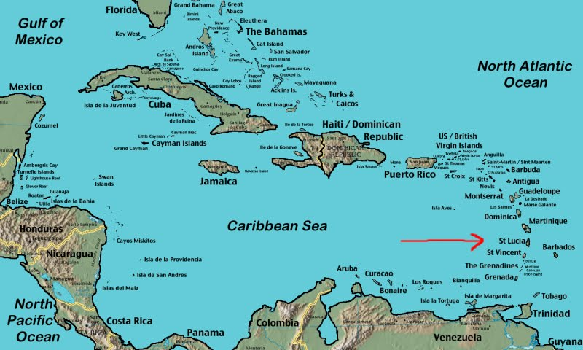

Figure 2. Relief Map of Saint Lucia

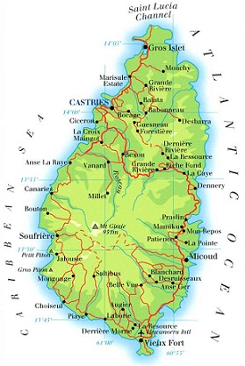
The west and southwestern edges of the country are geologically newer with more rugged and steeper mountainous terrain and dramatic drops. The Pitons of Soufriere (over 2000 ft 750m) are located in this area and form part of a massive caldera that contains the town of Soufriere and then drops off into Soufriere Bay. The southwestern area stretching from Gros Piton inland to Mount Grand Magazion and down to Vieux Fort and the sea has an extensive flat southern area extending to the sea. This area has deeply cut, narrow, steep-sided gorges as evidence of older geologic activity and time. The town of Vieux Fort lies within the flat sandy plain mentioned above.

3.4 Climate

Saint Lucia has two seasons; a dry season which starts from December and usually ends in May, and a wet season which is from June to November. It is during the wet season that St. Lucia is very vulnerable to hurricanes and other tropical storm occurrences as this is known as the hurricane season. It has been observed that some changes to what was considered clearly defined seasons have been occurring, and this has been attributed to factors of global climate change.

Annual rainfall in Saint Lucia ranges from 250” in the wet central mountainous interior to 60” in the dry coastal locations. This is largely due to the orographic effect as a result of the general topography of the island with a high central mountain range and lower coastal areas.

The island enjoys a relatively pleasant climate with temperatures averaging around 27°C, a maximum temperature is 32° C. with minimum temperature of about 22° C experienced in the mountainous interior during the cool months of November to January. While the island’s relative humidity hardly varies, ranging in the high 70% year round, it is highest in the warmer parts of the year. The island is subject to the northeast Trade Winds with winds generally travelling from the east. It has been observed that stronger winds tend to occur during the drier season of the year.

3.5 Human Settlement

Historical settlement patterns have followed along flat coastal areas near major rivers such as Castries. The population of St. Lucia is concentrated in the north of the island, particularly the northwestern and northeastern part which includes Castries, Gros Islet, and Babonneau. This area contains what is referred to as the Northwest Urban Corridor. As the population has increased, the settlement pattern has slowly creeped up from the low lying urban areas into the surrounding hillsides creating expanding suburban settlements. Many of these settlements are unplanned. This urban sprawl is largely the result of rural urban migration. Lower income households generally reside in some of these areas on the hillsides, and coupled with inadequate drainage and unplanned sewage systems and services, find themselves vulnerable to landslides and exposures to hurricanes.

3.6 Geohazards

Saint Lucia is vulnerable to a number of natural hazards such as hurricanes, earthquakes, volcanic activity, drought, tsunamis, flooding, and landslides. The effects of these phenomena can be exacerbated by the activities of population such as deforestation, indiscriminate garbage disposal, poor building practices, and unplanned settlements in environmentally sensitive areas.

With the increased frequency of more intense weather events as a result of climate change, the possibility for disasters to occur increases placing increased strain on the limited national technical and financial resources and the country’s ability to respond. Hurricane Tomas was a clear example of this. The island has also experienced two period of drought, in 2002, and again between 2009 and 2010, placing tremendous strain on the limited national water supply. It is critical that St.Lucia increases its capacity to reduce its vulnerability to these geo hazards and in so doing reduce the loss to life and property.

As an example of the vulnerability of St. Lucia to natural disasters, Hurricane Tomas which impacted Saint Lucia in October 2010 was a major disaster affecting areas around the country resulting in landslides, infrastructural damage, loss of property, and life. Several major landslides and debris flows occurred along major roadways and settlements, with several others occurring in many forested areas affecting critical water supply infrastructure. Figures 3 and 4 depict the location of the major areas affected by major damage and landslides.

Figure 3. Areas Affected by Hurricane Tomas 2010 - Central to North of Island.

Source: GIS Section, Ministry of Physical Development, Housing, and Urban Renewal. Sept. 2013

Figure 4. Areas Affected by Hurricane Tomas 2010 – Central to south of Island.

Source: GIS Section, Ministry of Physical Development, Housing, and Urban Renewal. Sept. 2013

4.0 PROJECTED IMPACTS

4.1 Analysis of Projected Impacts

The following impacts relate to the activities under consideration and are generally small to midsized civil works. While none of the projects are being implemented in historic or cultural sites, the WASCO intake rehabilitation may occur within the natural forest therefore care must be taken during the reconstruction activities. Pertinent environmental management measures must be implemented.

The social, cultural, historical, and socio economic impacts of these projects are being detailed in a separate social impact assessment document under another consultancy.

There are both positive and negative impacts attendant to the project and its components. An initial list of projects was provided by the PCU for which an impact matrix was prepared as below. The capacity building or institutional strengthening projects could be considered environmentally benign with no adverse impacts. The Table below provides a list and summary of impacts.

Table 3. Impact Matrix of List of Projects initially provided by the PCU

 | Proposed activities | Agency | Possibility of Environ-mental Impact? | Environmental Impact Aspect,  positive(+) or  negative(-) | Level of Environmental Impacts
1 | Environmental Health Surveillance System | MOH | No | None | None
2 | Land Stabilization and Road Rehabilitation Post Tomas | MIPSAT | Yes | - Potential poor construction and management practices leading to poor end products (-)  - Air pollution from dust and vehicular / machinery fumes  - Poor Solid waste management from works (-).  - Potential resident and worker safety issues (-).  - Disturbance to urban traffic (-).  - Disruption to natural habitat in Forest Reserve (-). | Moderate but not overly significant if managed with good practices and supervision from implementation to completion; in some areas could be potentially significant if improperly managed within Forest Reserve or involving highly erodible soils.
3 | Develop Bridge Maintenance Plan | MIPSAT | No | None | None
4 | Public Education and Awareness Campaign | Ministry of Physical Development/ SDED | No | None | None
5 | GIS, Spatial Data management and sharing/ Geo Node activities | Ministry of Physical Development/ SDED |  | None | None
6 | Terrestrial and Bathymetry Survey | Ministry of Physical Development | Yes | - Potential resident and worker safety issues (-).  - Disturbance to urban traffic (-).  - Disruption to natural habitat in Forest Reserve (-).
7 | Develop a Geographic information System to assist in reducing the risk to human and natural assets resulting from Climate change. | WASCO | No | None | None
8 | To provide scientifically derived information to support decision making in developing a policy on Waste Water management | SDED | No | None | None
9 | Development of the Millet Intake within the John Compton Dam Raw Water Supply | WASCO | Yes | - Potential poor construction management practice issues (-).  - Air pollution from dust and fumes from vehicles/ machinery (-).  - Solid waste management issues, increased siltation of intakes and water supplies from works (-).  - Potential resident and worker safety issues (-).  - Potential disturbance and removal of natural vegetation (-).  6. Potential disturbance and removal of natural vegetation and damage to natural habitat in forest areas (-).  7. Impact on fauna via noise impact and presence of human activity (-). | Moderate but has potential to be significant if not properly scoped and works not properly implemented and managed; may require additional assessment to design best environmental management plan.
10 | Reconstruction of Anse La Raye Venus Road d |  |  | 1. Potential poor construction management practice issues (-).  2. Air pollution from dust and fumes from vehicles/ machinery (-).  3. Solid waste management issues, increased siltation of intakes and water supplies from works (-).  4. Potential resident and worker safety issues (-).  5. Potential disturbance and removal of natural vegetation (-).  6. Potential disturbance and removal of natural vegetation and damage to natural habitat in forest areas (-).  7. Impact on fauna via noise impact and presence of human activity (-). | Moderate but has potential to be significant if not properly scoped and works not properly implemented and managed; may require additional assessment to design best environmental management plan.
11 | Reconstruction of Louisy Intake | WASCO | Yes | 1. Potential poor construction management practice issues (-).  2. Air pollution from dust and fumes from vehicles/ machinery (-).  3. Solid waste management issues, increased siltation of intakes and water supplies from works (-).  4. Potential resident and worker safety issues (-).  5. Potential disturbance and removal of natural vegetation (-).  6. Potential disturbance and removal of natural vegetation and damage to natural habitat in forest areas (-).  7. Impact on fauna via noise impact and presence of human activity (-). | Moderate but has potential to be significant if not properly scoped and works not properly implemented and managed; may require additional assessment to design best environmental management plan.
12 | Optimization of the meteorological and hydrological monitoring network | WRMA | Yes | 1. Potential poor construction management practice issues (-).  2. Poor solid waste management issues (-).  3. Increased siltation of intake from works within stream channels (-). | Limited and manageable if works properly scoped, implemented, and managed.
13 | Developing of Guidelines for Watershed management | WRMA | Yes | 1. Change in forest land use or restriction to access (-). | Low but can be managed with good planning and coordination.
14 | Procurement of Software and equipment | WRMA | No | None | None
15 | Procurement of Water Quality Field Testing Equipment to enhance capacity of WRMA | WRMA | No | None | None
16 | Training in Installation and Maintenance of equipment and Software | WRMA | No | None | None
17 | Strengthening Sea Level Monitoring Network | WRMA | No | None | None
18 | Flood Early Warning System- Dennery River | NEMO | No | None | None
19 | Integrated Slopes, landslides, and riverbank stabilization project | MAFF Forestry Dept | Yes | 1. Potential issues from land disturbance through improper implementation methods/ practices (-).  2. Poor solid waste management issues (-).  3. Increased siltation of waterways from works (-).  4. Potential worker safety issues especially in snake areas or on steep or unstable slopes (-).  5. Potential disturbance of natural vegetation (-).  6. Impact on fauna through noise and presence of human activity (-). | Moderate but can be managed with good practices, experienced crew, and proper supervision from implementation to completion, including special care for activities within Forest reserves.
20 | Enhancing Coral reef Recovery | MAFF-Fisheries | Yes | 1. Changes to marine ecosystems and natural habitat (-). | Insufficient Information at Present
21 | Enhancing the capacity of the Fire Department | Fire Department | No | None | None
22 | Mainstreaming Rainwater Harvesting (RWH) in Saint Lucia | CEHI (now CARPHA) | No | None | None
23 | Rehabilitation of Choc | MIPST | Yes | 1. Potential poor construction management practices (-).  2. Air pollution from dust and fumes from vehicles / machinery (-).  3. Potential removal of natural vegetation and damage to natural habitat in forest areas (-).  4. Noise impact (-). | Moderate but has potential to be significant if not properly scoped and works not properly implemented and managed; may require additional assessment for natural habitat concerns to design best environmental management plan.
24 | Rehabilitation of Piaye Bridge | MIPST | Yes | 1. Potential poor construction management practices (-).  2. Air pollution from dust and fumes from vehicles / machinery (-).  3. Potential removal of natural vegetation and damage to natural habitat in forest areas (-).  4. Noise impact (-). | Moderate to low; environmental management plan sufficient

The level or significance of impact indicated above is based on the level of detail of the information provided on the project activities, the intensity of the proposed development, its size, as well as an assessment of the existing environment where the intervention is to be implemented. It should be noted that while the levels of significance of potential impacts have been estimated based on currently available information, there is always the possibility that during implementations, methodologies, poor practices or management may be utilized or occur that may increase the significance of the impact in a negative way. This is why proper management and monitoring is critical.

It can be seen from Table 3 above that most of the proposed activities with any potential impacts are generally small to midsized civil works. It is expected that most of the negative impacts associated with the sub-projects are likely to occur during the construction phases. Those projects with no environmental impacts whatsoever require no further consideration in the context of this report.

While none of the projects are being implemented in historic or cultural sites there may civil works may occur within areas of natural forest and therefore due diligence is required during its implementation. Protocols or special policies do not exist to address such activities. In one case there may be risk to workers who have to work within a known snake-infested area. The forest reserves most likely represent Natural Habitat and so it is possible that additional assessment studies would need to be conducted (most likely in the form of a specific EIA) and a more detailed EMP would need to be developed with conditions that would apply to those specific works.

A full EIA has been carried for the proposed Dennery polyclinic.

The Venus - Anse La Raye Road works would traverse part of the Central Forest Reserve. The site is classified as a sensitive area, should there be endemic wild life such as snakes present in the area. A specific focused EIA may be required and would require screening. The forest reserves most likely represent Natural Habitat and so it is possible that additional assessment studies would need to be conducted (most likely in the form of a specific EIA) and a more detailed EMP would need to be developed with conditions applicable to the works. In addition the soil conditions along the road are unique in that very loose, soft, powdery volcanic deposits are present which erode very easily and therefore present a substantial risk of collapse, slope failure, erosion, and sedimentation, which would affect nearby rivers and streams and the associated natural habitat of the area. Finally, the Water Intake Structure of WASCO is at the downstream end of the works and must be protected against excessive sedimentation which could damage the intake and treatment plant. These works will now be included as part of the Additional Financing (AF).

In the case of the Marchand River Bank Stabilization, final site clean-up after completion of the works must be undertaken. This is very important to reducing the environmental impact of the civil works. An environmental assessment has been undertaken as part of the Design Report, cleared by the World Bank. The EMP and associated measures contained in the approved Design Report has been incorporated in the Bidding Document issued for procurement of works.

As part of detailed designs for the reconstruction of the Choc Bridge an Environmental Assessment was prepared. Using the Design Report an environmental evaluation (or limited assessment) needs to be undertaken to determine the following and to develop a detailed Environmental Management Plan (EMP) based on the findings of the environmental evaluation.
- whether that are any zones that will be cleared or affected in the mangroves,
- Evaluate whether there are any sensitive, endangered or threatened species (birds, plants, aquatic life);
- Include the area indirectly affected, especially at the mouth of the river and the surrounding beaches and marine zone;
- Develop an Erosion Control Plan to include sedimentation controls (haybales, silt fences, berms, etc.) and temporary re-routing of the river to minimize or avoid works directly in the riverbed; the plan should include monitoring of turbidity (up- and down-stream), with contingencies for corrective measures.
- Include a slope stability plan, with plans for safe grades, shoring or support for trenches more than 2 meters, and revegetation plan.
- Prepare a Traffic Safety and Routing Plan, including proposed by-pass routes during construction, and signage requirements (day and night).
The EMP should include recommendations for works to be executed.

The Piaye Bridge would require an environmental management plan following an evaluation of areas at the mouth of the river, erosion control including sedimentation control and traffic safety and routing plan.

4.1.1 Positive Impacts

There are a number of potential positive impacts of the project and associated works. These will only be highlighted here, as the focus will be on negative impacts, and mitigative measures. The most obvious positive impact is the national benefit of the reduction of the nation’s vulnerability to disasters ensuring safety of property and life. There is also the positive benefit of employment and income generation during the construction phase and after in the operational phase, although for a less amount of persons. This would be discussed in more depth by the Social Impact Assessment being prepared under another consultancy. With each sub-project there may be certain specific positive impacts that can be summarized as follows:

- Improving the access to health services by the upgrading and provision of health facilities as in the case of Dennery.
- Conservation of water in the case of the CEHI rain water harvesting project.
- The creation of temporary employment opportunities and long-term income generation as already mentioned above for a number of the construction projects from the rehabilitation of the community centres to the construction of road and river stabilization works.
- The provision of improved services such as water with the improvements to the WASCO intakes and provision of the new 1200m pipeline.
- Improved learning environments and access to education as in the case of the new school at Dennery.
- The provision of training as in the case of the capacity building project components such as in the case of the MET and WRMA projects.

Efforts to maximize the positive benefits of the works should be sought during design and implementation.

4.1.2 Negative Impacts

There is the possibility of the occurrence of the following negative impacts associated with the projects.

- Increased traffic and potential for traffic conflict
- Increased Vibration and Noise levels
- Poor Solid and Liquid Waste Management
- Deforestation
- Air pollution
- Marine pollution and impacts on marine habitats
- Terrestrial pollution
- Soil erosion and land slippage
- Occupational Health and safety issues
- Loss of or damage to historical or cultural artifacts

Each of the impacts is described in more detail below. The EMP will describe the measures to avoid, minimize, and mitigate the negative effects, as described later in this report.

4.1.2.1 Increased Traffic and Potential for Traffic Conflict

There is always the possibility of increased construction-related traffic for civil works of certain sizes. The potential for vehicular/vehicular and pedestrian/vehicular conflict increases as the scale of construction increases if proper traffic management procedures are not implemented. This can lead to very tempered negative response from the nearby residents or the community affected. The matter of safety also becomes a great concern in relation to the speed of the vehicles as well as the alertness of the drivers as they traverse the highways and through communities especially if there are children within the vicinity who may be accustomed to playing on the roads or sidewalk areas. The breakdown of a large project vehicle causing the blockage of a well travelled route can escalate tensions within a community especially if it contributes to loss of travel time to work, school, or returning home.

4.1.2.2 Increased Noise levels

Increased noise and vibration levels through construction activities such as the movement of heavy supply trucks into and out of the site, the use of various forms of heavy equipment such as demolition equipment, can have negative impacts on both the terrestrial and marine environments especially along the coast as well as in the forested areas. In secluded or forested areas, fauna habitats can be disturbed causing such creatures to flee their homes and nesting areas. Similarly, increased noise levels from activities adjacent to or within communities and residential areas, can be deemed as an unnecessary and unwanted nuisance affecting local business and day to day activities. Care must be taken in the judicious usage of any form of heavy noise and vibration equipment. Associated vibrations from the use of heavy equipment such as rollers can negatively impact surrounding communities, causing nuisances by shaking household items and possibly affecting the stability of nearby structures.

4.1.2.3 Poor Solid and Liquid Waste Management

The improper management and disposal of both solid and liquid wastes can be detrimental to both the terrestrial and to the nearby marine environment. The mishandling of construction wastes such as chemicals, detergents, greases, oils, building materials, can lead to the poisoning of the terrestrial environment. The entry into the marine environment of any waste or chemical, either through runoff, in drains, or are blown by the wind, they can also poison the marine environment or damage the fragile marine ecosystem. The management of human wastes on site is very critical as well to ensure a healthy working environment and reduce the risk of faecal contamination. The management of food wastes is also critical to reducing the incidence of vector entry into an area and infestation.

4.1.2.4 Deforestation

The practice of land clearing and especially mass and sometimes indiscriminate land clearing, excavation practices, as well as poor site drainage can lead to land slippage and eventually siltation leading to the loss of loss of life and coastal marine pollution and destruction. This is especially so on steep slopes. In forested areas, such deforestation to accommodate development can lead to loss of habitat for forest and endemic flora and fauna as well as a loss of biodiversity. Particular care must be exercised in these cases.

4.1.2.5 Air Pollution

Air pollution can come from a number of sources. The vehicles and machinery being utilized can both produces noxious fumes such as carbon monoxide, diesel fumes, as well as burnt oil fumes. There is the increased potential for air pollution to come from older or improperly service vehicles and machinery as well. Dust also arises from cleared land that has been exposed to the sun, is dried, and the wind carries this material to nearby residences or communities. Similarly, uncovered fines such as sands or even cement can be light enough to be blown by the wind. This is a nuisance to nearby facilities or communities. The mishandling of particularly noxious chemicals such as solvents or chemical washes, greases, as well as the burning of solid wastes on the construction site, especially chemical containers, can lead to air pollution and negative resultant health impacts.

4.1.2.6 Terrestrial and Marine Pollution

The potential for terrestrial and marine pollution can occur with indiscriminate disposal of both solid and liquid wastes. The mishandling of chemicals and especially waste oils during construction activities is critical and can poison the landscape. The same would apply to cementitious materials as well. During rainfall events chemicals can mix or be carried with runoff and create liquid wastes that impact both terrestrial and marine environments. Improper disposal of human wastes can lead to similar effects. This also applies to the use of pesticides and insecticides to treat termite infestation. With the occurrence of civil works projects along or adjacent, or within the coastal waters such as the potential projects by SLASPA and MAFF-Fisheries, there is the possibility of impact on the marine ecosystem which must be evaluated as project details become more clear.

4.1.2.7 Soil Erosion and Land Slippage

The practice of land clearing and especially mass and sometimes indiscriminate land clearing, excavation practices, as well as poor site drainage can lead to exposed soil. This, the nature of the exposed soil, in combination with the precipitation and /or poor drainage, can lead to land slippage especially on steep slopes. This can result in loss of life and property. Eventually this material can wash down into rivers and then to the sea causing siltation and sedimentation. The resulting effect within the coastal marine environment, can lead to pollution if there are oils or chemical elements in the soil, and destruction of that ecosystem and livelihoods.

4.1.2.8 Occupational Health and Safety Issues

Worker safety is critical to any operation and the mishandling of equipment, the improper storage and usage of various chemicals and construction materials on site, poor and unsafe working conditions, high levels of continuous noise and fumes, as well as inadequate safety equipment can cause serious injury and down time to the workers and project. The relevant best management practices will have to be implemented and appropriate legislation will have to be followed. Proper facilities will need to be provided for workers so that they are able to dispose of their solid wastes, as well as sanitary wastes without any negative impacts on the environment.

4.1.2.9 Loss of or Damage to Historical and Cultural Artifacts

During construction activities, there is the possibility of coming across or “chance finding” what may appear to be an historical or cultural artifact which may need to be studied and preserved by the relevant authorities. For example, during the site visit to the Dennery Hospital, it was observed that there was what appeared to be an old stone oven or store room like structure below a large tree to the lower west of the facility. Discussions with a local person present provided the insight that this structure was in fact a temporary morgue for the placement of recently dead persons in the early part of this century. Luckily this structure had been away from the main construction area and so suffered no damage from such activities. In cases like this, such an artifact could have been lost due to careless construction activities prior to the relevant authorities determining whether or not it is worthy of preservation. In such cases it is also recommended to consult with local stakeholders as to the final design of the facility, and the disposition of any potential physical and cultural resources, because the valuation of such items is ultimately subjective and they are of most value to local stakeholders.

5.0 MITIGATIVE MEASURES

5.1 Mitigative Measures

Mitigative measures address the potential impacts of the projects to reduce or avoid any negative impact on the environment. As indicated in the section on impacts, most of the negative impacts associated with the sub-projects are expected to occur during construction phase. While these impacts are not expected to be major, the careful implementation of mitigative measures will allow for the reduction or avoidance of any adverse effects. It is expected that the projects would receive adequate technical review by qualified technical professionals to ensure their technical and environmental soundness. Engineering review for all construction details and designs should be integral in this process.

A number of general impacts have been identified above and the following in Table 4 is a list of the potential mitigative measures. The measures are presented in a manner that makes them easily incorporated into an EMP and, with appropriate wording, can become contract clauses for the contractor who will undertake the civil works. This also allows for ease of monitoring as well.

Additional mitigative measures would be derived from any conditions imposed by any statutory agency who reviewed the sub-projects and provided recommendations or conditionalities. These could also be converted to contract clauses as necessary.

The following Table 4 presents the potential impact areas and the proposed mitigative measures.

Table 4. Impact Areas and Mitigative Measures

 | IMPACT AREA | MITIGATIVE MEASURES
1 | Traffic impacts | - A traffic management plan to be developed and implemented by contractor.  - Alternative routes to be identified in the instance of extended road works or road blockages.  - The public to be notified of all disturbance to their normal routes.  - Signposting, warning signs, barriers and traffic diversions must be clearly visible and the public warned of all potential hazards.  - Provision must be made for the safe passages and crossings for all pedestrians where construction traffic interferes with their normal route.  - There must be active traffic management by trained and visible staff at the site or along roadways as required to ensure safe and convenient passage for the vehicular and pedestrian public.  - Adjustment of working hours to local traffic patterns, e.g. avoiding major transport activities during rush hours or times of livestock movement.
2 | Noise | - Construction / work activities will occur within specified daylight hours e.g. 8:00 am to 4:00pm.  - Community / public to be informed in advance of any work activities to occur outside of normal working hours or on weekends.  - Sites should be hoarded wherever possible.  - During operations, the engine covers of generators, air compressors and other powered mechanical equipment shall be closed, and equipment placed as far away from residential areas as possible.  - There will be no excessive idling of construction vehicles at sites.  - Noise suppression equipment or systems supplied by manufacture will be utilized.  - Ensure all vehicles and equipment are properly serviced.  - The contractor must develop and implement a public notification and noise management plan.
3 | Solid and Liquid Waste Management (general) | - Contractor to develop and implement waste management plan.  - Contractor to abide by all pertinent waste management and public health laws.  - Waste collection and disposal pathways and sites will be identified for all major waste types expected from demolition and construction activities.  - Construction and demolition wastes will be stored in appropriate bins.  - Liquid and chemical wastes will be stored in appropriate containers separated from the general refuse.  - All waste will be collected and disposed of properly in approved landfills by licensed collectors.  - The records of waste disposal will be maintained as proof for proper management as designed.  - Whenever feasible the contractor will reuse and recycle appropriate and viable materials (except asbestos).  - Construction related liquid wastes must not be allowed to accumulate on or off the site, or to flow over or from the site in an uncontrolled manner or to cause a nuisance or health risk due to its contents.
4 | Solid and Liquid Waste Management (hazardous) | - Contractor must provide temporary storage on site of all hazardous or toxic substances in safe containers labeled with details of composition, properties and handling information.  - The containers of hazardous substances shall be placed in an leak-proof container to prevent spillage and leaching.  - The wastes shall be transported by specially licensed carriers and disposed in a licensed facility.  - Paints with toxic ingredients or solvents or lead-based paints will not be used.  - Banned chemicals will not be used on any project.  - Any project activity which involves the purchase or use of significant amounts of pesticides (other than as described in (g) below) will be excluded during the screening process.  - If termite treatment is to be utilized, appropriate chemical management measures will be implemented to prevent contamination of surrounding areas and use only licensed and registered pest control professionals with training and knowledge of proper application methods and techniques.
5 | Solid and Liquid Waste Management (asbestos) | - If asbestos is located on the project site, it shall be marked clearly as a hazardous material.  - If work has already commenced, all work in the area must stop immediately.  - An asbestos management plan must be prepared by the contractor and approved by the relevant local health and waste management authorities.  - Where possible the asbestos and its location must be appropriately contained and sealed to minimize exposure.  - The asbestos prior to removal (if removal is necessary) will be treated with a wetting agent to minimize asbestos dust.  - Asbestos will be handled and disposed by skilled & experienced professionals using appropriate PPE (personal protective equipment) such as respirators and tyvec suites.  - If asbestos material is be stored temporarily, the wastes should be securely enclosed inside closed containments and marked appropriately.  - Security measures must be implemented against unauthorized removal of asbestos from the site.  - No removed asbestos will be reused.
6 | Solid and Liquid Waste Management (Medical Wastes) | - The contractor must ensure that all persons handling medical wastes are provided with proper protective clothing.  - All medical wastes must be treated as hazardous.  - All medical wastes must be secured in specially labeled and sealed containers separate from other wastes streams.  - All medical wastes must be disposed of according to relevant local legislation at specified disposal sites.
7 | Deforestation | - There must be no unnecessary clearing of natural vegetation.  - Avoid the use of herbicides or other chemicals.  - Any works to be undertaken in a protected forest area must be done under the supervision of a representative of the Forestry Department.  - The contractor must ensure that any work undertaken in the forest reserve must be done by manual means.  - There must be minimal impact to flora and fauna in the forest area.  - All recognized natural habitats, wetlands and protected areas in the immediate vicinity of the activity must not be damaged or exploited.  - The contractor must ensure that all staff will be strictly prohibited from hunting, foraging, logging or other damaging activities.  - A survey and an inventory shall be made of large trees in the vicinity of the construction activity, large trees shall be marked and cordoned off with fencing, their root system protected, and any damage to the trees avoided.  - There will be no unlicensed borrow pits, quarries or waste dumps in protected areas.  - Upon completion, all wastes must be immediately removed out of the forested area.
8 | Air Quality | - Construction materials such as sand, cement, or other fines should be kept properly covered.  - Cement should be kept stored within a shed or container.  - The sand and fines can be moistened with sprays of water.  - Unpaved, dusty construction roads should compacted and then wet periodically.  - During interior demolition debris-chutes shall be used above the first floor.  - Demolition debris shall be kept in controlled area and sprayed with water mist to reduce debris dust.  - During pneumatic drilling/wall destruction dust shall be suppressed by ongoing water spraying and/or installing dust screen enclosures at site  - The surrounding environment (sidewalks, roads) shall be kept free of debris to minimize dust.  - There will be no open burning of construction / waste material at the site.  - There will be no excessive idling of construction vehicles at sites.  - The bins of all haulage vehicles transporting aggregate or building materials must be covered on all public roads.
9 | Terrestrial and Marine Pollution | - The contractor must implement all necessary waste management plans and measures.  - All construction materials, including chemicals, must be properly stored.  - The contractor will establish appropriate erosion and sediment control measures such as hay bales, sedimentation basins, and / or silt fences and traps to prevent sediment from moving off site and causing excessive turbidity in nearby streams, rivers, wetlands, and coastal waters.  - If works are long coastal marine areas or near major streams and rivers, water quality monitoring must be done before construction, and at regular intervals to determine turbidity levels and other quality parameters.  - See soil erosion and slippage mitigative measures below.  - Construction vehicles and machinery will be washed only in designated areas where runoff will not pollute natural surface water bodies.
10 | Soil Erosion and Slippage | - The contractor must ensure that appropriate erosion control measures such as silt fences are installed.  - Proper site drainage must be implemented  - Any drain clogged by construction material or sediment must be unclogged as soon as possible to prevent overflow and flooding.  - The use of retaining structures and planting with deep rooted grasses to retain soil during and after works must be considered.  - The use of bio-engineering methods must be considered as a measure to reduce erosion and land slippage.  - Keep angle of slopes within limits of soil type.  - Balance cut and fill to limit steepness of slopes.  - All slopes and excavated areas must be monitored for movement.
11 | Occupational Health and Safety Issues | - The contractor must ensure that an Occupational Health and Safety Plan is in place to guide work activities, and provide a safe environment for workers.  - The contractor must ensure that all workers operate within a safe environment.  - All relevant Labour and Occupational Health and Safety regulations must be adhered to ensure worker safety.  - Workers must be provided with necessary equipment as well as protective gear as per their specific tasks such as hard hats, overalls, gloves, goggles, boots, etc.  - Sanitary facilities must be provided for all workers on site.  - The contractor must ensure that there are basic medical facilities on site and that there are staff trained in basic first aid.  - Appropriate posting of information within the site must be done to inform workers of key rules and regulations to follow.
12 | Loss of or damage to Historical and Cultural Artifacts | - The contractor must ensure that provisions are put in place so that artifacts or other possible “chance finds” encountered in excavation or construction are noted and registered, responsible Authorities contacted, and works activities delayed or modified to account for such finds.  - No item believed to be an artifact must be removed or disturbed by any of the workers.

6.0 SCREENING PROCEDURES

This section of the report provides an important element of the Environmental Management Framework (EMF) document, namely the screening procedure for future work activities and subprojects. At present the proposed works are known at a general level of detail and their potential impacts are also known only in a general sense. The preliminary project descriptions, impact evaluations, and generalized mitigative measures given previously in this report therefore provide a good starting point, but as is often the case details and particulars may change over time. In the future as detailed actions emerge and are ready to begin physical works, the scope, scale, and design of particular activities become fully known. At that time it will be necessary to ascertain their potential environmental impacts through a screening process, identify potential environmental impacts, and provide standardized mitigation measures in the form of an EMP. Perhaps more importantly it will be necessary to identify works which could have more significant impacts and which would require additional evaluation, assessment, and careful planning to best manage impacts during project execution. Accordingly, this part of the report contains the guidelines, procedures and protocols that will be used to serve as a guide for environmental management of future subprojects or activities once they are defined in sufficient detail for execution.

6.1 Screening Processes

Each sub-project may have site specific issues that contribute to potential environmental impacts. A screening mechanism and scoping exercise are key tools to assist assessing officers in red flagging potential environmental risks or issues as part of the assessment process at an early stage in the project identification cycle. This process would allow for the highlighting of potential impacts, mitigative measures to address the potential impacts, and allowing for the incorporation of these mitigative measures as contract clauses for the proposed small works. While some agencies such as the Development Control Authority have a form of screening checklist, it is specific to addressing only a specific set of issues, and it usually during the scoping exercise that an officer may be able to determine that a project may have certain environmental ramifications. During the interviews and meetings for this report a number of agencies, including the DCA acknowledged that a formalized screening instrument would be helpful in assessing potential environmental issues associated with a specific project initiative.

As part of the general assessment process, The Bank, as the main project sponsor with its own internal procedures, would determine whether all of the collective suite of potential sub-projects that together create a program such as the DVRP might have a significant environmental impact or not, as was the case with this project. This would be part of the initial screening, and resulted in a classification of “Category B” meaning that while there will be some negative impacts, they can be identified and managed through fairly standard means, such as a specifically designed simple checklist that could highlight the general impact areas associated with the proposed construction activities, which would then feed into the generalized standard environmental contract clauses for the contractor to follow. In most of the sub-projects identified in this DVRP, this will be the case. In other sub-projects, however, it will be found as details emerge that the possible environmental effects could be significant, that issues surrounding the proper management are more complex than previously assumed, or that sensitive areas or natural habitats require special attention to avoid doing harm. In those cases, additional study is merited in the form of a separate EIA appropriate to the scale of the potential effects, which would have as its end product a specific tailor-made EMP to best manage the project in question.

To facilitate the process it is necessary for the assessing individual or agency to use a screening or scoping tool, typically a checklist, to determine the potential red flags or issues, and to trigger specific responses as appropriate. These should be simple tools that are easily used by the assessing officer or agency. The checklist must be a tool that should help to identify and assess potential impacts and contribute to the wider decision making process involving the proposed project and project activities. The checklists and its response will feed into the EMP and proposed mitigative measures to address potential issues that have been identified and as necessary, trigger additional measures such as impact analysis.

6.2 Local Permitting

The Development Control Authority (DCA) is the main authority with legislated responsibility for granting planning permits or approvals as highlighted earlier in this report. In doing so, this authority relies of pre requisite reviews and approvals from other statutory agencies such as the Fire Service, Ministry of Health, and the Saint Lucia Solid Waste Management Authority depending on the type of project being applied for. Construction projects such as commercial, apartments, hotels, or industrial building designs as well as large residential or commercial subdivisions with civil works such as roads, drains, retaining walls, must have been reviewed and certified by an engineer. This is to ensure integrity in the designs. The DCA utilizes a checklist to appraise such developments and to red flag any potential issues. A copy of this appraisal checklist is provided in appendix 8. While the checklist highlights planning related issues such as access, services, topography, services, etcetera, it does not focus on potential environmental hot spots explicitly, but rather identifies a broader array of issues associated with development in Saint Lucia. The DCA staff utilizes the list of projects in schedule 4 of the Planning Act to determine if a proposal requires an EIA (Refer to appendix 6). However, during the scoping phase of the project assessment, and based on an officer’s training and experience, a project may not be on the list but the officer may determine that by reason of its proximity to a coastal area, marine or terrestrial reserve, the existing topography that may be disturbed, an EIA would be requested. For all projects in the DVRP, the requirements of the DCA must be followed, as well as all laws and regulations pertaining to environmental protection in Saint Lucia. In addition, for World Bank projects, there are additional criteria that are required specific to environmental aspects of the DVRP.

6.3 Screening Criteria and Checklists

The screening criteria for the DVRP projects addresses the environmental aspects and allows for flagging of the pertinent World Bank policy response if or as necessary. To begin it is necessary to determine whether a proposed project falls into one of two groups: those which involve more complex environmental conditions and/or potentially significant environmental effects (if unmitigated) and which therefore require more cautious planning efforts; or, those comprising relatively simple or uncomplicated works where the impacts are minimal (e.g., effects during construction of repairs and retrofitting) and which can be addressed through standardized or generic mitigation measures.

6.3.1 Relatively Complex Sub-projects

There are several criteria to determine if a sub-project or activity is environmentally complex or may have potentially significant impacts if unmitigated. These would include the following:

- Potential impact to natural habitats (OP/BP 4.04): whether or not a specific activity or subproject would potentially affect land or water areas where the biological communities are formed largely by native plant and animal species where human activity has not essentially or heavily modified the area's primary ecological functions.

- Potential impact to physical cultural resources (OP/BP 4.11): whether or not a specific subproject or activity would potentially affect objects, sites, structures, natural features or landscapes that have archaeological, paleontological, historical, architectural, religious, aesthetic, or other cultural significance.

- Potential for Hazardous Waste: whether or not special or hazardous wastes would need to be handled, for example waste solvents, asbestos, medical waste, infectious or biohazard materials, or radioactive materials.

The PCU already has a checklist prepared as part of the screening process for small civil works on other projects. Rather than re-invent the wheel, the PCU checklist was adapted with modifications to fit the specific suite of sub-projects being considered by the DVRP. To assist the PCU and proposing agencies in determining if a project is likely to have significant environmental impacts or presents complex conditions for which an environmental assessment is required, the following checklist is proposed in Table 5 below:

Table 5. Identification of Complex/Sensitive Sub-Projects or Activities
Characteristic of Sub-project or Activity: | Yes/No | Observations
1. Does the project involve construction of new roads, or major rehabilitation of existing roads?
2. Does the project involve dam construction, reconstruction, rehabilitation, or strengthening?
3. Does the project involve hazardous materials management and disposal (e.g. asbestos, medical or infectious waste, solvents or gasoline) excepting small amounts normally used during construction?
4. Will the project significantly modify any coastal zone features, reef or marine features?
5. Could the project activities significantly affect any natural or protected areas or Forest Reserves located within 1 km of the Project?
6. Could the project impact or affect the habitat of endangered species of plants or animals?
7. Could the project adversely affect critical resources such as drinking water diversions?
8. Could the project adversely affect natural waterways (streams, rivers, or wetlands) by sedimentation, pollution, flooding, draining, or filling)?
9. Would the works adversely affect cultural property, including archeological and historical sites?
10. Would the works require leveling and clearing of lands with natural habitat (those water or land areas where most of the original plant and animal species are still present)?
11. Does the project involve the use of introduced, non-native species?
12. Does the project involve the use of pesticides, herbicides, or other agents to destroy pests? *
13. Does the project pose a high risk of causing landslides, slips, slumps, rock falls, debris-flows, or excessive erosion?
14. Will the project result in the violation of St. Lucian law, international treaty, or Bank policy?

* Note that projects involving the purchase or use of significant amounts of pesticides are not eligible under the DVRP (only incidental amounts by licensed and registered professional contractors are to be approved during the screening process, as needed).

In cases where it is suspected that a specific sub-project or activity could meet these criteria, the screening procedure would result in a positive determination. Projects where the use or purchase of significant amount of pesticides is envisioned are not eligible under the DVRP and would therefore be excluded and “screened out”. In addition, projects that would trigger the Forest policy are also to be excluded during the screening process (i.e., projects which have or may have impacts on the health and quality of forests, projects that affect the rights and welfare of people and their level of dependence upon or interaction with forests, and projects that aim to bring about changes in the management, protection, or utilization of natural forests). Other projects that could affect natural habitats, physical cultural resources, or that have other complex environmental or social conditions as identified in the checklist above would require a separate stand-alone EIA to be done specifically for that sub-project. For sub-projects requiring a stand-alone EIA, the EIA will be completed prior to initiation of the works and will establish environmental requirements for the design and construction phase of the activity in the form an EMP specific to that sub-project. Draft Terms-of-Reference (TORs) to assist the PCU in contracting and undertaking the EIA are included in Annex 9. World Bank staff may assist in preparing the TORs and reviewing the EIAs.

Based on the discussion and analysis of the DVRP sub-projects presented in Section 4 of this report, most are fairly simple and do not involve significant impacts. There are only a few which meet the criteria presented in Table 5 above and therefore merit additional analysis. Once the details of the activities encompassed in those sub-projects are known with greater precision, the screening tools should be applied and an informed decision made with respect to the need for additional assessment and planning.

6.3.2 Relatively Simple Sub-projects

If none of the criteria in Table 5 apply to a particular sub-project or activity, then it is considered to have only a limited and minor environmental impact. Based on the discussion and analysis in Section 4 of this report, most of the sub-projects with minor civil works will involve only limited or minor impact, and can be easily mitigated by using standardized generic environmental controls that represent best practice for construction of civil works. For the relatively uncomplicated environmental actions required of these activities, standardized generic construction contract clauses are sufficient, and can be applied as needed to works construction contracts. The draft language for inclusion in contracts can be found in Annex 10 of this report, and further discussion of the generic Environmental Management Plan (EMP) is provided in section 7 of this report.

6.4 Emergency Procedures

Component 4 of the DVRP is intended to provide financing for emergency sub-projects. Because most of the elements financed under Component 4 are likely to be related to emergency provision of critical goods, it is expected that those subprojects will fall into Category C and therefore would require no environmental screening or assessment work. However, some Component 4 activities could include demolition, removal, repair or reconstruction of damaged public infrastructure, clearing of debris, or other activities which could have potential negative impacts if not mitigated, and would therefore fall into Category B. It is even possible that there may be exceptional cases where a proposed sub-project would involve work in highly ecologically sensitive areas, potentially affect physical cultural resources, or require acquisition of substantial areas of land either temporarily or permanently for reconstruction work or relocation of a vulnerable population. In order to ensure that Component 4 emergency subproject activities are consistent with the World Bank Safeguard Policies as outlined in this Environmental Assessment & Environmental Management Framework document, the activities identified for financing under Component 4 will be subject to an expedited review by safeguards specialists to determine if they are eligible under the safeguard policies and compliance procedures used by the PCU for all activities financed under the DVRP. This will allow the possibility to exclude certain activities if the environmental or social impacts are too great, or to include appropriate mitigation measures for a proposed activity if feasible. Having the existing safeguards screening process in place will also allow a certain degree of flexibility and efficiency in processing potential subprojects or activities. As is the case for the other components of the DVRP, sub-projects involving the purchase or use of significant amounts of pesticides (other than incidental amounts by licensed registered professionals) are not eligible under the component 4.

7.0 ENVIRONMENTAL MANAGEMENT PLAN

This section of the report describes the link between the predicted environmental impacts, the needed mitigation measures identified during the screening and assessment process, provisions for budgeting the costs of such measures, and the roles of those responsible for ensuring that the mitigation measures are carried out.

7.1 Mitigative Measures

The mitigative measures for relatively simple environmental management issues are based on best management practice and industry standards. These are the mitigation measures which are expected of all professional contractors who are performing civil works, and represent the minimum standard of execution for environmental protection during the execution of such works.

As discussed in Section 4 of this report, most of the civil works in the DVRP will be fairly straightforward and relatively simple from the point of view of environmental management, and only the standard generic mitigation measures need be considered. Following in Table 6 is a listing of those measures, which have been described more fully in Table 4 under Mitigative Measures and need not be repeated here. The generic environmental clauses in Appendix 10 of this report will feed into the specific contract clauses for these types of works which are deemed to have minimal or limited impacts. The following Table 6 provides the elements of the standardized EMP for such works, and includes monitoring responsibilities and time frames.

Table 6. Standard Minimum Elements of the Environmental Management Plan (EMP)

 | Category of Project | Impact Area | Mitigative Measures | Mitigation Responsibility | Monitoring | Frequency
1 | Rehabilitation or demolition of existing buildings. | Air Quality | As per mitigative measures (a) to (k) | Contractor | MOST  PCU | weekly
1 | Rehabilitation or demolition of existing buildings. | Traffic Impacts | As per mitigative measures (a) to (g) | Contractor | MOST, PCU | weekly
1 | Rehabilitation or demolition of existing buildings. | Noise | As per mitigative measures (a) to (h) | Contractor | MOST, PCU | weekly
1 | Rehabilitation or demolition of existing buildings. | Solid and Liquid Waste Management (general) | As per mitigative measures (a) to (i) | Contractor | MOST, PCU | weekly
1 | Rehabilitation or demolition of existing buildings. | Solid and Liquid Waste Management (hazardous) | As per mitigative measures (a) to (f) | Contractor | MOST, PCU | weekly
1 | Rehabilitation or demolition of existing buildings. | Occupational Health and Safety Issues | As per mitigative measures (a) to (g) | Contractor | MOST, PCU | weekly
1 | Rehabilitation or demolition of existing buildings. | Solid and Liquid Waste Management (Medical Wastes) | As per mitigative measures (a) to (d) | Contractor | MOH, PCU | weekly
2 | New Building and general construction | Air Quality | As per mitigative measures (a) to (k) | Contractor | Min Educ, MOH, MIPST, WASCO | weekly
2 | New Building and general construction | Traffic Impacts | As per mitigative measures (a) to (g) | contractor | Min Educ, MOH, MIPST, WASCO | weekly
2 | New Building and general construction | Noise | As per mitigative measures (a) to (h) | Contractor | Min Educ, MOH, MIPST, WASCO | weekly
2 | New Building and general construction | Solid and Liquid Waste Management (general) | As per mitigative measures (a) to (i) | Contractor | Min Educ, MIPST | weekly
2 | New Building and general construction | Solid and Liquid Waste Management (hazardous) | As per mitigative measures (a) to (f) | Contractor | Min Educ, MIPST | weekly
2 | New Building and general construction | Occupational Health and Safety Issues | As per mitigative measures (a) to (g) | Contractor | Min Educ, MIPST | weekly
2 | New Building and general construction | Terrestrial and Marine Pollution | As per mitigative measures (a) to (f) | Contractor | Min Educ, MIPST | weekly
2 | New Building and general construction | Soil Erosion and Slippage | As per mitigative measures (a) to (h) | Contractor | Min Educ, MIPST | weekly
2 | New Building and general construction | Loss of or damage to Historical and Cultural Artifacts | As per mitigative measures (a) to (b) | Contractor | Min Educ, MIPST | weekly
2 | New Building and general construction | Deforestation | As per mitigative measures (a) to (j) | Contractor | Min Educ, MIPST | weekly
3 | Road and drain construction and rehabilitation | Air Quality | As per mitigative measures (a) to (k) | Contractor | MIPST, PCU | weekly
3 | Road and drain construction and rehabilitation | Terrestrial and Marine Pollution | As per mitigative measures (a) to (f) | Contractor | MIPST, PCU | weekly
3 | Road and drain construction and rehabilitation | Soil Erosion and Slippage | As per mitigative measures (a) to (h) | Contractor | MIPST | weekly
3 | Road and drain construction and rehabilitation | Occupational Health and Safety Issues | As per mitigative measures (a) to (g) | Contractor | MIPST, PCU | weekly
3 | Road and drain construction and rehabilitation | Terrestrial and Marine Pollution | As per mitigative measures (a) to (f) | Contractor | MIPST, PCU | weekly
3 | Road and drain construction and rehabilitation | Solid and Liquid Waste Management (general) | As per mitigative measures (a) to (i) | contractor | MIPST, PCU | Weekly
3 | Road and drain construction and rehabilitation | Solid and Liquid Waste Management (hazardous | As per mitigative measures (a) to (f) | contractor | MIPST, PCU | Weekly
3 | Road and drain construction and rehabilitation | Traffic Impacts | As per mitigative measures (a) to (g) | Contractor | MIPST, PCU | Weekly
4 | River, flood mitigation, and Bridge Works | Air Quality | As per mitigative measures (a) to (k) | Contractor | MIPST, PCU | weekly
4 | River, flood mitigation, and Bridge Works | Soil Erosion and Slippage | As per mitigative measures (a) to (h) | Contractor | MIPST, PCU | weekly
4 | River, flood mitigation, and Bridge Works | Occupational Health and Safety Issues | As per mitigative measures (a) to (g) | Contractor | MIPST, PCU | weekly
4 | River, flood mitigation, and Bridge Works | Terrestrial and Marine Pollution | As per mitigative measures (a) to (f) | Contractor | MIPST, PCU | weekly
4 | River, flood mitigation, and Bridge Works | Solid and Liquid Waste Management (general) | As per mitigative measures (a) to (j) | Contractor | MIPST, PCU | weekly
4 | River, flood mitigation, and Bridge Works | Traffic Impacts | As per mitigative measures (a) to (g) | Contractor | MIPST, PCU | weekly
4 | River, flood mitigation, and Bridge Works | Solid and Liquid Waste Management (hazardous | As per mitigative measures (a) to (f) | contractor | MIPST, PCU | weekly
5 | Water Intake and pipeline Works | Deforestation | As per mitigative measures (a) to (j) | Contractor | WASCO, PCU, Forestry | Weekly
5 | Water Intake and pipeline Works | Air Quality | As per mitigative measures (a) to (k) | Contractor | WASCO, PCU, Forestry | Weekly
5 | Water Intake and pipeline Works | Soil Erosion and Slippage | As per mitigative measures (a) to (h) | Contractor | WASCO, PCU, Forestry | Weekly
5 | Water Intake and pipeline Works | Occupational Health and Safety Issues | As per mitigative measures (a) to (g) | Contractor | WASCO, PCU, Forestry | Weekly
5 | Water Intake and pipeline Works | Solid and Liquid Waste Management (general) | As per mitigative measures (a) to (i) | contractor | WASCO, PCU, Forestry | Weekly
6 | Slope Stabilization | Soil Erosion and Slippage | As per mitigative measures (a) to (h) | Contractor | Forestry, PCU | weekly
6 | Slope Stabilization | Occupational Health and Safety Issues | As per mitigative measures (a) to (g) | contractor | Forestry, PCU | weekly
6 | Slope Stabilization | Solid and Liquid Waste Management (general) | As per mitigative measures (a) to (j) | contractor | Forestry, PCU | weekly
7 | minor civil works | Solid and Liquid Waste Management (general) | As per mitigative measures (a) to (j) | Contractor | WRMA, MET | weekly
7 | minor civil works | Occupational Health and Safety Issues | As per mitigative measures (a) to (j) | Contractor | WRMA, MET | weekly

The proposed sub-projects in the DVRP can be classified into the general categories in Table 6 based on the types of works for which impacts can be determined and mitigative measures already identified in Table 4 (Impact Areas and Mitigative Measures). For example, the works to be done on the community centres and schools can be classified as rehabilitation or demolition of existing buildings. New construction would include new structures such as schools, storage facilities, or warehouses. Road and drain construction and rehabilitation, River and Bridge Works, water intake and pipeline works, and slope stabilization works are also provided with separate categories in Table 6 above. These categories provide guidelines for the selection of the appropriate mitigative measures to be included, as a minimum, in contract documents for each type of project.

If DCA approval has been sought and granted for the relevant sub-project, then the generic minimum mitigative measures and monitoring conditions in Table 6 above should be amended to include the conditions and recommendations of DCA, as well as those of any other statutory agency who was part of the permitting. If an EIA has been conducted for a particular sub-project due to its environmentally sensitive or complex nature (see section 6 and Table 5), then the specific recommendations for mitigative measures in that EIA should also be included in the specific EMP for that sub-project as well, in addition to the standard minimum EMP in Table 6 above.

7.2 Environmental Performance Clauses for Works Contracts

Standard environmental related clauses were developed and are to be appended to or incorporated into the contracts as necessary depending on the type of works to be conducted or the findings of the checklist by the appraising project officer. These form part of the environmental management plan and the mitigative measure presented there. These are based checklists used by PCU as well as on the findings of the assessment of the general impacts of the proposed works. These clauses are general and may be modified to conform with applicable Saint Lucian laws and contract procedures for such works and shall remain in force throughout the contract period.

Generic contract clauses are provided in Appendix 10 for the following general conditions for small civil works, roads, buildings, and other works expected to have minor impacts:

- Permits and Approvals
- Site Security
- Discovery of Antiquities
- Worker Occupational Health and Safety
- Noise Control
- Use and Management of Hazardous Materials, fuels, solvents and petroleum products
- Use and Management of Pesticides
- Use of Preservatives and Paint Substances
- Use of Explosives
- Site Stabilization and Erosion Control
- Traffic Management
- Management of Standing Water
- Management of Solid Wastes -trash and construction debris
- Management of Liquid Wastes

Additional clauses for the following special conditions are also within Appendix 10:

- Management of Medical Wastes
- Management of Asbestos
- Water Pipeline Installation
- Works in designated Forest Reserves

It is expected that these generic clauses will be incorporated into all contracts, as applicable. In addition, specific project-related recommendations may also be forthcoming from statutory permitting agencies such as the DCA or the Ministry of Health, and these can be reformatted in to contract clauses as well. Finally, if an EIA has been conducted for a particular sub-project due to its environmentally sensitive or complex nature (see section 6), then the specific recommendations for mitigative measures in that EIA should also be included as contract clauses.

For purposes of cost estimation and budgeting, the contractors should be aware of the existence of the environmental mitigation measures and associated EMP requirements, and include cost items for such purposes in their proposals.

7.3 Supervision, Monitoring, and Reporting

A unified and integrated approach must be adopted in reviewing the EMP, monitoring the projects from pre to post positions, and responding to any issue that may arise. The purpose of the EMP and its conditions reflected in the construction and operational contract are to ensure accepted good practices are employed and maintained in order to mitigate any adverse environmental impacts.

The person or entity responsible for on-ground implementation and abiding by the contract clauses, recommendations, and mitigative measures will be the contractor. The frequency of monitoring will be determined by the requesting agencies, but will be frequent enough to allow them to determine site changes, the environmental conditions, and the adequacy of the mitigative measures, and the overall ability of the contractor to execute the works in the specified and sustainable manner.

The overall agency with the responsibility to supervise and monitor the sub-projects is the PCU. The PCU would have the ability to co-opt other technical departments and ministries to assist in executing this duty especially where it came to monitoring and report on the technical aspects of the civil works. However, the PCU simply does not have the staff to facilitate assessment of each sub-project or to carry out any form of extensive monitoring, so it expected that the agencies who requesting the work, or hired consultants, will need to exercise the simple checklist and provide their findings as part of the project document to the DCA for review and approval. Any findings and approval conditions will have to be incorporated into the project documents and contract clauses. The agencies will also have to be part of the monitoring and reporting effort to support the PCU’s efforts.

It must be understood that environmental management is a cross sectoral task especially within a small island developing state as Saint Lucia. With limited financial and technical resources the agencies must collaborate to monitor projects and to ensure sustainable development. The Project Coordination Unit (PCU) will serve as overall project coordinator for the DVRP project undertaking the tasks of evaluation, supervision and implementation. The Sustainable Development and Environment Division (SDED) as the country’s leading environmental agency will serve as the Project’s technical advisory unit and co-opt other technical Ministries and departments as necessary to assist in those functions to ensure fruitful project implementation and sustainability.

It is expected that the PCU, in ensuring the sustainability of the various projects, would assist in ensuring that they are subject to DCA review and approval prior to implementation, if a DCA review or permit is required of a particular sub-project or activity. The DCA would have to provide a very timely review of the projects reverting to the PCU within a predetermined timeframe that considers the PCU’s requirement for a speedy turnaround time to facilitate project implementation, in such cases.

Supervision for environmental compliance will be managed through the PCU with periodic technical assistance from the Bank. The PCU will designate a field representative who shall conduct periodic inspections to assure environmental compliance. In addition to Bank requirements, the PCU will also be responsible for ensuring the proper application of any national environmental requirements. The PCU may staff an additional environmental specialist or engineer to support environmental supervision, especially as regards inspection in the field.
Annex 1: Disclosure and Consultation

The EMF for the Parent project was disclosed on the Saint Lucia Government website on January 22, 2014 and on the World Bank website on January15, 2014. Workshops with government agencies and stakeholders were held throughout project preparation (see Annex 4). For the Additional Financing (AF) the EMF was revised to include the Piaye Bridge which has minor impacts, and re-disclosed in-country on March 16, 2016 and through the Bank’s Info shop on March 14, 2016. Other AF projects (e.g. Anse La Raye Road and Millet Intake) had already been assessed and disclosed in the parent project EMF. Finally, it was clarified that the Pest Management Policy was triggered for minor amounts of pesticide use (e.g. termite treatment for building foundations) and that projects involving purchase or use of significant amounts of pesticides are to be excluded through the screening process.

The majority of works contemplated involve the repair and retrofitting of existing infrastructure. In these cases, impacts to stakeholders would relate to temporary inconveniences associated with construction activities and would be managed to minimize impacts to the greatest extent possible. Advanced public notifications would inform potentially affected persons. Relevant line ministries would assist the PCU in these efforts.

In addition, consultation with stakeholders on the disposition of potential physical cultural resources would be sought as contributions to project conceptual design in the case of antiquated or historically valuable structures possibly meriting preservation in reconstruction or rehabilitation of schools, clinics, and similar projects.

When subproject-specific EIAs are required, specific stakeholders will be identified and public meetings would be conducted to enable the reflection of stakeholder concerns in project design. These requirements have been incorporated into the TORs for EIAs. Projects identified as potentially requiring EIAs include those which demonstrate environmentally complex aspects, or which may directly or indirectly affect natural habitat, sensitive areas, or physical cultural resources. Examples of such projects may include SLASPA activities, activities within designated forest reserves such as slope stabilization measures or water diversion infrastructure. Once specific interventions are identified, specific EIAs may be required and will require full engagement of the affected communities through meetings and public consultations. Community comments and concerns would be integrated into the project design, while plans for public engagement during the construction phase of subprojects would be provided as part of the assessment process. A record of public meetings and community engagement activities would be required as part of the assessment and implementation program.

Annex 2: Project Site Photographs

Roblot Community Centre - conditions
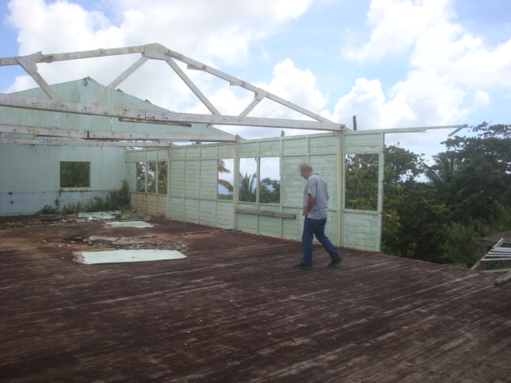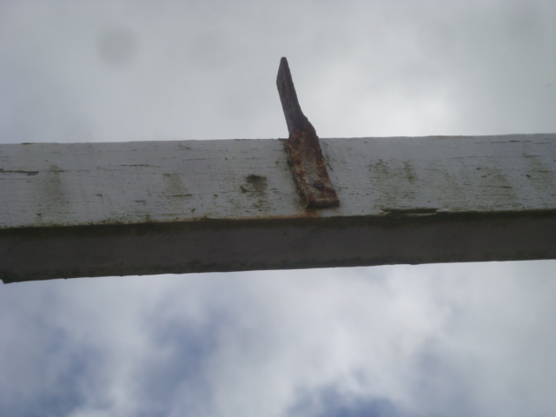
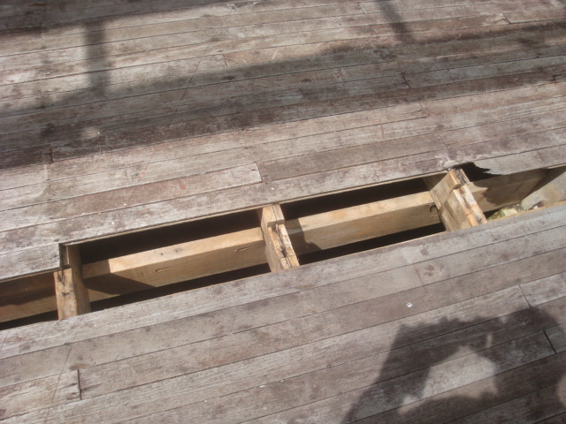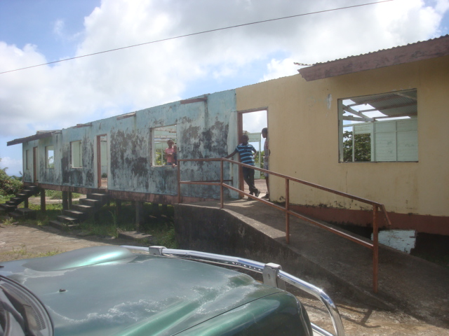
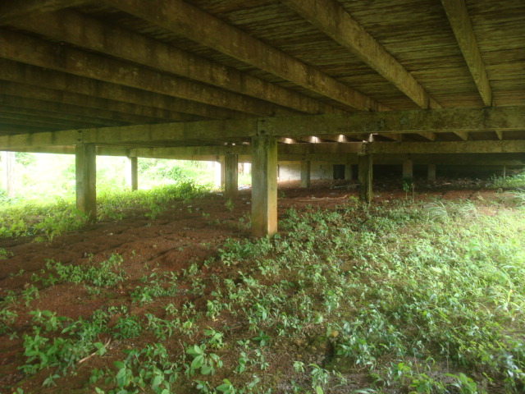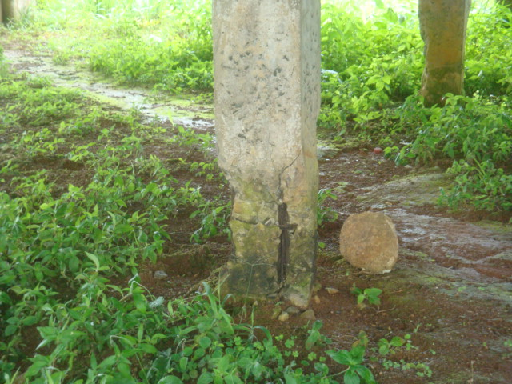

La Fargue Community Centre – conditions
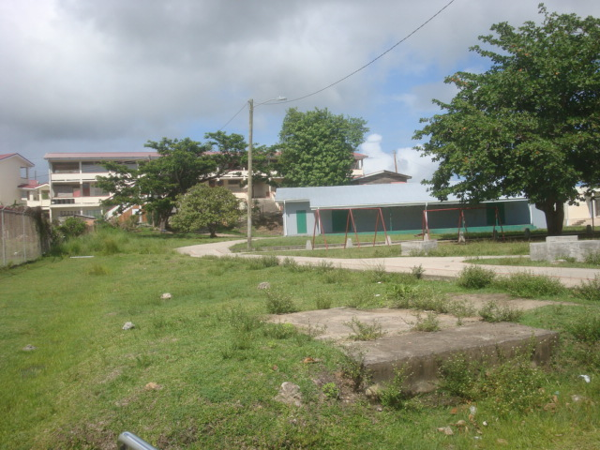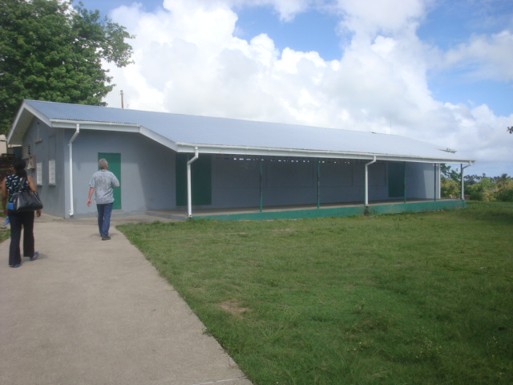
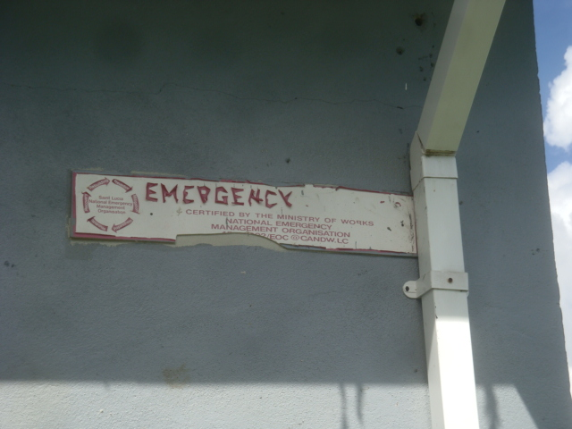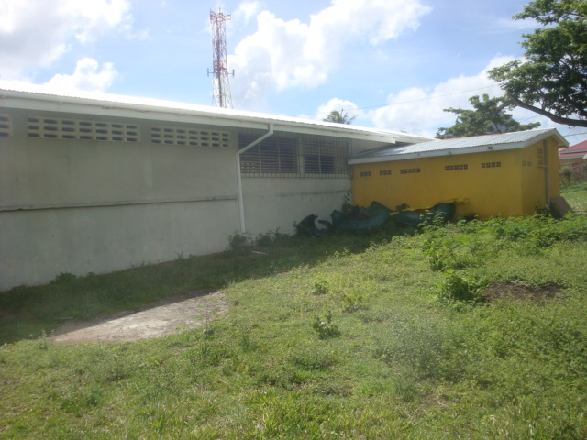
Piaye Community Centre - conditions
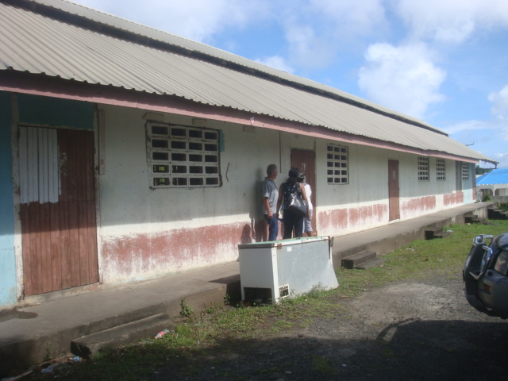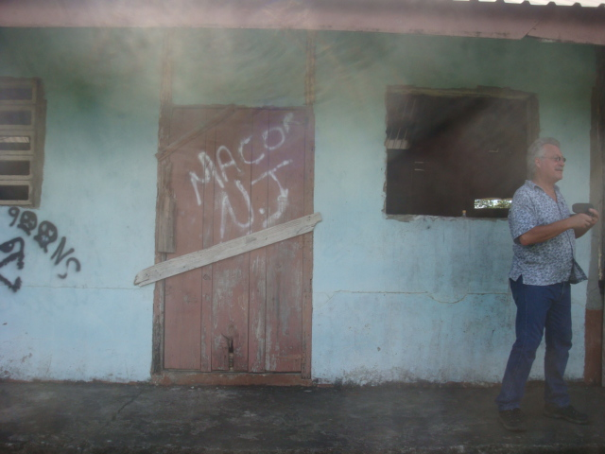
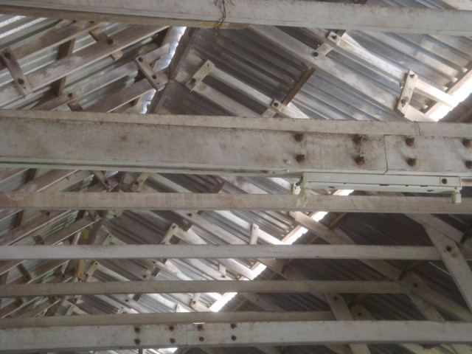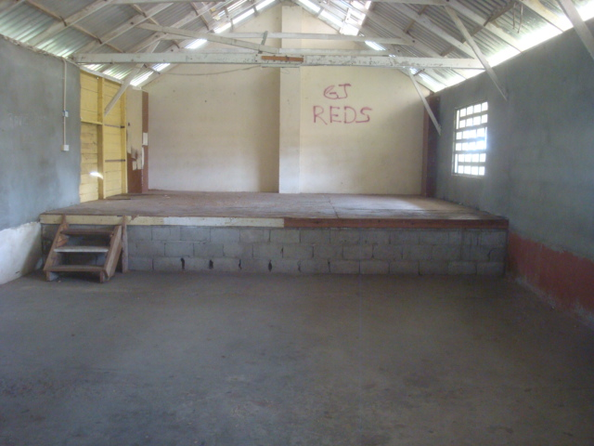
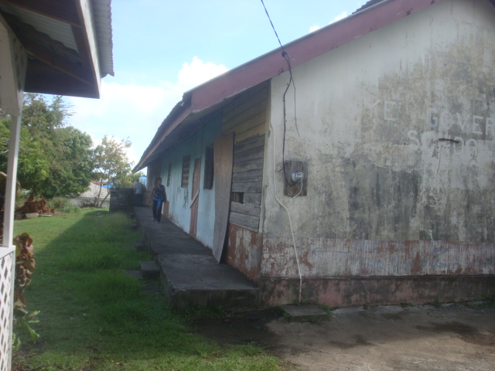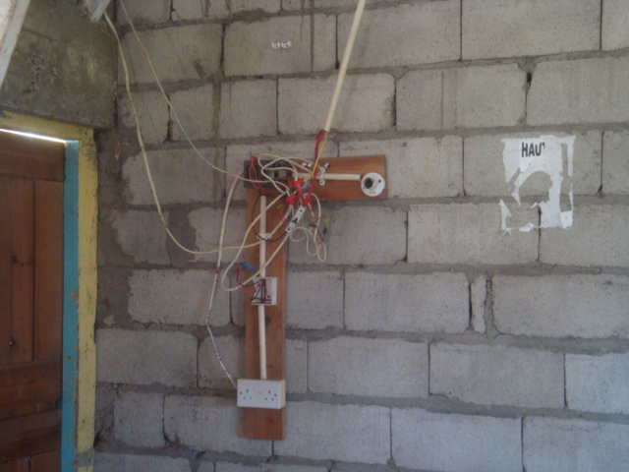

Annex 3: Fact Gathering Interviews and Meetings

Agency | Person Interviewed/ meetings | Date
WASCO | Mr. John Joseph- Managing Director,  Mr. Justin Sealy- Technical Services Supervisor, Mr. Ale Anthony- Sewage Services,  Mr. Alva – Project Engineer  Mr. Jim King- Southern Services Manager | 2 May 2013
WASCO | Mr. Justin Sealy- Technical Services Supervisor- site visit | 2 May 2013
MAFF | Mr. Adam Toussaint- Deputy Chief Forestry Offcier | 15 May 2013
MOST | Mrs. Joanna Reyenolds- Arthuton- Permanent Secretary | 21 May 2013
MOST | Ms. Velda Joseph- Deputy Director Community Services and Social Transformation. | 21 May 2013
MIPSAT/ DVRP | Mrs.Laurna Raoul- Project Engineer | 16 May, 2013  18 June 2013,  10 July 2013, 21 August 2013
MIPSAT | Mr. Nicholas Johnny – Project Engineer | 19 June 2013
MAFF | Ms.Allena Joseph – Fisheries Biologist | 19 June 2013
WRMA | Mr. Micheal Andrew- Director WRMA | 23 June 2013
WRMA | Mrs. Farzane Leon – Water resources Specialist | 23 June 2013
NEMO | Ms. Dawn French- Director | 26 June 2013
MPDHUR | Mr. Hildreth Lewis – Deputy Permanent Secretary | 27 June 2013
NEMO | Ms. Dawn French- Director | 27 June 2013
MPSSEST | Mr. Crispin D’Auvergne- Chief Sustainable Officer | 27 June 2013
MAFF | Mrs. Serita Willam Peter – Senior Fisheries Biologist | 28 June 2013
WRMA | Mr. Micheal Andrew - Director | 28 June 2013
WRMA | Mrs. Farzane Leon – Water Resources Specialist | 28 June 2013
DCA/ PPS-MPDHUR | Mr. Cosmas Louis – Senior Planning Officer | 27 June 2013, 19 August 2013
DCA/ PPS-MPDHUR | Ms. Karen Agustin- Chief Planner /Executive Secretary DCA | 4 July 2013
DCA/ PPS-MPDHUR | Mr. David Desir – Deputy Chief Planner | 4 July 2013
CARPHA | Dr. Christopher Cox- Programme Manger/ technical coordinator | 5 July 2013
SLFES | Mr. Leslie Fontenell – Chief Fire Officer | 6 July 2013
MIPSAT | Mr. Thomas Auguste- Director of Meteorological Services | 10 July 2013
MSDEST | Mrs. Dawn Pierre Nathaniel- Senior Sustainable Development and Environment Officer | 10 July, 2013
PCU | Mrs Myrtl Drysdale – Procurement and M&E officer | 13 July, 2013
SLASPA | Mr. Chedi Tobias – Chief Engineer,  Mr. Cuthbert Nathaniel- Internal Project Auditor | 22 July 2013
MHWHSGR | Mr. Margtus Henry – Project Building Technician | 23 July 2013
CCE | Mr. Neil O. Williams – Project Engineer –Dennery Poly Clinic and Dennery New Hospital | 30 July 2013
MISTP | Mr. Dominic Mathurin – Director of Works, Building Projects Unit, Ministry of Infrastructure | 13 August 2013
SLDC | Mr. Gavin Francis - Senior Development Loans Supervisor | 20 August 2013

Annex 4: List of Participants Attending the Multi-stakeholder Consultation / World Bank Safeguards Seminar
Ministry of Infrastructure Conference Room – 20th August, 2013
Agency | Person | Position
DCA/ MPDHUR - PPS | Ms. Karen Agustin | Executive Secretary DCA/ Chief Planner
DCA/ MPDHUR -PPS | Mr. David Desir | Deputy Chief Planner
DCA/ MPDHUR -PPS | Ovid Martyr | Civil Engineer
MPDHUR -Arch Sectn | Mr. Agustin Poyotte | Chief Architect
WRMA | Mr. Micheal Andrew | Director
WASCO | Mr. Justin Sealy | Technical Services Supervisor
SLDB | Mr. Gavin Francis | Senior Development Loans Supervisor
MSDEST | Neranda Maurice | Programme Officer
MPDHUR | Jenny Daniel | Chief Housing Officer
MIPST | Laurna Raoul | Project engineer
MIPST | Rachel Skeete-Alexander | Geo Soils engineer
MPDHUR | Vincent Jn. Baptiste | Deputy Chief Surveyor
NEMO | Ms. Dawn French | Director
PCU | Mrs Myrtl Drysdale | Procurement and M&E officer
PCU | Ms. Cheryl Mathurin | Project Coordinator

Annex 5: Schedule 3 of the Physical Planning and Development Act of 2001- PERMITTED Development
SCHEDULE 3 (Section 18)
PERMITTED DEVELOPMENT
- A Garden Huts, other than garages, in approved residential areas and not used for human habitation or for the conduct of any activity of a commercial nature.
- Gates, fences, and walls not exceeding 4 feet in height.
- Agricultural out buildings not used for human habitation and enclosures and works on agricultural holdings that are requisite for or incidentail to the use of land for the purpose of agriculture not including subdivision of land for agricultural purposes.
- Repair to roads, bridges and harbour installations
- Repair to services
- Internal alterations to buildings not involving changes to the basic structure or façade of the buildings
- Subject to any requirements of the regulations prescribing minimum building setback, site coverage, and building height limitations, the enlargements or improvement of an existing single dwelling house provided that the floor of the enlargement or improvement does not exceed 1/3 of the floor area of the existing single dwelling house.
(Amended by Act3 of 2005)

Annex 6: Schedule 4 of the Physical Planning and Development Act of 2001 Projects requiring an EIA
SCHEDULE 4 (section 22)
MATTERS FOR WHICH ENVIRONMENTAL IMPACT ASSESSMENT IS ORDINARILY REQUIRED
1. Hotels of more than the number of rooms specified in the Regulations;
2. Sub-divisions of more than the number of plots specified in the Regulations;
3. Residential development of more than the number of units specified in the Regulations;
4. Any industrial plant which in the opinion of the Head of the Physical Planning and Development Division is likely to cause significant adverse impact on the environment;
5. Quarrying and other mining activities;
6. Marinas;
7. Land reclamation, dredging and filling of ponds;
8. Ports;
9. Dams and reservoirs;
10. Hydro-electric projects and power plants;
11. Desalination plants;
12. Water purification plants;
13. Sanitary land fill operations, solid waste disposal sites, toxic waste disposal sites and other similar sited;
14. Gas pipeline installations;
15. Any development projects generating or potentially generating emissions, aqueous effluent, solid waste, noise, vibration or radioactive discharges;
16. Any development involving the storage and use of hazardous materials;
17. Coastal zone developments;
18. Development in wetlands, marine parks, national parks, conservation areas, environmental protection areas or other sensitive environmental areas.
Annex 7: DVRP Agency Questionnaire

Dear ……………………………………….
Could you provide me with a response to the following as part of my information gathering for the DVRP project. Much appreciated.

- Under what legislation does your Ministry/ Agency operate?
- What are the core functions of your agency/ ministry?
- Does your Ministry consider itself an environmental or environmental management agency?
- In what manner does your agency engage in Environmental Management?
- How many staff does your agency / Ministry employ?
- Are any of your staff are formally trained in Environmental Impact assessment (EIA)? If yes, how many and to what levels?
- Are any of your staff are involved in environmental monitoring? If yes, how many?
- Are any of your staff are involved in monitoring of construction / infrastructural projects? If yes how many?
- Does your agency/ Ministry carry out environmental assessments for various types of projects including construction projects?
- Does your agency assist other agencies in the execution of environmental activities such as monitoring of projects and environmental conditions?
- Do you believe your agency has the full capacity (staff, equipment, etc) to undertake its environmental function if any such as compliance activities?
- If no, what are your constraints?
- Are there any constraints or deficiencies in the present legislation that prohibits or constrains you from undertaking your Agency’s environmental management functions?
- Does the Ministry have any form of standard or documented Environmental guidelines or conditions that the Ministry staff or selected contractors have to abide by during the implementation of projects
- Does your agency have any form of environmental screening procedures that it uses to assess the potential environmental impacts of projects proposed or potential mitigative measures?
- If no, would a screening procedure such as a checklist be useful to your agency?
- What would you like to see such an instrument contain or reflect to assist your functions?
- Is there any additional information that you would like to contribute that would be useful to this assessment?

Annex 8: Project Screening Form from Development Control Authority
___________________________________________________________________
Development Control Authority
Major Application Appraisal

Application Registration

Reference Number:

Name of Developer:

Type of Development:

Type of Approval:

Location of Development:

Date of submission:

Date of amendment: N.A.

Designer:

Fees:
Receipt no:

Enforcement/Stop/Abatement Notice Served: N.A

PROPOSAL
The developer is seeking DCA Approval.

APPRAISAL
Legal Documentation
Parcel LRTP Reference Number:

Area of Parent Parcel:

Area to be developed:

DCA Previous Consideration
Application no.: Type of approval: Date: Use:

Land Use Analysis
Present Land Use:

Adjacent Land Uses:

Wider Surrounding land uses:

Site Topography: Flat Gentle Moderate Steep

Site suitability: Good Fair unsuitable engineering works

Proposed Land Use: Acceptable Incompatible

Existing Access:(indicate width) Adequate Needs Upgrading to……..

Proposed Access: Adequate Needs Upgrading to……..

Parking Rate:

Parking Required:

Parking Proposed: Functional y n Needs Improving (No.)……………….

Subdivision
Proposed lot sizes: (range) Low Density Medium Density High Density

Open Space Required: (amount)

Open Space Provided: (amount) Adequate Inadequate

Existing Access: (width) Adequate Needs Upgrading to:

Services/Utilities: Water Electricity Sewage Garbage Disposal Transportation

Certification
Certified Drainage Plan submitted: Yes No Adequate Inadequate

Certified Drainage Details submitted: Yes No Adequate Inadequate

Road Intersection Details submitted: Yes No Adequate Inadequate

Splay Details submitted: Yes No Adequate Inadequate

Cul de Sac Details submitted: Yes No

Structural Certification by:

Proposed Construction
Proposed Building Setbacks: North Adequate Required
South Adequate Required
East Adequate Required
West Adequate Required

Building Plot coverage standard:

Building Plot coverage: Adequate Inadequate

Room Density standard:

Permitted Room Density: Proposed density:

Structural Certification by:

Approvals
Health Approval date:

Fire Approval date:

Electrical Approval date:

Comments

Issues
Yes No

1.
2.
3.
4.

Recommendation
Technical Staff recommend………….

Full Approval with conditions
1.
2.
3.
4.

Full Approval with no conditions

Deferral pending
1.
2.
3.
4.

Rejection
1.
2.
3.
4.

Officer
Date

Annex 9: Sample Terms-of-Reference (TORs) for Sub-project EIA

TERMS OF REFERENCE FOR SERVICES TO CONDUCT AN
ENVIRONMENTAL IMPACT ASSESSMENT (EIA)
OF {PROJECT TITLE}, SAINT LUCIA

Introduction.

{General Description of the Activity and need for EIA}
According to the Bank’s Environmental Assessment Policy [OP4.01] the project is classified as Category B meaning that environmental impacts for the type of work anticipated under the project are expected to be moderate in nature and can be managed through the application of appropriate engineering and management measures.
{The purpose of this consultancy is to …..}

Background Information.

{Describe setting and relevant attributes of the project and environs}

Objectives.

{Describe specific objectives of the EIA}
The EIA will be conducted in compliance with World Bank requirements as presented in OP 4.01, Environmental Assessment and shall include considerations as presented in Bank Safeguards OP/BP 4.04, Natural Habitats and OP/BP 4.11, Physical Cultural Resources.

Scope.

{Describe Scope of EIA and limiting factors}

Specific EIA Requirements.

{Detail specific activities to be accomplished and known issues to be examined in addition to those to be discovered during the assessment}
{EIA Outline}
At a minimum, the EIA will include the following:

- Executive Summary of not more than 2 pages
- Description of the proposed Sub-Project
- Legal framework
- applicable environmental, land use, water management laws and regulations
- other applicable regulations or agency requirements
- institutional or lender requirements
- Description of the Existing Environment
- Biological
- Physical
- Socioeconomic
- Analysis of project Impacts
- Biological
- Physical
- Socioeconomic
- Mitigation Plan
- Environmental Management Plan
- Proposed Contract Clauses
- Record of consultations
- Technical Annexes
- List of Preparers

{Add additional reporting as needed}

Qualifications of Consultant.

The consultant shall have a minimum of a bachelor’s degree in natural sciences or related discipline and a minimum of 5 years experience in the development of Environmental assessments and analysis. Consultant shall have demonstrated experience in the analysis of impacts related to civil works.

Schedule.

{Provide period of execution and deliverable schedule}

Annex 10: Environmental Contract Clauses

The following are standard environmental related clauses that may be appended to or incorporated into the contracts for the small civil works which have been determined to be of minimal environmental impact. These mitigation measures are the core of a generic, standardized EMP (Environmental Management Plan) for these types of small works and the typical associated minor impacts which can be routinely addressed with best industry practice. These clauses are general and may be modified to conform with applicable Saint Lucian laws and contract procedures for such works and shall remain in force throughout the contract period. These mitigative measures are intended for relatively simple environmental management issues and are based on best management practice and industry standards. These are the mitigation measures which are expected of all professional contractors who are performing civil works, and represent the minimum standard of execution for environmental protection during the execution of such works. (Specific project related recommendations may also be forthcoming from statutory permitting agencies such as the DCA or the Ministry of Health, and these can be reformatted in to contract clauses as well. Finally, if an EIA has been conducted for a particular sub-project due to its environmentally sensitive or complex nature, then the specific recommendations for mitigative measures in that EIA should also be included as contract clauses.)

- Permits and Approvals

The contractor shall be responsible for ensuring that he or she has all relevant legal approvals and permits required to commence works.

- Site Security

The contractor shall be responsible for maintaining security over the construction site including the protection of stored materials and equipment. In the event of severe weather, the contractor shall secure the construction site and associated equipment in such a manner as to protect the site and adjacent areas from consequential damages. This includes the management of onsite, construction materials, construction and sanitary wastes, additional strengthening of erosion control and soil stabilization systems, and other conditions resulting from contractor activities which may increase the potential for damages.

- Discovery of Antiquities

If, during the execution of the activities contained in this contract, any material is discovered onsite which may be considered of historical or cultural interest, such as evidence of prior settlements, native or historical activities, evidence of any existence on a site which may be of cultural significance, all work shall stop and the supervising contracting officer shall be notified immediately. The area in which the material was discovered shall be secured, cordoned off, marked, and the evidence preserved for examination by the local archaeological or cultural authority. No item believed to be an artifact must be removed or disturbed by any of the workers. Work may resume, without penalty of prejudice to the contractor upon permission from the contracting officer with any restrictions offered to protect the site.

- Worker Occupational Health and Safety

The contractor shall ensure that all workers operate within a safe environment. Sanitation facilities shall be provided for all site workers. All sanitary wastes generated as a result of project activities shall be managed in a manner approved by the contracting officer and the local authority responsible for public health. The contractor shall ensure that there are basic medical facilities on site and that there are staff trained in basic first aid. Workers must be provided with the necessary protective gear as per their specific tasks such as hard hats, overalls, gloves, goggles, boots, etc. The contractor shall provide the contracting officer with an occupational health and safety plan for approval by the local health authority prior to the commencement of site activities.

The contractor must ensure that all workers operate within a safe environment. All relevant Labour and Occupational Health and Safety regulations must be adhered to ensure worker safety. Sanitary facilities must be provided for all workers on site. Appropriate posting of information within the site must be done to inform workers of key rules and regulations to follow.

- Noise Control

The contractor shall control noise emissions generated as a result of contracting activities to the extent possible. In the case of site locations where noise disturbance will be a concern, the contractor shall ensure that the equipment is in good working order with manufacturer supplied noise suppression (mufflers etc.) systems functioning and in good repair. Where noise management is a concern, the contractor shall make reasonable efforts to schedule activities during normal working hours (between 8 am and 5 pm). Where noise is likely to pose a risk to the surrounding community either by normal works or working outside of normal working hours or on weekends, the contractor shall inform the contracting officer and shall develop a public notification and noise management plan for approval by the contracting officer.

Specific elements of the noise control activities by the contractor shall include: construction / work activities will occur within specified daylight hours e.g. 8:00 am to 4:00pm; community / public to be informed in advance of any work activities to occur outside of normal working hours or on weekends; sites should be hoarded wherever possible; during operations, the engine covers of generators, air compressors and other powered mechanical equipment shall be closed, and equipment placed as far away from residential areas as possible; there will be no excessive idling of construction vehicles at sites; noise suppression equipment or systems supplied by manufacture will be utilized; ensure all vehicles and equipment are properly serviced; the contractor must develop and implement a public notification and noise management plan.
- Use and Management of Hazardous Materials, fuels, solvents and petroleum products

The use of any hazardous materials including oils, fuels and petroleum products shall conform to the proper use recommendations of the product. Waste hazardous materials and their containers shall be disposed of in a manner approved by the contracting officer. A site management plan will be developed by the contractor if the operation involves the use of these materials to include estimated quantities to be consumed in the process, storage plans, spill control plans, and waste disposal practices to be followed. This plan and the manner of management are subject to the approval of local authority responsible for safety, and waste management, and the contracting officer.

Elements of the hazardous materials management shall include: contractor must provide temporary storage on site of all hazardous or toxic substances in safe containers labeled with details of composition, properties and handling information; the containers of hazardous substances shall be placed in an leak-proof container to prevent spillage and leaching; the wastes shall be transported by specially licensed carriers and disposed in a licensed facility; paints with toxic ingredients or solvents or lead-based paints will not be used; banned chemicals will not be used on any project.

- Use and Management of Pesticides

The project will not fund activities that involve the purchase or use of significant quantities of pesticides. For incidental, minor use of pesticides, the use of pesticides shall be approved by the contracting officer and shall conform to the manufacturers’ recommendations for use and application. Any person using pesticides shall demonstrate that they have read and understood these requirements and are capable of complying with the usage recommendations to the satisfaction of the contracting officer. All pesticides to be used shall conform to the list of acceptable pesticides that are not banned by the relevant local authority.

If termite treatment is to be utilized, the PCU will ensure appropriate chemical management measures are implemented to prevent contamination of surrounding areas, and will use only licensed and registered pest control professionals with training and knowledge of proper application methods and techniques.

- Use of Preservatives and Paint Substances

All paints and preservatives shall only be used with the approval of the contracting officer. Information shall be provided to the contracting officer which describes the essential components of the materials to be used so that an informed determination can be made as to the potential for environmental effects and suitability can be made. Storage, use, and disposal of excess paints and preservatives shall be managed in conformance with the manufacturers’ recommendations and as approved by the contracting officer. The contractor shall provide the contracting officer with a list of materials and estimated quantities to be used, storage, spill control and waste disposal plans to be observed during the execution of the contract. This plan is subject to the approval of the contracting officer.

- Use of Explosives

Use of explosives shall be at the approval of the relevant local authority and shall be supervised and undertaken by a qualified explosives technician. Blasting will be limited to between the hours of 9:00am and 4:00 pm unless specifically approved by the local authority and the contracting officer. Any use of explosives shall be permitted only after an explosives management and blasting plan has been approved by the relevant local authority and the contracting officer.
This plan shall include:
A. Description of the explosive agent, charge description, intended use.

B. Site safety plan including:
1. Storage of initiators, booster charges and principal blasting agents
2. Handling precautions to be observed
3. Transport to and from site
4. Security of stored materials
5. Disposal of excess or damaged explosive materials.

C. Analysis of risk to surrounding area and mitigation measures to be employed including:
1. Over-pressure event
2. Noise
3. Flying debris
4. Seismic transmission
5. Accidental detonation

D. Name and qualifications for all persons responsible for handling explosive agents

- Site Stabilization and Erosion Control

The Contractor shall implement measures at the site of operations to manage soil erosion through minimization of excavated area and time of exposure of excavated areas, preservation of existing ground cover to the extent possible, provision of approved ground cover. Where excavations are made, contractor shall implement appropriate stabilizing techniques to prevent cave-in or landslide. Measures shall be approved by the contracting officer.

The contractor must ensure that appropriate erosion control measures such as silt fences are installed. Proper site drainage must be implemented. Any drain clogged by construction material or sediment must be unclogged as soon as possible to prevent overflow and flooding. The use of retaining structures and planting with deep rooted grasses to retain soil during and after works must be considered. The use of bio-engineering methods must be considered as a measure to reduce erosion and land slippage. Keep angle of slopes within limits of soil type. Balance cut and fill to limit steepness of slopes. All slopes and excavated areas must be monitored for movement.

All construction materials, including chemicals, must be properly stored. The contractor will establish appropriate erosion and sediment control measures such as hay bales, sedimentation basins, and / or silt fences and traps to prevent sediment from moving off site and causing excessive turbidity in nearby streams, rivers, wetlands, and coastal waters.

An erosion management plan will be required where the potential exists for significant sediment quantities to accumulate in wetlands, lakes, rivers and nearshore marine systems. This plan shall include a description of the potential threat, mitigation measures to be applied, and consideration for the effects of severe weather and an emergency response plan.

If works are long coastal marine areas or near major steams and river, water quality monitoring must be done before construction, and at regular intervals to determine turbidity levels and other quality parameters. Construction vehicles and machinery will be washed only in designated areas where runoff will not pollute natural surface water bodies.

- Air Quality

The following conditions apply to work sites for the control of air quality including dust control:

- Construction materials such as sand, cement, or other fines should be kept properly covered.
- Cement should be kept stored within a shed or container.
- The sand and fines can be moistened with sprays of water.
- Unpaved, dusty construction roads should compacted and then wet periodically.
- During interior demolition debris-chutes shall be used above the first floor.
- Demolition debris shall be kept in controlled area and sprayed with water mist to reduce debris dust.
- During pneumatic drilling/wall destruction dust shall be suppressed by ongoing water spraying and/or installing dust screen enclosures at site
- The surrounding environment (sidewalks, roads) shall be kept free of debris to minimize dust.
- There will be no open burning of construction / waste material at the site.
- There will be no excessive idling of construction vehicles at sites.
- The bins of all haulage vehicles transporting aggregate or building materials must be covered on all public roads.

- Traffic Management

In the event that contractor / construction activities will result in the disruption of area transportation services, including temporary loss of roadways, blockages due to deliveries and site related activities, the contractor shall provide the contracting officer with a traffic management plan including a description of the anticipated service disruptions, community information plan, and traffic control strategy to be implemented so as to minimize the impact to the surrounding community. This plan shall consider time of day for planned disruptions, and shall include consideration for alternative access routes, access to essential services such as medical, disaster evacuation, and other critical services. The plan shall be approved by relevant local authority and the contracting officer.

Elements of the traffic management plan to be developed and implemented by contractor shall include: alternative routes to be identified in the instance of extended road works or road blockages; the public to be notified of all disturbance to their normal routes; signposting, warning signs, barriers and traffic diversions must be clearly visible and the public warned of all potential hazards; provision must be made for the safe passages and crossings for all pedestrians where construction traffic interferes with their normal route; there must be active traffic management by trained and visible staff at the site or along roadways as required to ensure safe and convenient passage for the vehicular and pedestrian public; Adjustment of working hours to local traffic patterns, e.g. avoiding major transport activities during rush hours or times of livestock movement .

- Management of Standing Water

Under no circumstances shall the contractor permit the collection of standing water as a consequence of contractor activities without the approval of the contracting officer and consultation with the relevant local environmental health authority. Recommendations from that local authority on how to manage and treat the standing water must be implemented. The condition of the standing water must be monitored by the contractor to ensure that it does not present itself as a breeding ground for any pests such as mosquitoes.

- Management of Solid Wastes -trash and construction debris

The contractor shall provide the contracting officer with a solid waste management plan as part of a site waste management plan that conforms to the solid waste management policies and regulations of the relevant St. Lucian authority. Under no circumstances shall the contractor allow construction wastes to accumulate so as to cause a nuisance or health risk due to the propagation of pests and disease vectors. The site waste management plan shall include a description of how wastes will be stored, collected and disposed of in accordance with current law. Additionally the contractor shall provide for the regular removal and disposal of all site wastes and provide the contracting officer with a schedule for such removal.

- Management of Liquid Wastes

The contractor shall provide the contracting officer with a liquid waste management plan as part of a site waste management plan that conforms to the waste management policies and regulations of the relevant St. Lucian authority. Under no circumstances shall the contractor allow construction related liquid wastes to accumulate on or off the site, or to flow over or from the site in an uncontrolled manner or to cause a nuisance or health risk due to its content. The site waste management plan shall include a description of how these wastes will be stored, collected and disposed of in accordance with current law. Additionally the contractor shall provide for the regular removal and disposal of all site wastes and provide the contracting officer with a schedule for such removal.

Specific elements of the contractor’s liquid waste management plan shall include: contractor to abide by all pertinent waste management and public health laws; waste collection and disposal pathways and sites will be identified for all major waste types expected from demolition and construction activities; construction and demolition wastes will be stored in appropriate bins; liquid and chemical wastes will be stored in appropriate containers separated from the general refuse; all waste will be collected and disposed of properly in approved landfills by licensed collectors; the records of waste disposal will be maintained as proof for proper management as designed; whenever feasible the contractor will reuse and recycle appropriate and viable materials (except asbestos); construction related liquid wastes must not be allowed to accumulate on or off the site, or to flow over or from the site in an uncontrolled manner or to cause a nuisance or health risk due to its contents.

- Special Condition - Management of Medical Wastes

In the event that the contractor discovers medical wastes, the contractor shall provide the contracting officer with a medical waste management plan as part of a site waste management plan that conforms to the waste management policies and regulations of the relevant St. Lucian health and waste management authorities. The plan shall include a description of how these wastes will be stored, collected and disposed of in accordance with current law. The contractor must ensure that all persons handling medical wastes are provided with proper protective clothing. All medical wastes must be secured in specially labelled and sealed containers, and disposed of according to relevant local legislation at specified disposal sites. Medical wastes must be kept separate from the other waste streams on site.

The waste management plan provided by the contractor must ensure that all persons handling medical wastes are provided with proper protective clothing. All medical wastes must be treated as hazardous. All medical wastes must be secured in specially labeled and sealed containers separate from other wastes streams. All medical wastes must be disposed of according to relevant local legislation at specified disposal sites.

- Special Condition - Management of Asbestos

In the event that during the course of work activities the contractor discovers asbestos at the existing site and there is need to stabilize and remove it, the contractor shall contact the relevant local authorities and the contracting officer immediately. If work has already commenced, all work in the area must stop immediately. An asbestos management plan must be prepared by the contractor and approved by the relevant local health and waste management authorities and the contracting officer describing how this material will be stored, collected and disposed of in accordance with current law, and identifying the approved experienced professional who will undertake this work. The plan must include:

- Description of the issue and extent of contamination
- Site safety measures
- Stabilization techniques to be employed
- Storage and transport plan
- Approved disposal procedure
- Worker awareness and training

In preparing the plan, the contractor should liaise with the relevant local health and waste management agencies to ensure that the adequacy of the measurements being proposed.

Site management shall consist of enclosing relevant sections of the site with appropriate material by the contractor. Where possible the asbestos and its location must be appropriately contained and sealed to minimize exposure, and any asbestos shall be marked clearly as a hazardous material. Stabilizing friable asbestos will be done prior to removal (if removal is necessary) and it will be treated with a wetting agent to minimize asbestos dust. Asbestos will be handled and disposed by skilled & experienced professionals using appropriate PPE (personal protective equipment) such as respirators and tyvec suites which will be provisioned to workers to protect them and prevent contamination with asbestos fibers. Respiratory protection together with measures to prevent the contamination of clothing and inadvertent transport of asbestos fiber off-site shall be provided to all exposed workers. If asbestos material is be stored temporarily, the wastes should be securely enclosed inside closed containments and marked appropriately. Security measures must be implemented against unauthorized removal of asbestos from the site. No removed asbestos will be reused.

- Special conditions - Water Pipeline Installation

The Contractor shall utilize the following measures to mitigate potential environmental, health and safety impacts during the construction and installation of the water pipeline:

- Trenching. Soil stockpiling will be done in designated areas alongside the trench using piles no higher than 2 meters, convex in shape, and located so as to minimize disturbance and hazard to passersby or traffic. The contractor shall ensure that stockpiles do not cause damming of water or runoff, or that such stockpiles are themselves not washed away.

- Dewatering. Removal of water from trenches shall be done in such a manner to prevent the discharge of mud or sediment into any water body, or the creation of standing water bodies on lands outside the work area.

- Dust Control. During dry periods when dust is a nuisance it shall be mitigated by spraying of water onto work surfaces along the pipeline work area. Dust shall not be allowed to travel outside of the work zone.

- Traffic Control. For all works alongside roadways, appropriate safety signage and barriers shall be used to ensure the safety of any foot traffic or vehicular traffic. If the trench is exposed to foot or vehicle traffic appropriate restrictive barriers, taping, and warning signage shall be used. Traffic shall be controlled and stopped as necessary on public thoroughfares in accordance with good safety practice and national requirements. Trenches or equipment exposed to public access must be clearly demarcated and restricted to public access. Mud and sand brought onto paved public access roads shall be washed and cleared daily.

- Safety Plan. The Contactor will prepare a Health and Safety Plan which shall include emergency response and first aid procedures, awareness training suitable to the tasks being conducted, vehicle and equipment safety provisions, and personal protective equipment information. The contractor will provide hard hats, work boots, protective eyewear and gloves to workers and will ensure that they are used by workers on the job.

- Vegetation and Topsoil Clearing. If any vegetation or brush is cleared, or topsoil removed, it shall be done in such a way as to avoid disturbance or effects outside the established work area. Herbicides or burning may not be used to dispose of any cleared vegetation, rather such vegetation must be chipped, shredded, and dispersed in approved areas or hauled to an approved landfill. Should fauna be encountered work will cease until such fauna have been safely relocated. If any agricultural land is crossed, topsoil shall be stored separately and replaced by spreading on the land surface upon completion of work.

- Access Roads. No new access roads will be opened, only existing roadways will be used for all the entry and exit of materials and equipment to and from the work zone.

- Work Areas. Contractor will delineate approved work areas for all activities including excavation, stockpiling, access, equipment placement during excavation, and materials storage. Such work areas are subject to approval by the contract manager and/or supervising engineer, and Contractor may use only those lands for which approval and access has been provided by the contracting officer and/or supervising engineer. Any rental, use or acquisition of lands from private parties is not permitted without previous notification to and express written approval by the PCU through application of relevant World Bank Policy.

- Vehicle and Equipment Fueling and Maintenance. All gasoline and diesel filling, oil changing, and maintenance of vehicles and equipment will be done outside of the project area at established facilities. If fuel trucks are used they will have adequate safety equipment and fire extinguishers, be free of leaks and be fitted with appropriate dispensers, and have spill kits and absorbent materials ready to retrieve any leaked or spilled fuels. No fuel, new oil or waste oil will be stored on the work site, and vehicles will not be washed on the work site or in adjacent areas.

- Special conditions – works in Forest Reserves

For any work in a designated Forest Reserve, the following will apply:
- There must be no unnecessary clearing of natural vegetation.
- Avoid the use of herbicides or other chemicals.
- Any works to be undertaken in a protected forest area must be done under the supervision of a representative of the Forestry Department.
- The contractor must ensure that any work undertaken in the forest reserve must be done by manual means.
- There must be minimal impact to flora and fauna in the forest area.
- All recognized natural habitats, wetlands and protected areas in the immediate vicinity of the activity must not be damaged or exploited.
- The contractor must ensure that all staff will be strictly prohibited from hunting, foraging, logging or other damaging activities.
- A survey and an inventory shall be made of large trees in the vicinity of the construction activity, large trees shall be marked and cordoned off with fencing, their root system protected, and any damage to the trees avoided.
- There will be no unlicensed borrow pits, quarries or waste dumps in protected areas.
- Upon completion, all wastes must be immediately removed out of the forested area.

The Climate Adaptation Financing Facility (CAFF) is a pilot financing mechanism meant to promote increased climate resilience, including the provision of retail loans (sub-loans) to eligible households and private enterprises, to finance climate adaptation investments to build resilience of assets and livelihoods intended to reduce risks associated with catastrophic hydro-meteorological shocks. The development objective of this component is to build an affordable and self-sustaining loan portfolio in climate adaptation in Saint Lucia.
The Contingent Emergency Response Component (CERC) is a provisional component, which would finance emergency recovery and reconstruction subprojects under an agreed action plan of activities. The CERC is designed as a mechanism that enables the Government of Saint Lucia to rapidly access IDA funds through a rapid re-categorization and reallocation of project financing, to partially cover emergency response and recovery costs in the event of a disaster.
Additional centres at Blanchard and Babonneau were mentioned during meeting with MOST staff on 21 May 2013.
A preliminary structural report was commissioned by MOST to determine the condition of the community centres and to assist in the preparation of tender documents.
Mr. Thomas August, the Director of Meteorological Services on 10 July, 2013 outlined the project and noted that this would be undertaken jointly with the Water Resource Management Authority (WRMA) to share benefits as Mr. Michael Andrew, the director of the WRMA had also indicated in a meeting on the 23 June 2013.
Engineer Laurna Raoul of the MISTP and project engineer under DVRP was directed by the Chief Engineer of MIPST to meet with this consultant and facilitate the provision of all required information on the various MISTP projects and site visits. Meetings and site visits occurred over a number of days from 16 May to 21 August 2013.
Meeting and discussion with Adam Toussaint Department Chief Forestry Officer on 15 May, 2013
Meeting with Adam Toussaint Dep Chief forestry officer on 15 May, 2013
Source: http://www.worldbank.org/opmanual
Source:http://web.worldbank.org/WBSITE/EXTERNAL/PROJECTS/EXTPOLICIES/EXTSAFEPOL/0,,contentMDK:20507440~pagePK:64168427~piPK:64168435~theSitePK:584435,00.html
Source:http://web.worldbank.org/WBSITE/EXTERNAL/PROJECTS/EXTPOLICIES/EXTOPMANUAL/0,,contentMDK:20064724~menuPK:64701637~pagePK:64709096~piPK:64709108~theSitePK:502184,00.html
Source: http://web.worldbank.org/WBSITE/EXTERNAL/PROJECTS/EXTPOLICIES/EXTSAFEPOL/0,,content MDK:20543943~menuPK:1286597~pagePK:64168445~piPK:64168309~theSitePK:584435,00.html
Meeting with Engineer Laurna Raoul who articulated the Ministry of Infrastructure’s position on works that it had to undertake and their belief that there was no need to submit such projects to the DCA. This has been a sore point with some of DCA staff. The Deputy Permanent Secretary of the Ministry of Physical Development Mr. Lew did indicate at the meeting of 27 June 2013 that this matter was going to be addressed in the near future at both the DCA Board and technical levels. The fact that the chief Engineer of the Ministry of Infrastructure sat on the DCA Board did not prevent the Ministry of Infrastructure from presenting their projects for approval. Hildreth Lewis indicate at the meeting of 27 June 2013 that this matter was going to be addressed in the near future at both the DCA Board and technical levels. The DCA staff felt that the fact that the chief Engineer of the Ministry of Infrastructure sits on the DCA Board does not prevent the Ministry of Infrastructure from presenting their projects for approval. Discussions with DCA Executive Secretary Ms Agustin, Deputy Chief Planner Mr. Desir, and Mr. Louis confirmed similar sentiments
2012 Mid year population estimate from 2012 fact sheet from the Central Statistics Office, Castries, St.Lucia
Organization of American States, Saint Lucia Development Atlas. Department of Regional Development, OAS General Secretariat, Washington D.C. USA. 1987
The Caribbean conservation Association. St.Lucia Country Environmental Profile. St. Michael, Barbados. 1991
Screening process and list prepared by the PCU. Project ID and Environmental Tracking.
The local authority in this case is the Archaeological and Historical Society. The Saint Lucia National Trust would also be involved only after discussion and agreement with the Archaeological and Historical Society.
The Ministry of Health , Wellness, Human Services, and Gender Relations, in particular the Environmental Health Department is the agency responsible for public and environmental health matters, and the issuing of the relevant health permits. The also review Occupational Health and Safety plans as part of their project review.
The local Authorities here are the St. Lucia Fire and Emergency Services, The St. Lucia Solid Waste management Authority, and the Ministry of Health.
The Royal St. Lucia Police Force is the responsible agency who reviews blasting plans and provides recommendations on the management and use of explosives. St. Lucia Fire and Emergency Services must also be informed when such activities are scheduled.
The Transport Division of the Ministry Infrastructure, Port Services, and Transport, with the assistance of the Chief Engineer’s Office in that Ministry is the authority responsible for reviewing and approving traffic management plans.
The St. Lucia Solid Waste Management Authority is the responsible agency. The Environmental Health Department of the Ministry of Health have requested such plans as part of their permitting process as well.
As per 31 above.
As per 31 above.
The St.Lucia Solid Waste Management Authority and the Environmental Health Department of the Ministry of Health. A local engineering contractor, Mr. Norman St.Ville, recently undertook such work at the St.Aloysius Roman Catholic Boy’s School in Castries. His credentials are available at the PCU offices for reference.

