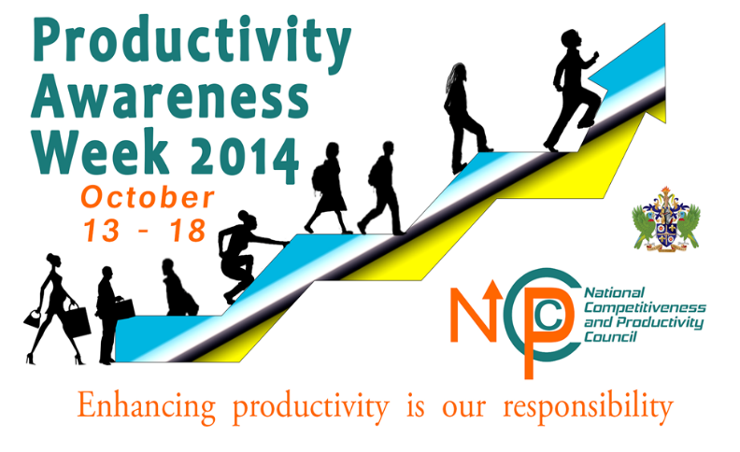
Essay Competition – Secondary Schools



The National Competitiveness and Productivity Council (NCPC) in collaboration with the Government of Saint Lucia, will be hosting its first ‘Productivity Awareness Week’ during the period 13 - 18 October, 2014. The NCPC therefore, invites students in forms 3, 4 and 5 to take part in the 2014 essay competition!
The topic:
There are many ways in which one can define productivity. One definition is as follows: Productivity is about the effective and efficient use of all resources. Resources include time, people, knowledge, information, finance, equipment, space, energy, materials. The Saint Lucia productivity philosophy is “Productivity is embracing a mindset that continuously strives for excellence.”
Write an essay in 500- 800 words, delivering an address to your peers on how they can become more productive students.

How to Enter:
Send entries to: productivityessay@gmail.com. The subject of the email should read “Productivity Awareness Week Essay Competition.”
Students should send in their typed essays in Microsoft Word format or the typed essay can be submitted through the participants’ respective school principal.
Deadline: All essays should be submitted by Tuesday, September 30, 2014.
Prizes:
1st Place: Tablet & EC$500 cash
School: Trophy & EC$800 cash
2nd Place: Tablet & EC$300 cash
3rd Place: EC$100 cash, $ EC$100 grocery voucher & a cellular phone

Write, Enter, Win

Prizes sponsored by:
Saint Lucia National Competitiveness and Productivity Council – Tel: 468-5571

